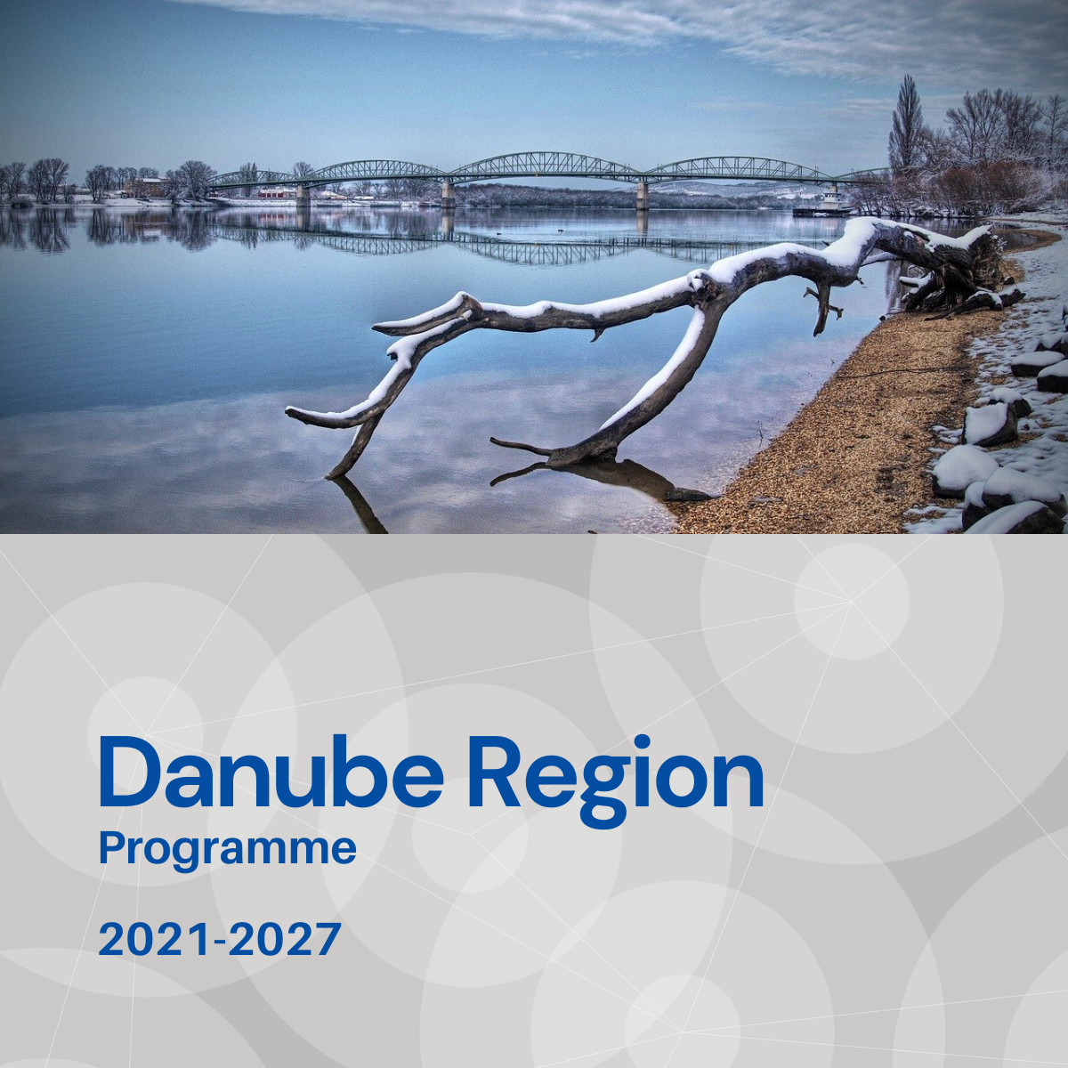

Specific objective 4.2
Factsheet

Priority 4 – A better cooperation governance in Danube Region

Specific objective 4.2
Increased institutional capacities for territorial and macro-regional governance

Background
Comprising 14 countries - old and new Member States, candidate countries, a potential candidate and neighbourhood countries - the Danube Region is characterized by distinct administrative fragmentation and low level of institutional integration. Lagging behind legal harmonization and limited capacities of public bodies to engage into transnational cooperation, especially on sub-national levels, are substantially hindering integrated territorial developments along shared functional ties.

Focus
With Specific Objective 4.2 the DTP addresses a niche in which transnational cooperation can play a key-role in creating multi-level governance solutions for major territorial challenges such as demographic change or increasing urban-rural disparities. Territorial focus, cross-sectorial, multi-level approach and a clear bottom-up perspective are the outstanding features of this Specific Objective within the DTP portfolio.
For achieving a high leverage effect, a clear focus should be put on promoting truly integrated approaches under strong involvement of civic and local actors, fostering inter-institutional relations along functional areas and strengthening capacities of public bodies in selected fields. The holistic character of projects shall be reflected not only by the integration of different administrative levels but also through embedding sectorial aspects like transport or accessibility into broader territorial governance scenarios. The improved provision of public services of general interest and digitalization are to be considered as horizontal elements. All measures shall substantially take into account, moreover, existing main territorial/spatial development frameworks such as the Territorial agenda 2030 or the New Leipzig Charter.

What we finance
- Integrated governance models for addressing challenges arising from demographic change (e. g. aging, depopulation, brain drain);
- Integrated urban-rural governance models including specific territorial development strategies for rural/remote areas as well as accessibility aspects and transport bottlenecks;
- Support for more and stronger inter-institutional relations for the integrated development of transboundary functional areas;
- Capacity building considering especially a better involvement of local and regional public bodies as well as civic actors in transnational policy making, territorial development frameworks and governance models;
- Support for the monitoring and analysis of territorial processes affecting the cohesion and cooperation of the Danube Region to assist capacity building and institutional capacity
With regard to the EUSDR this Specific Objective is expected to provide direct contributions especially to actions and targets defined under the EUSDR Action Plan for PA10.

What we do not finance
- Projects which do not demonstrate that cooperation is needed on transnational level to address the identified governance-challenges
- Projects not being clearly embedded in a territorial scenario and not considering respective existing frameworks (like Territorial Agenda 2030 or the New Leipzig Charter)
- Projects with pre-dominant focus on infrastructure or mere technical (IT-) solutions;
- Projects missing a clear focus on strengthening institutional capacities;
- Projects lacking multi-level governance character with respect to objectives, activities, outputs and especially partnership composition;
- Projects with narrowed sectorial focus (e. g. project focussing on educational/training schemes for certain target groups might fit better under Priority 3):

Whom do we address
- Local and regional (public) bodies are expected to be at the core of each partnership, since those actors are the closest to their communities, offering many essential public services and having in-depth knowledge on the needs of civil society and businesses.
- Civil Society Organisations and private actors (e. g. SMEs, private service operators) as further indispensable pillars of the envisaged governance schemes.
- Support organizations (chambers of commerce, employment agencies, expert bodies in the field of urban or rural-urban development and similar).
- National public bodies, EUSDR-related actors and international organizations for adding policy-relevance and strategic momentum (to be involved either as financing or strategic PP).
- Academia as further knowledge providers.

