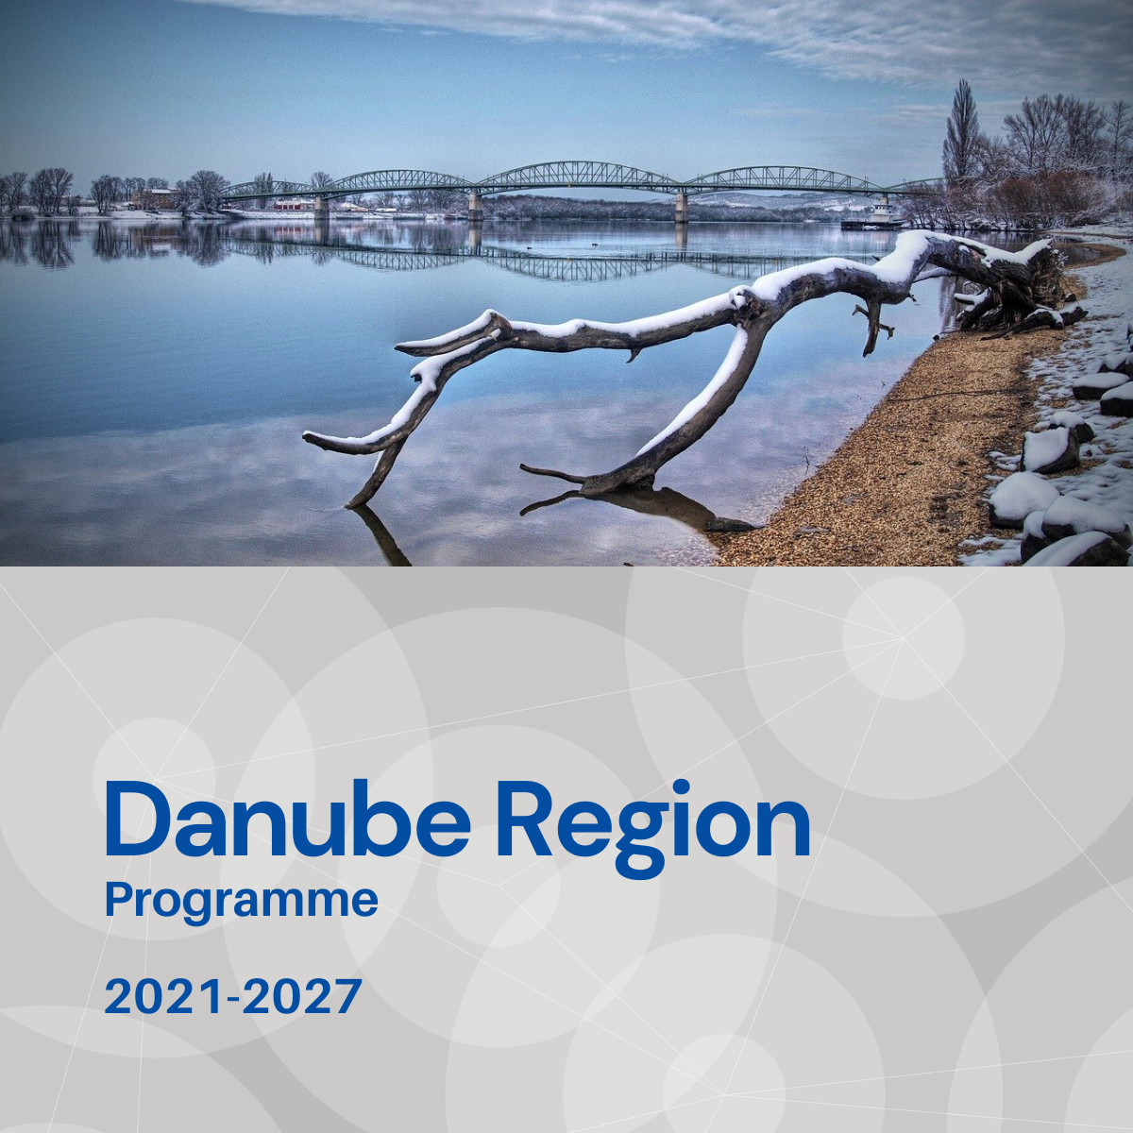

Specific objective 1.1
Factsheet

Priority 1 – A smarter Danube Region

Specific objective 1.1
Developing and enhancing research and innovation capacities and the uptake of advanced technologies

Background
Danube Region is characterised by large competitiveness gaps between the old, the new Member States and the non-EU countries, including their status within the regional innovation ecosystem. There is a low share of technology and knowledge-intensive activities. The RDI activities are overly concentrated within the western regions or the major urban hubs, including capital cities or university towns. Current scientific and technological transnational cooperation is hindered by different levels of knowledge transfers and innovations capacities. In addition, the spatially and structurally fragmented human resources and financial expenditures for innovation keep the transnational ecosystem badly functioning.

Focus
With Specific Objective 1.1 the DTP addresses a niche in which transnational cooperation can play a key-role to complement national and regional mainstream with innovative and coordinated policy, planning and pilot tested led delivery. By involving ERDF/NDICI/IPA countries to projects often from different levels in innovation standing, innovation chain around the Danube Region can be connected while not focusing on the research and development side, but linking it with the user region wide. The focuses shall be the followings:
- RDI related transnational policies and processes for closing innovation gaps and towards the uptake of innovation and advanced technologies e. g. nanotechnologies, advanced materials, advanced manufacturing and processing (production technologies) and biotechnology.
- Transnational RDI related activities for capacity building along thematic value chains.
- Technology transfer and technology uptake towards and from SMEs and improved access to quadruple transnational research and innovation infrastructures with macro-regional significance.
- Circular economy policies and processes in specific related domains e. g. electronics and ICT batteries and vehicles, packaging, plastics, textiles, construction and buildings, food and nutrients.
- Developing smart, sustainable and green transport technologies and networks, as well as e-mobility solutions.
- Integration of smart cities and smart regions solutions in the planning, management and development of Danube Region territory and cities.

What we finance
- Improving transnational cooperation to support joint technology generation, uptake and upscaling in the following fields: nanotechnologies, advanced materials, advanced manufacturing and processing (production technologies) and health industry (establishing joint medicine research clusters/centres, usage of digitalization and artificial intelligence in medicine/health care, analysing big data sets in medicine, biotechnology).
- Support for transnational uptake of technologies alongside thematic value chains: specialisation in transnational Danube Region clusters for emerging industries, support for a higher level and new forms of collaboration within the quadruple helix to encourage co-inventions and innovation cooperation as well.
- Support for transnational circular economy collaboration forms, harmonisation of related policies and uptake of technologies in specific related domains (e. g. electronics and ICT batteries and vehicles, packaging, plastics, textiles, construction and buildings, food and nutrients).
- Support for technology generation and uptake of related technologies regarding smart, sustainable and green transport technologies and networks, as well as e-mobility solutions in relation to transnational transport networks and transboundary functional urban areas.
- Support for the uptake of advanced technologies in relation to smart infrastructure in Danube Region cities: integration of smart cities and smart regions solutions in the planning, management and development of the Danube Region cities and regions.
With regard to the EUSDR this Specific Objective is expected to provide direct contributions especially to actions and targets defined under the EUSDR Action Plan for PA7 and PA8.

What we do not finance
- Projects not being clearly embedded in a territorial scenario.
- Projects not involving countries of different level of innovation capacities.
- Projects with pre-dominant focus on infrastructure.
- Projects with pre-dominant focus on mere technical solution development without ensuring its application by the target users.
- Projects with pre-dominant focus on research and data collection activities without translating their outcomes into applied solutions and, or policy strategies, plans still within the project.
- Projects missing a clear focus and potential on closing the innovation gap in the Danube Region.

Whom do we address
- Key stakeholders for a successful transnational project with real impact in the field of
- research and innovation
- technology transfer
- sectoral and regional development
- research and development
- business support
- higher education and training

