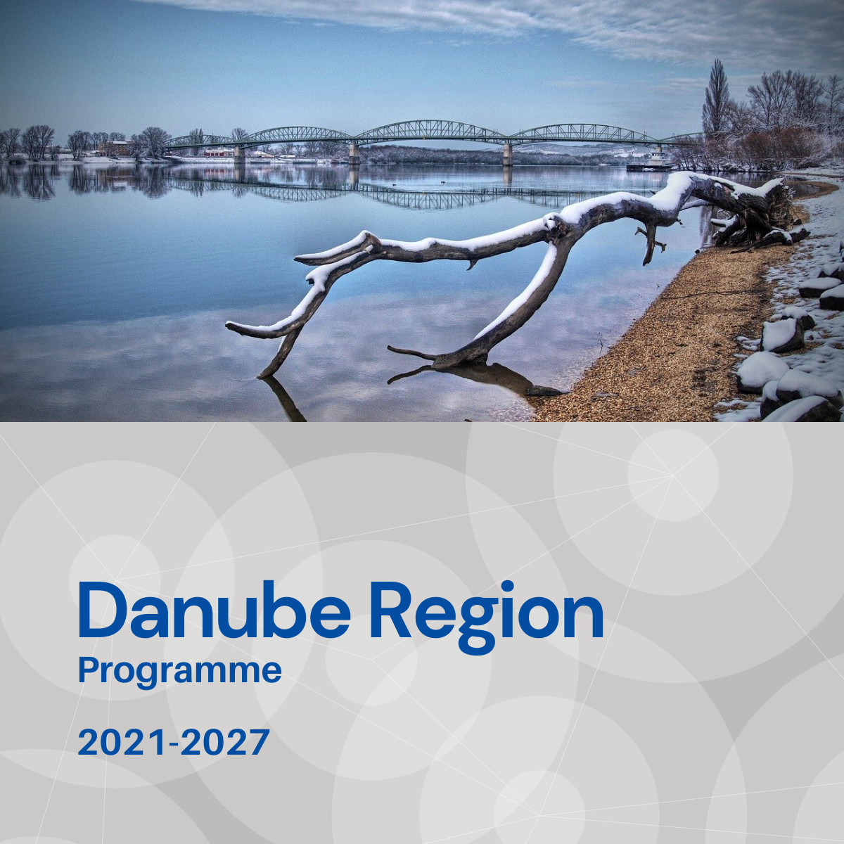

Specific objective 2.3
Factsheet

Priority 2 – A greener, low carbon Danube Region

Specific objective 2.3
Sustainable, integrated, transnational water and sediment management in the Danube River Basin ensuring good quality and quantity of waters and sediment balance

Background
The Danube Region covers almost the entire water system of the Danube River Basin (DRB) and beyond the Danube River there are shared water bodies and water catchment areas of transnational importance, like the Tisa (TRB), Sava (SRB), Mura-Drava River Sub-basins. Pressures affecting the water quantity quality and sediment balance of these transboundary river(basin)s, surface and underground water bodies like contamination and water pollution or increasing water use, decreasing ground water levels, shrinking supplies, increasing periods of low water in transnational river systems can have serious impacts beyond country borders that make necessary the cooperation of key actors from upstream and downstream countries.

Focus
Specific Objective 2.3 addresses water management issues that need cooperation of key actors on transnational level in order to ensure good quality and quantity of waters and sediment balance within the DRB. Accordingly, water management actions supported in the frame of SO 2.3 shall focus on the main transboundary river(-basin)s of the DRB, following a territorially integrated, cross-sectoral approach and shall take into consideration the potential negative effects of climate change.
- Strengthening capacities for prevention and mitigation of water pollution or for restoration of good quality of transnational water bodies.
- Harmonising management practises between water management, agriculture, environment, navigation, hydropower and flood protection to improve the quality and quantity of water and sediment in transnational river systems, taking into consideration the potential impacts of climate change.
- Transnational coordination of water supply management, especially in relation to basin-wide importance of groundwater bodies.

What we finance
SO 2.3 support measures that strengthen cooperation of key stakeholders in order to improve policies and institutional capacities (e.g. by integrated strategies, action plans, policy and sectorial dialogs, trainings), harmonising management processes (e.g. management plans), elaborating and pilot testing joint solutions (e.g. monitoring, forecasting tools, data bases), which are:
- Ensuring harmonised data availability by more effective monitoring and modelling systems for improving transnational water management measures.
- Strengthening institutional, management and technical capacity to prevent and mitigate water pollution or to restore good quality of water with special regard to hazardous and emerging substances pollution, agriculture and waste water management, taking also into account the possible impacts of climate change on the quality of water.
- Improving sediment balance and related morphodynamics, or exploring the potentials of reconnection of adjacent floodplains / wetlands in order to improve water quality, in transnational water bodies.
- Developing harmonised, joint monitoring and modelling sytem(s) in order to better understand the transboundary groundwater systems of Danube River Basin.
- Defining joint strategies and harmonised measures, elaborating and adopting innovative solutions in relation to water exploitation and protection ensuring balanced use of water, taking also into account the impacts of climate change for future water demand.
- Ensuring harmonised data availability, adaptation of integrated strategies, plans and solutions in connection to climate change induced increase of low water periods on the main transnational rivers of DRB, affecting sediment transport, navigation, hydropower management and the ecosystem.
Projects financed in the framework of SO 2.3 are expected to directly contribute to the objectives of EUSDR, especially to the actions and targets of PA4.

What we do not finance
- Projects, which do not focus on one of the main transboundary river(-basin)s of the DRB and not demonstrate that cooperation is needed on transnational level to address the specific water management challenge.
- Projects with pre-dominant focus on infrastructure.
- Projects with pre-dominant focus on technical solution (e. g. monitoring tool) development and without ensuring its application by the target users and the improvement of institutional capacities within the project.
- Projects with pre-dominant focus on research and data collection activities without translating their outcomes into applied solutions and, or policy strategies, plans within the project.
- Projects addressing issues of emergency response to accidental pollution of main transboundary river(-basin)s of the DRB are not in the scope of SO 2.3 (to be addressed in SO2.2).
- Projects exploring the potentials of floodplain restoration are out of scope of SO 2.3 in case their focus is on flood protection (can be addressed in SO2.2), or on reconnection of flood plains and wetlands in relation to ecological corridors and biodiversity (can be addressed in SO2.4).

Whom do we address
- National, regional and local public authorities and organisations responsible for water management, or related environmental issues.
- Hydro-meteorological services.
- Infrastructure and (public) service providers (e. g. for water supply, waste water treatment, hydro power plants, inland navigation).
- Interest groups including NGOs (e. g. international organisation, environmental organisations, farmer associations).
- Research and development institutions, universities.

