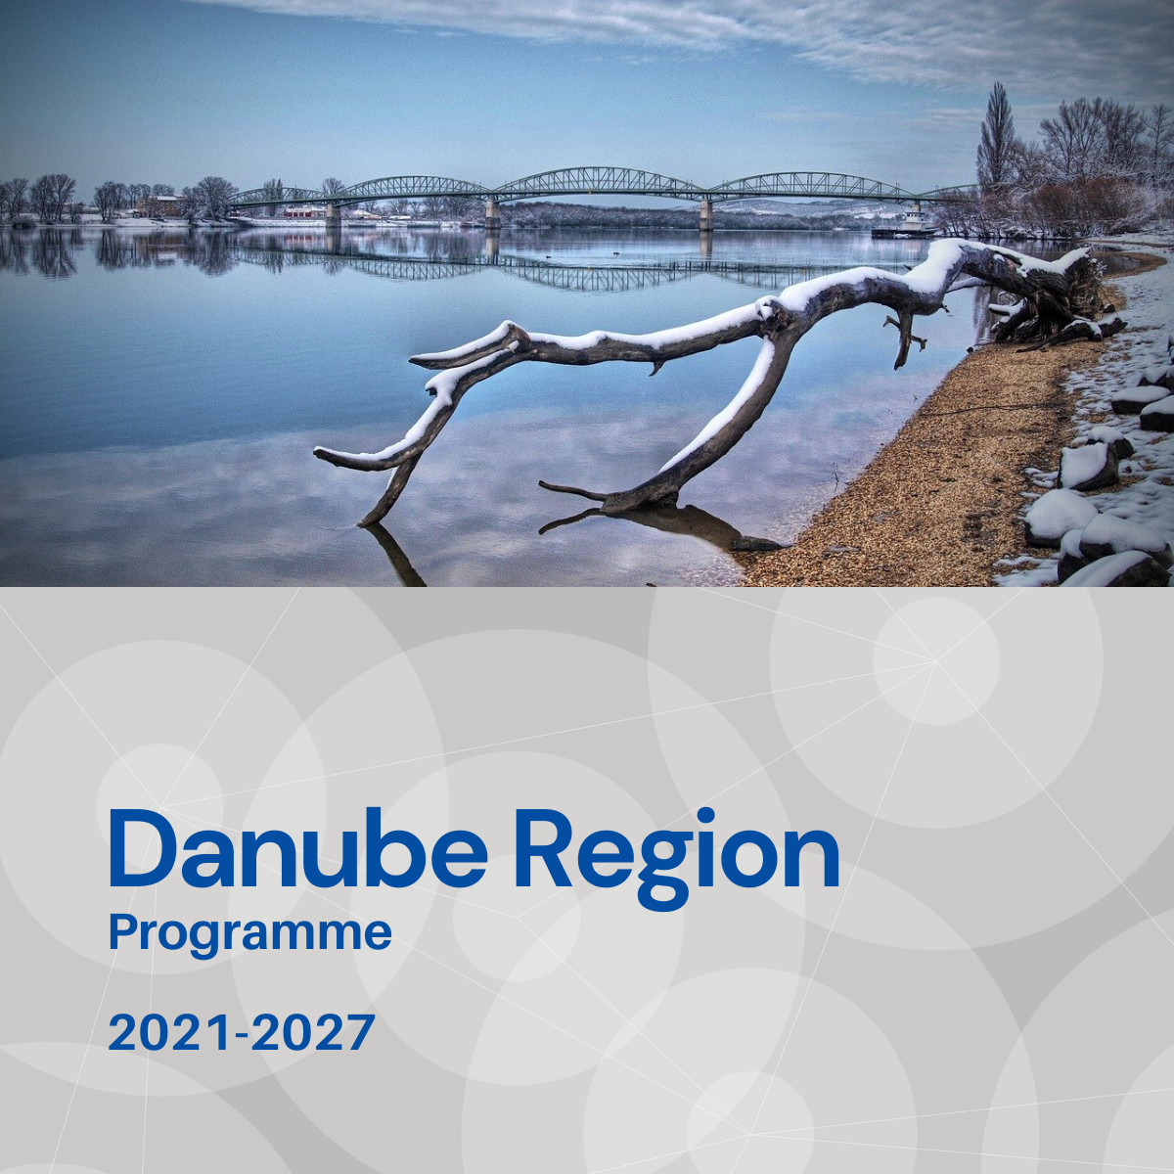

Specific objective 2.2
Factsheet

Priority 2 – A greener, low carbon Danube Region

Specific objective 2.2
Promoting climate change adaptation capacities in the Danube Region and disaster management on transnational level in relation to environmental risks, taking into account ecosystem-based approaches

Background
The Danube Region is forecasted to be exposed to climate change greatly by increasing annual mean temperatures, the wet regions becoming wetter, the dry regions drier in general, as well as increase in the intensity and frequency of heat waves, dry periods, and of heavy rainfalls on local, regional level. The frequency and severity of environmental disasters like floods, droughts, or forest fires are predicted to increase in the next decades. The impacts of the changing climate and of the more frequent and extreme related disasters affect the ecosystem, economic sectors and human life in the Danube Region also on a transboundary scale.

Focus
Specific Objective 2.2 intends to promote climate change adaptation capacities in the Danube Region and disaster management in relation to transnationally relevant environmental risks (floods, droughts, accidental pollution of rivers, wild fires), taking into account ecosystem-based approaches. Within these thematic fields the emphasis is on strengthening cooperation of key actors of a broader, transnational area, following a territorially integrated, cross-sectoral approach. Flood and accidental pollution management actions supported in the frame of SO 2.2 shall target the main transboundary river(-basin)s of the DRB. The main focus areas are:
- Supporting harmonised, joint capacities and data availability in Danube Region scale climate change forecasting and vulnerability assessment to support policy making and awareness raising.
- Supporting harmonised, coordinated, joint disaster prevention, preparedness and response activities on environmental risks, on floods, droughts, or accidental pollution of rivers on transnational river(-basin) scale and climate-change related other disasters (e. g. wildfires, heat waves).
- Strengthen the preparedness and adaptive capacity of the society (including also disaster management organisations, volunteer rescue teams), economy and nature to cope with impacts of climate change and establish climate services to foster the resilience.

What we finance
SO 2.2 support measures that strengthen cooperation of key stakeholders in order to improve policies and institutional capacities (e.g. by integrated strategies, action plans, policy and sectorial dialogs, trainings), harmonising management processes (e.g. management, contingency plans), elaborating and pilot testing joint solutions (e.g. monitoring, forecasting tools, data bases). More specifically:
- Harmonised, joint solutions and measures for climate change modelling, forecasting and vulnerability assessment on Danube Region / River Basin scale ensuring their application at policy and, or operational level.
- Integration of new research results into climate change adaptation practice for different types of territories in targeted thematic fields (e. g. floods, droughts) and improving skills and competences for policy makers and stakeholders.
- Coordinated, harmonised efforts on transnational river(basin) scale to prevent flood risks, or drought, including application of nature-based solutions (exploring the potentials of floodplain restoration measures can fit SO 2.2, if specifically focusing on flood management).
- Harmonised, joint planning, monitoring and alert systems, accident hot-spot inventories on industrial, mining and contaminated sites, improving operational cooperation, interoperability, institutional and technical capacities of emergency response authorities and non-governmental organisations to combat environmental risks, such as flood, drought or accidental pollution of transboundary river(-basin)s, or wildfires and climate-change related other disasters.
- Developing and implementing regional level climate change, environmental risks related disaster preparedness activities and establish standardised minimum requirements for disaster responders to achieve better and more effective transnational disaster response in the region.
Projects financed in the framework of SO 2.2 are expected to directly contribute to the objectives of EUSDR, especially to the actions and targets of PA5.

What we do not finance
- Projects, which do not demonstrate that cooperation is needed on transnational level to address the specific climate change adaptation challenge, or disaster management in relation to transnationally relevant environmental risks.
- Projects addressing flood, or accidental pollution management, but missing the focus on one of the main transboundary river(-basin)s of the DRB.
- Projects with pre-dominant focus on infrastructure.
- Projects with pre-dominant focus on technical solution (e. g. monitoring tool) development and without ensuring its application by the target users and the improvement of institutional capacities still within the project.
- Projects with pre-dominant focus on research and data collection activities without translating their outcomes into applied solutions and, or policy strategies, plans still within the project.
- Projects addressing water scarcity aspects of CC adaptation in relation to low water periods affecting the balanced use and the quality of water, avoiding overexploitation, are out of scope of SO 2.2 (to be addressed in SO2.3).
- Projects addressing biodiversity related CC adaptation, especially in relation to their effects on habitats, protected areas and forestry are out of scope of SO 2.2 (to be addressed in SO2.4).

Whom do we address
- National, regional and local public authorities and organisations responsible for water-flood management, or related environmental issues.
- Hydro-meteorological services.
- Disaster management authorities.
- Professional and volunteer civil protection and rescue organisations.
- Local/regional governments/municipalities.
- Regional development agencies.
- Interest groups including NGOs (e. g. international organisation, environmental organisations).
- Research institutions and universities.

