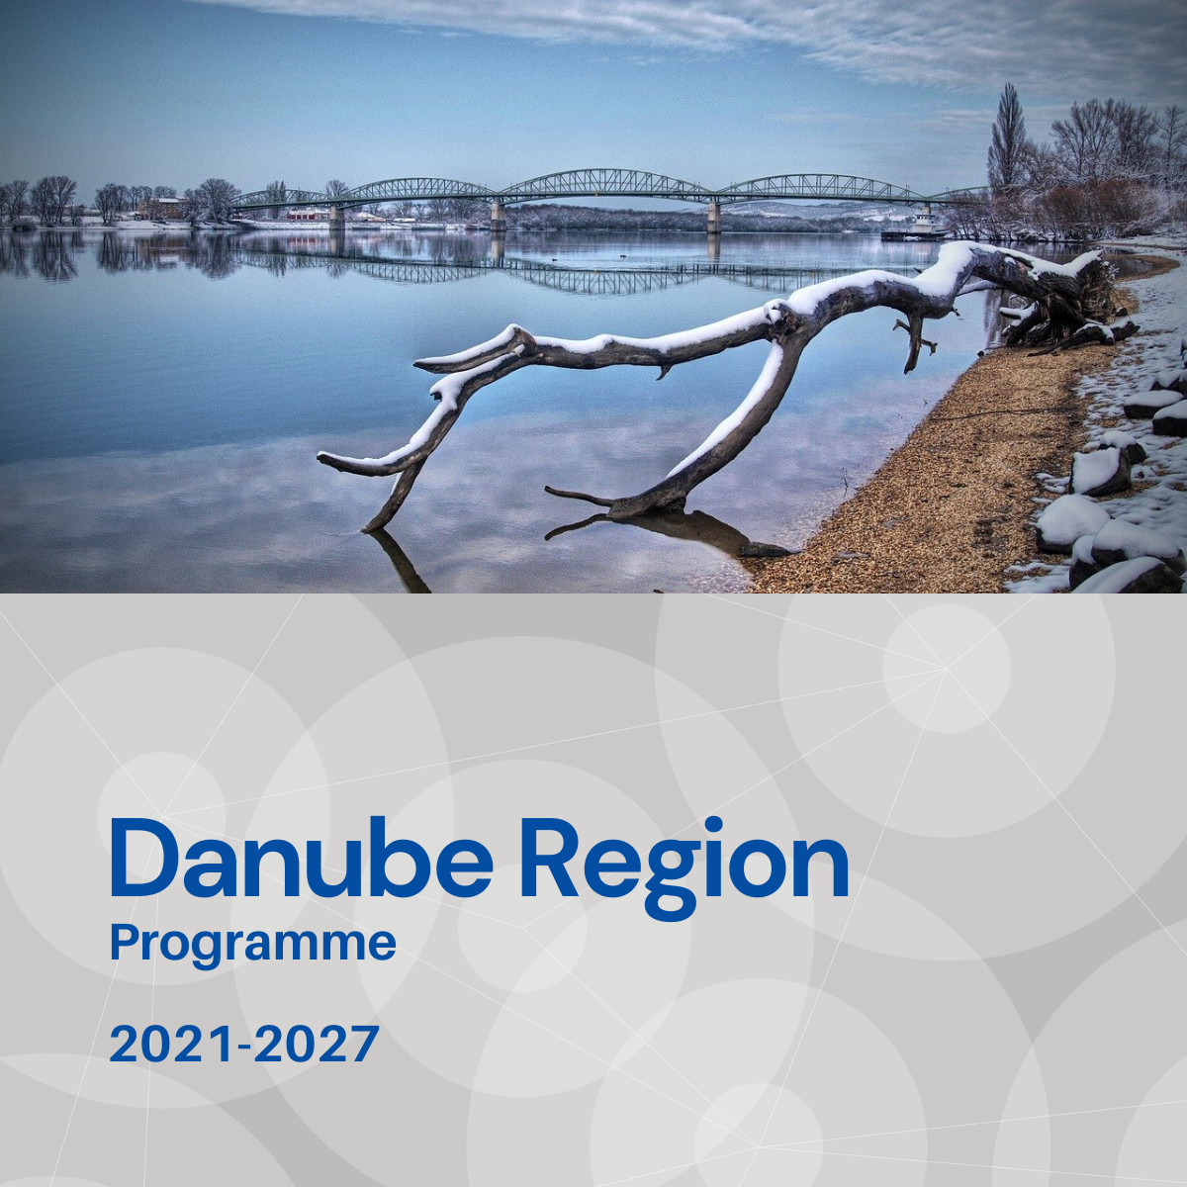

Specific objective 2.4
Factsheet

Priority 2 – A greener, low carbon Danube Region

Specific objective 2.4
Protecting and preserving the biodiversity in ecological corridors and eco-regions of transnational relevance in the Danube Region

Background
The Danube Region is a colourful mosaic of different biogeographical regions resulting in high biodiversity. The major rivers, the Danube River and its tributaries and mountain ranges, Carpathians, Dynaric Alps, Czech Forest-Bavarian Forest, are also important transnational ecological corridors providing connectivity between key habitats. However, this rich biodiversity is endangered by many factors, human interventions, spreading of invasive alien species and the climate change impacting the conditions of ecosystems, which need solutions often on a broader territorial level, in which transnational cooperation can be essential.

Focus
The geographic focus of the supported cooperation projects within Specific Objective 2.4 are broader, transnational ecological corridors, transboundary ecological regions, water habitats, wetlands along major transnational rivers and depending on the thematic focus, they shall strive for an integrated territorial approach involving other key sectors beyond environmental and nature protection relevant in the specific context and area. The addressed main thematic focus areas are the following:
- Transnational cooperation for the improvement of ecological connectivity between habitats, nature protection areas along transnationally relevant ecological corridors of the Danube Region and for transnational conservation and restoration measures for endangered umbrella species as well.
- Creation and strengthening of networks of cooperation in relation to the ecological regions and among protected areas.
- Coordinated and harmonised measures within transnationally relevant ecological regions ensuring resilience and adaptation to climate change to reduce its impacts on biodiversity.

What we finance
SO 2.4 support measures that strengthen cooperation of key stakeholders in order to improve policies and institutional capacities (e.g. by integrated strategies, action plans, policy and sectorial dialogs, trainings), strengthening cooperation frameworks and networks, harmonising management processes (e.g. management plans), elaborating and pilot testing joint solutions (e.g. monitoring, decision making tools, data bases). More specifically:
- Harmonised, joint efforts to improve, restore, manage and monitor ecological connectivity along transnationally relevant ecological corridors, including examination of the potentials of green and blue infrastructure developments and solutions for effective defragmentation.
- Actions in revitalisation and rehabilitation of water habitats along major transnational river (systems), exploring the potentials of restoration and reconnection of floodplains, wetlands and their adjacent areas.
- Establishing (institutionalised) management and cooperation network(s) of ‘Danubian’ transboundary ecological regions, harmonised management strategies and solutions, conservation and preservation techniques, toolkits ensuring also sustainable use of natural resources.
- Increasing the resilience of habitats and ecosystems of transboundary ecological regions and their ability to adapt to climate change impacts by development of eco-friendly land use systems, landscape management and soil protection and restoration measures.
- Coordinated, joint solutions in prevention and control of IAS and management of their priority pathways.
- Joint and harmonised development and implementation of transnational monitoring, conservation and restoration and management plans for endangered umbrella species (e. g. sturgeons, large carnivores) of the Danube Region.
Projects financed in the framework of SO 2.4 are expected to directly contribute to the objectives of EUSDR, especially to the actions and targets of PA6.

What we do not finance
- Projects, which do not demonstrate that cooperation is needed on transnational level to address the specific biodiversity challenge of the Danube Region, as well as not properly targeting a transnationally relevant geographic area (ecological corridor, transboundary ecological region).
- Projects with pre-dominant focus on infrastructure.
- Projects with pre-dominant focus on technical solution (e. g. monitoring tool) development and without ensuring its application by the target users and the improvement of institutional capacities still within the project.
- Projects with pre-dominant focus on research and data collection activities without translating their outcomes into applied solutions and, or policy strategies, plans still within the project.
- Projects exploring the potentials of floodplain restoration, reconnection are out of scope of SO 2.4 in case their focus is on flood protection (can be addressed in SO2.2), or on water quality issues (can be addressed in SO2.3).

Whom do we address
- National, regional public authorities and organisations responsible for environmental and nature protection issues, agriculture (farming, forestry, fishery).
- Spatial planners.
- Infrastructure and (public) service providers (e. g. water management, transport, hydropower).
- Interest groups including NGOs (e. g. international organisation, environmental organisations, voluntary association, etc.).
- Research institutions, universities.
- Education/training centres and schools.

