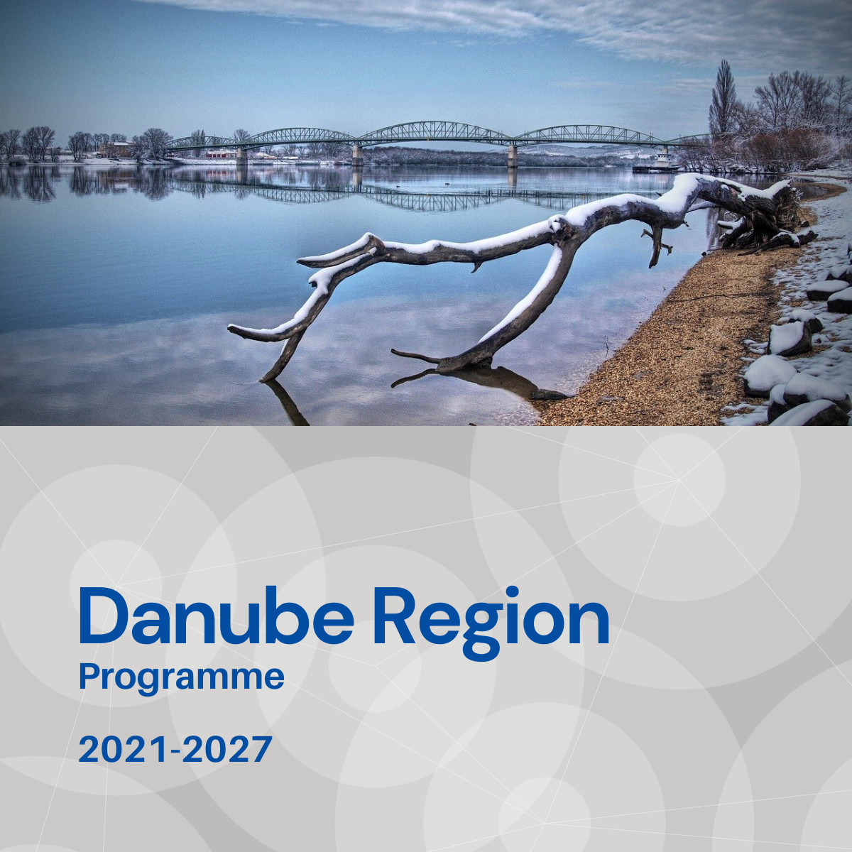

Specific objective 2.1
Factsheet

Priority 2 – A greener, low carbon Danube Region

Specific objective 2.1
Promoting renewable energy in accordance with directive (EU) 2018/2001, including the sustainable criteria set out therein.

Background
The power systems of the Danube Region’s (DR) countries still heavily rely on fossil fuels. In some of those countries (e. g. Germany, Austria, Slovakia, Hungary) the energy dependency is higher than the EU average (53,6%). The share of renewables in gross final energy consumption is low, and has never reached 50% in any of the DR countries. Energy dependency and lack of high energy safety triggered by underutilized renewable energy resources characterizes the current situation within the Danube region.

Focus
The SO’s main goal is to contribute to the reduction of the region’s dependency on imported fossil fuels by facilitating a better integration of renewable energy sources and consequently greening the energy and transport sectors and focuses on the following:
- Increasing the share of renewable energy in the Danube region.
- Decreasing carbon intensity in the power and transport sectors.

What we finance
- Strategy making and policy support in reaching low-carbon energy production and supporting the decrease of energy dependency in countries and regions most dependent on fossil fuels and resources from external (non-macro-regional) energy markets.
- Capacity building for sustainable energy planning especially in regions with high share of non-RES energy production or consumption.
- Support for harmonised actions and transnational cooperation in the buildings’ heating and cooling sector (e. g. decreasing carbon intensity in heating, RES integration in building sector combining it with storage and charging solution systems for e-mobility) with special attention to countries and regions with outstanding shares in energy consumption of the heating and cooling sector.
- Reduction of GHG emissions in the transport sector: introduction of alternative fuels and new technologies (e. g. electric vehicles) in transportation and innovative mobility solutions, support the shift towards environmentally friendly means of transportation, especially in public transport and freight transport, coordination between energy providers in relation to infrastructure elements of Danube Region relevance.
- Joint planning of infrastructure for the utilisation of renewable energy sources with the facilitation of knowledge exchange between regions of the lowest and the highest share of RES in the energy mix.
- Development of incentive policies to encourage the renewable energy production based on the Danube Region available resources.
With regard to the EUSDR this Specific Objective is expected to provide direct contributions especially to actions and targets defined under the EUSDR Action Plan for PA1a, PA1b and PA2.

What we do not finance
- Projects, which do not demonstrate that cooperation is needed on transnational level to address sustainable approaches for the promotion of renewable energy.
- Projects with pre-dominant focus on infrastructure.
- Projects with pre-dominant focus on technical solution (e. g. monitoring tool) development and without ensuring its application by the target users and the improvement of institutional capacities within the project.
- Projects with pre-dominant focus on research and data collection activities without translating their outcomes into applied solutions and/or policy strategies’ plans.

Whom do we address
- national, regional and local public authorities and/or institutions and related bodies governed by public law
- regional development agencies
- energy suppliers, energy management institutions and enterprises
- regional associations and regional innovation agencies
- NGOs
- financing institutions
- education and training centres as well as universities and research institutes
- EGTC
- international organisations and private bodies

