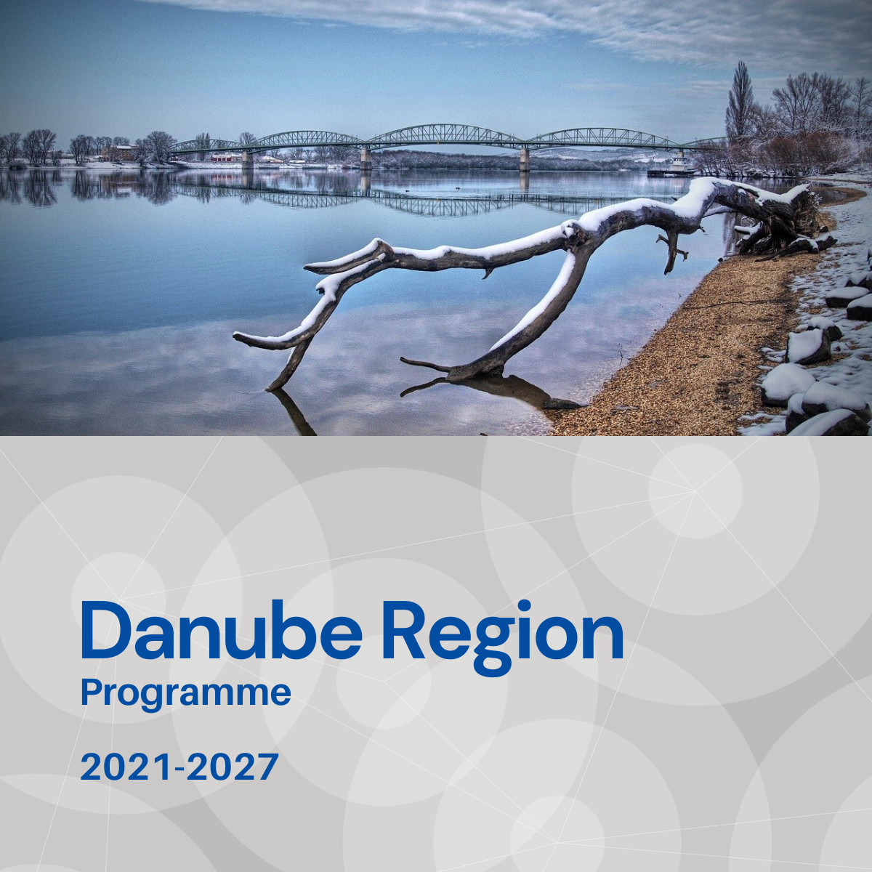

Specific objective 3.1
Factsheet

Priority 3 – A more social Danube Region

Specific objective 3.1
Accessible, inclusive and effective labour markets

Background
The Danube Region (DR) is affected by the interconnected challenges of persistent long-term unemployment, profound income inequalities, intensifying westward labour migration, skills gaps and a weak social economy. Prior to the Covid-19 pandemic there had been significant improvements in overall national employment rates across large parts of the DR, particularly in large urban conurbations. However, there exist patterns of entrenched long-term unemployment throughout the DR which have not changed as significantly. It can be observed that these patterns are mostly evident amongst vulnerable groups, which include ethnic minorities (e. g. Roma), the aged and those persons with disabilities. It is also generally observed that the vulnerability is enhanced in rural areas and amongst those with relatively low levels of education. This is compounded in certain regions which have historically relied on employment in mono functional industrial and agricultural production facilities which over time have been subject to closure, downsizing or re-purposing. The persisting north-west versus south-east divide in spatial inequalities on the labour markets is resulting in depopulation, ageing, low population retention, unfavourable economic structures with the risk of unemployment but at the same time skills gaps and labour shortage.

Focus
Specific Objective 3.1 addresses:
- The integration of vulnerable groups into the labour market, with special attention on regions that display high proportions of disadvantaged.
- Retaining skilled labour and developing a more sustainable migration of educated people.
- Capacity building for employment support bodies (information and data systems; coordination; training e. g. in social economy).

What we finance
SO 3.1 supports innovative jointly developed measures that strengthen the cooperation and effectiveness of key stakeholders in order to improve policy, planning and institutional capacity towards more accessible, inclusive and effective labour markets in the Danube Region.
- Joint coordination of policies and planning aimed at integrating disadvantaged groups (elderly people, people with disabilities, ethnic minorities, rural people, women, youth, etc.) to support inclusive employment in regions that display high proportions of disadvantaged populace;
- Support for designing innovative policies and planning to retain skilled labour and a more sustainable migration of educated people (e. g. by introducing transnational study and RDI programmes, promoting innovative employment schemes suitable for the needs of the tertiary educated living in rural regions or regions significantly affected by this type of migration);
- Creation of an information system and support for the provision of information and data about life events connected to periodic and permanent migration of workforce, caused by labour market inequalities; between the eastern and the western parts of the macro region;
- Coordinated policies and strategies to tackle active ageing (e. g. by social entrepreneurship) in regions and cities of the macro region affected by a high level of ageing;
- Developing cooperation and innovative planning between bodies responsible for labour market integration and the private sector towards enhancing the inclusion of the disabled in the labour market;
- Build-up of a “Danube observatory system” about labour migration and its impacts on cohesion; involving public bodies responsible for monitoring & evaluation, academia and civil society;
- Developing models to explore and demonstrate the effectiveness of remote working towards developing employment inclusiveness and meeting regional, social and economic goals;
- Restructuring and diversification of employment by the implementation of territorially integrated action plans for employment with a special focus on enhancing the spreading of innovative structures targeting mono-functional (e. g. agricultural, industrial) regions. This could include green jobs development.
Projects financed in the framework of SO 3.1 are expected to contribute to the objectives of EUSDR, especially to the actions and targets of PA9.

What we do not finance
- Projects with pre-dominant focus on research and data collection activities without translating their outcomes into applied solutions and, or policy strategies, plans.
- Projects with pre-dominant focus on infrastructure.
- Training which is not part of piloting e. g. expanding existing training
- Actions normally financed by national or regional support initiatives
- Actions which are more suited to ESF+

Whom do we address
- National, regional and local public authorities and organisations responsible for labour, employment and social welfare e. g. public employment services (PES).
- Social services providers.
- Labour market organisations.
- Non-governmental organisations.
- Social enterprises.
- Research and development institutions, universities with research facilities, higher education, vocational education and training providers.
- Employer organisations, business support organisations.
- Employee organisations e. g. trade unions.

