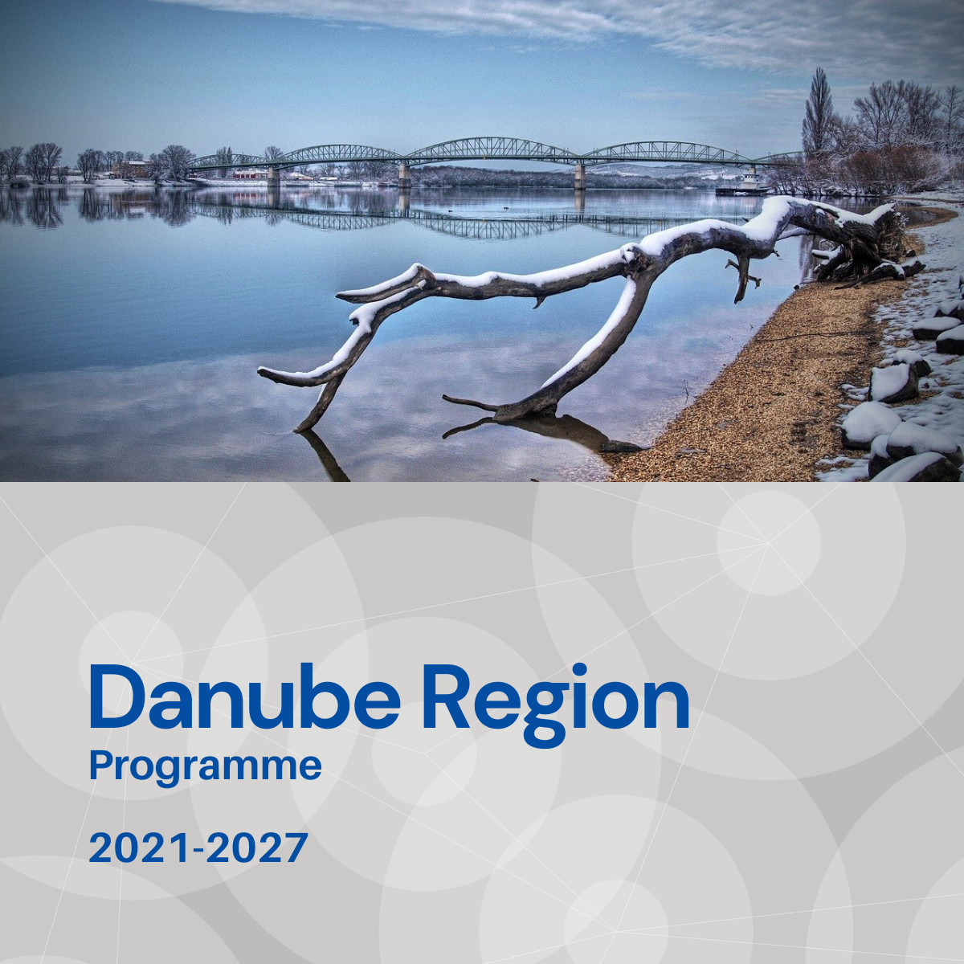

Specific objective 1.2
Factsheet

Priority 1 – A smarter Danube Region

Specific objective 1.2
Developing skills for smart specialisation, industrial transition and entrepreneurship

Background
Danube macro-region is characterised by countries with different economic and social development paths, performance convergence potentials or links to the European economic market. Whilst some regional economies of the Danube Region are heavily industrialised, most economies seem to be unprepared for the challenges arising from transitioning to industry 4.0 (i4.0). Support for transnational alignment of Smart Specialization Strategies (S3) and policies is of great importance.

Focus
With Specific Objective 1.2 the DTP addresses a niche in which transnational cooperation can play a key-role to develop and align S3 and to provide solutions through a smart networking of business, educational, scientific knowledge and infrastructure across the Danube Region, as it is fundamental for creating products and services with transnational impact. DTP is aiming to invest in developing skills for S3, industrial transition and entrepreneurship, especially in regard to i4.0. Post-COVID-19 Europe shall be greener, more digital, more resilient and better fit for the current and forthcoming challenges.
The focuses shall be the followings:
- Skills development for and of joint advancement of smart specialisation strategies and policies including a special focus on less advanced regions.
- Skills development and cross sectorial collaborations between smart industries and traditional type of industries for industrial transformation and transition towards industry 4.0, robotisation, mechatronics, digital technologies (including internet of things, artificial intelligence and creative industries).
- Skills development for delivering products and services with transnational impact.

What we finance
- Enhancing cooperation related to entrepreneurial skills in advanced technologies, industries of high Danube Region importance (i. e. owing to social impacts, market needs) to better combine existing capacities and competences;
- Building cooperation structures to obtain innovation capacity needed to be competitive at regional and EU level, identify niches within the EU market and become attractive as a partner within the Danube Region or towards other EU regions;
- Establishing platforms enabling transfer of knowledge and skills and building inter‐regional synergies for the development of regional smart specialisation strategies and policies with a special focus on the involvement of entrepreneurial actors and existing networks in discovering and exploiting promising areas of specialisation;
- Setting up and piloting measures for regions allowing for exchange of experience on implementation of smart specialisation strategies, e.g., networking of regions specialised in the field of industry 4.0 and related professional skills, support for related knowledge exchange between model regions and regions lagging behind in terms of elaborating and implementing industry 4.0 planning schemes.
With regard to the EUSDR this Specific Objective is expected to provide direct contributions especially to actions and targets defined under the EUSDR Action Plan for PA8 and partially for PA9.

What we do not finance
- Projects not being clearly embedded in a territorial scenario.
- Projects not involving countries of different level of innovation capacities.
- Projects with pre-dominant focus on infrastructure.
- Projects with pre-dominant focus on research and data collection activities without translating their outcomes into applied solutions and/or policy strategies, plans still within the project.
- Projects missing a coordinated policy, planning and pilot tested led delivery approach.
- Projects targeting mere skills developments without having a strategic and policy level approach and impact.

Whom do we address
- local, regional and national public authorities/institutions, bodies as key stakeholders for a successful transnational project with real impact.

