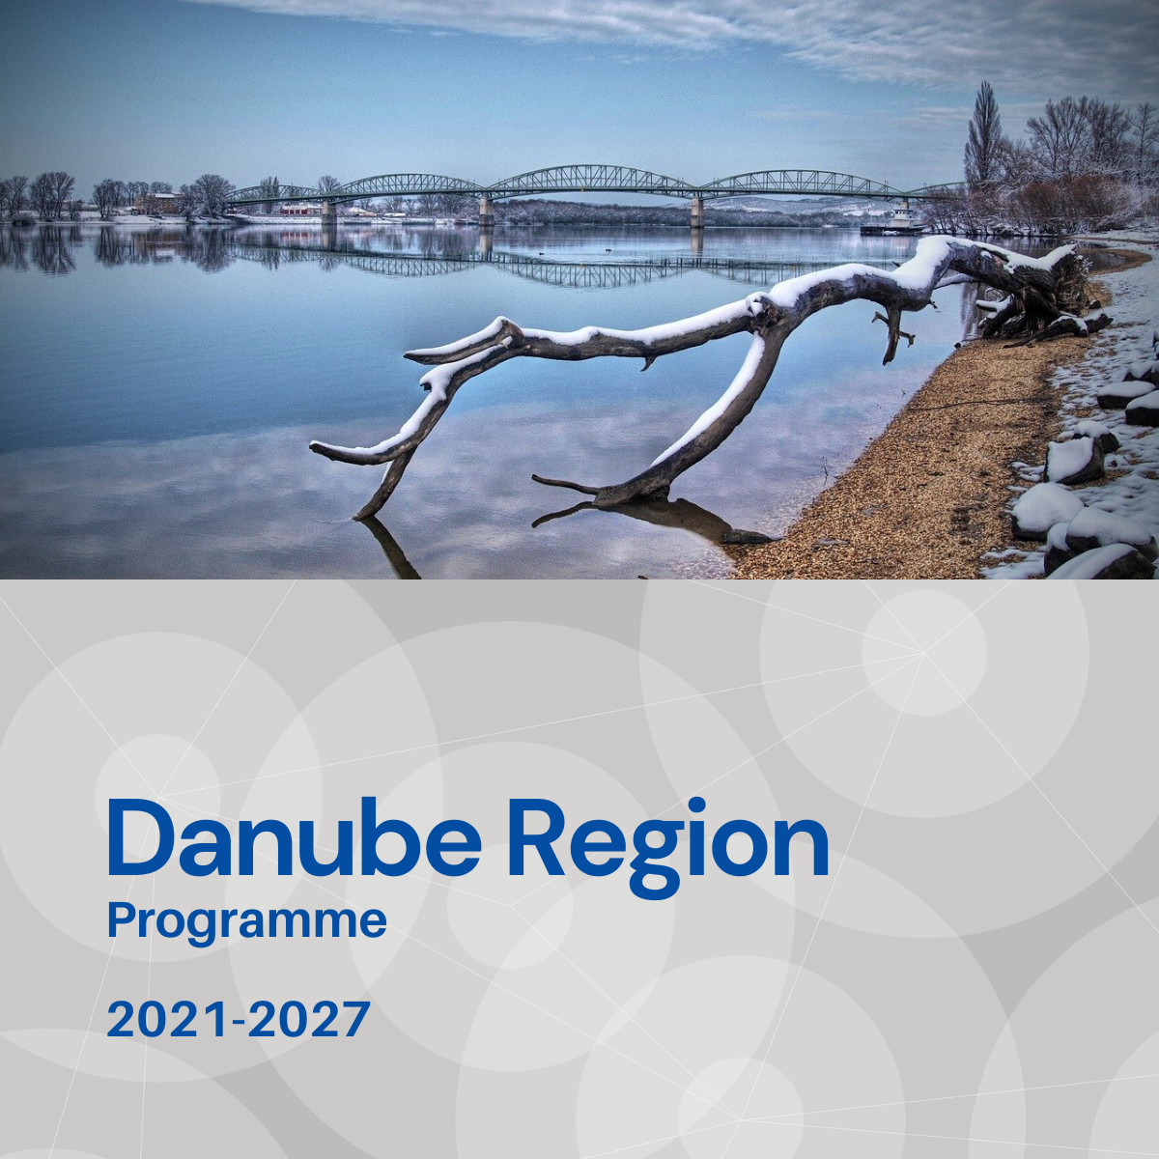

Specific objective 3.2
Factsheet

Priority 3 – A more social Danube Region

Specific objective 3.2
Accessible and inclusive quality services in education, training and lifelong learning

Background
The integration of an individuial into the labour market, their socio-economic well being, ongoing development and value to their society and region is highly dependent on their education and skills, vocational education and training and lifelong learning. There are good education models within the Danube Region to facilitate this but at the same time there are many regions that lack accessible, inclusive and effective structures and models to develop their human capital which contributes to regional imbalances and negative trends e.g. out migration, skills gaps and unemployment. It is fundamental therefore that the provider systems are accessible and inclusive and tailored to the level and background of individuals whilst at the same time providing relevant and recognised training and qualifications for the Danube Region employers and beyond.

Focus
Specific Objective 3.2 addresses:
- Developing innovative educational models, programs, practical tools and materials for disadvantaged learners, including early school leavers.
- Maximising the use of existing knowledge and experience to develop best practices in inclusive education policy and advancing education and policy reform.
- Innovative approaches to encourage and improve inclusive vocational education and training and life-long learning.

What we finance
SO 3.2 supports innovative measures that strengthen the cooperation and effectiveness of key stakeholders in order to improve policy, planning and institutional capacity towards accessible and inclusive quality services in education, training and lifelong learning.
- Development of joint innovative educational models, programs, practical tools and materials to support inclusive education for disadvantaged learners.The expected approach to develop on from model regions within the Danube region and with mutual learning developed from pilot regions;
- Developing best practices in education policy, gathering and disseminiating kowledge and advancing education and policy reforms at the national and regional level across the Danube Region;
- Establishment or development of existing scientific and educational networks to combat brain drain, whereby educated and skilled individuals leave regions for better prospects. Networks should bring existing knowledge and research together and develop concrete outputs;
- Innovative digital and remote education with e-solutions to mitigate rural disadvantage, provide employment related training and combat brain drain;
- Knowledge exchange and the sharing of experience in elaborating and developing inclusive vocational education and training models and systems. This should lead to concrete outputs e.g. the development of work based training schemes which better support relevant skills development to match the needs of the labour market.

Projects financed in the framework of SO 3.2 are expected to contribute to the objectives of EUSDR, especially to the actions and targets of PA 9.

What we do not finance
- Projects with a pre-dominant focus on research and data collection activities without translating their outcomes into applied solutions and, or policy strategies, plans.
- Projects with pre-dominant focus on infrastructure.
- Training which is not part of piloting e. g. expanding existing training.
- Projects which do not have a sound transnational and territorial logic.
- Actions normally financed by national or regional support initiatives.
- Actions which are more suited to ESF+ or ERASMUS+.

Whom do we address
- National, regional and local public authorities and organisations responsible for education, labour, employment, inclusion and social welfare.
- Social services providers.
- Schools and non-tertiary education providers.
- Non-governmental organisations (including with a focus on disability; minorities; women; youth).
- Social enterprises.
- Research and development institutions, universities with research facilities, higher education, vocational education and training providers.
- Employer organisations.
- Employee organisations e. g. trade unions.

