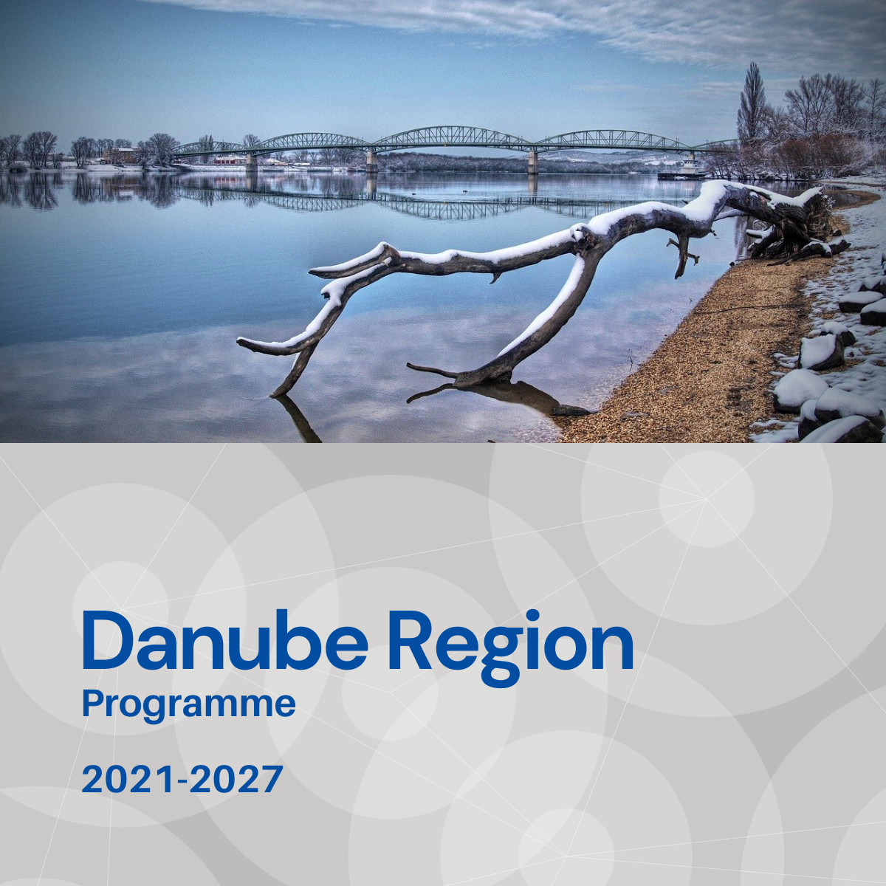

Specific objective 3.3
Factsheet

Priority 3 – A more social Danube Region

Specific objective 3.3
Enhancing the role of culture and sustainable tourism in economic development, social inclusion and social innovation

Background
The Danube Region is characterised by an outstanding cultural diversity that over the centuries has left a rich legacy of intangible and tangible heritage that is often not recognised for its potential towards economic development, social inclusion and social innovation. Generally, major cities have, to varying degrees, acknowledged and sought to use this value, whilst smaller communities in rural and remote areas have not, even though they have a great potential in valorising their diverse heritage towards increasing the well-being of their communities. Many of the remote, rural areas and smaller settlements are confronted with a lack of in-depth recognition of the heritage and cultural assets value potential that they have and miss inclusive strategic planning to guide and coordinate its valorisation. Part of the problem lies in the historically limited access to cultural and heritage assets and initiatives, both in a geographical and a socially inclusive sense in the Danube region. Efforts should therefore be made to make these assets and initiatives available to all, even if this can be a challenging process for minorities and rural and remote areas. With experience across 14 countries, transnational cooperation can support this with jointly developed valorisation and touristic models and solutions in rural, remote areas and smaller cities. This based on the existing heritage and culture and underpinned from the strong involvement of all parts of the local community.

Focus
Specific Objective 3.3 addresses:
- Valorisation of local cultural and natural heritage for the development of sustainable tourism products and tourism services in order to increase regional added value and employment.
- Improvement of accessibility of cultural and natural heritage for all, amongst others youth and vulnerable groups in order to promote social inclusion.
- Promoting community led natural and cultural heritage management and associated nature based and cultural tourism in rural areas and small cities.

What we finance
SO 3.3 supports measures that strengthen cooperation and effectiveness of key stakeholders in order to improve policy, planning and institutional capacities towards enhancing the role of culture and sustainable tourism in economic development, social inclusion and social innovation.
- Improving the accessibility of tourism and culture infrastructure, products and services for vulnerable groups, such as minorities, people with disabilities, the elderly and youth in regions with low levels of accessibility and high levels of vulnerable groups;
- Valorisation of joint natural and cultural heritage and cultural activities through the elaboration of new or improved thematic initiatives for example cultural, hiking, cycling or other thematic routes and initiatives across the macro-region with a special focus on rural or less visited areas;
- Capacity building and development of innovative models for community-based tourism to better secure the engagement of host communities by involving them in the planning, management and implementation tourism development in their respective regions;
- Capacity building in social innovation to better support valorisation of joint cultural and natural heritage, in particular for tourism and their heritage management schemes (study, collection, preservation, digitalization, exhibition and re-interpretation of joint tangible and intangible elements);
- Promoting quality products, services and transnational infrastructure in the tourism and culture sector to support the social inclusion of disadvantaged people via new employment forms and job opportunities. This especially in relation to regions with a high share of ethnic minorities and areas with a large share of population at risk of poverty including the youth, elderly or disabled;
- Promote sustainable and slow tourism concepts, planning methodologies, model regions, and management tools in the Danube Region, in regions of mass tourism as well as in regions having a weakly developed tourism sector. Actions should promote and safeguard employability and employment possibilities to vulnerable groups of host communities, and capitalise on EUSDR projects in the interconnected areas of culture, nature and tourism.
Projects financed in the framework of SO 3.3 are expected to contribute to the objectives of EUSDR, especially to the actions and targets of PA3.

What we do not finance
- Projects with pre-dominant focus on research and data collection activities without translating their outcomes into applied solutions and, or policy strategies, planning.
- Projects with pre-dominant focus on infrastructure.
- Training which is not part of piloting e. g. expanding existing training.
- Projects without the expected social consideration.

Whom do we address
- National, regional and local public authorities responsible for culture, heritage and tourism.
- Sectoral agencies, tourist operators, tourist information centres (points), regional tourism boards/ destination management organisations.
- Museums and cultural institutions.
- Research and development institutions, universities and other education institutions.
- Business support organisation (e. g. chamber of commerce, business innovations centres).
- NGOs and civil society associations.
- Private enterprises including SMEs and social enterprises.

