**VELENJE FINAL CONFERENCE**

***May 14th 2019***

**Venue**: **Vila Bianca**

Website: http://www.velenje-tourism.si/en/information/bianca

**Address**: Stari trg 3, 3320 Velenje

**Contact references:** Patricija Halilović, [patricija.halilovic@velenje.si](mailto:patricija.halilovic@velenje.si)

**Agenda**

**Tuesday, May 14th 2019**

**Meet & Greet**

|  |  |  |  |
| --- | --- | --- | --- |
| WP | Time | Venue | PP / people involved |
| 1-5 | 09:30-10:00 | Arrival of Participants  Registration and signature of participants | All partners |
| 1-5 | 10:00-10:10 | Welcome by hosting Municipality of Velenje  Welcome by representative Ministry of Infrastructure, Slovenia | Helena Knez  Franc Zepič |

**Final Conference**

|  |  |  |  |
| --- | --- | --- | --- |
| WP | Time | Venue | PP / people involved |
| 5 | 10:10-10:30 | SHORT OVERVIEW OF THE MAIN ACHIEVEMENTS OF THE CHESTNUT PROJECT | PP VUT Takeru Shibayama & Helmut Lemmerer |
|  | 10:30 – 10:35 | CHESTNUT VIDEO PRESENTATION | PP DURA - Ante Vekić |
|  | 10:35-10:40 | SHORT OVERVIEW ON THE DANUBE TRANSNATIONAL PROGRAMME | PO Ana Leganel/FM Antonios Melas of Danube Programme |
| 5 | 10:40 – 11:15 | PRESENTATIONS OF GOOD PRACTICES  10 minutes’ presentation by each speaker:  Dimitrovgrad on bike sharing (10 min)  Budapest14- Zuglo on Super blocks (10 min)  Weiz on electrical mobility (10 min) | PP Dimitrovgrad  PP Budapest 14  PP Weiz |
| 5 | 11:15 – 11:45 | PANEL SESSION / DEBATE  “Beyond SUMPs at FUA level”  Based on the results of CHESTNUT, the discussion will focus on transferability and capitalisation as well as on the next challenges in the project areas involved. Participants/panellists: Takeru Shibayama (Moderator), Helmut Lemmerer (Austria), Franc Zepič, Slavko Mežek (Slovenia), Slaviša Jelisić (Bosnia-Herzegovina) + 2 partners’ experts from Austria/Hungary/Croatia/Bulgaria/Romania (to be defined) |  |
| 5 | 11:45 – 12:00 | Conclusions |  |

**USEFUL INFORMATION**

## *VENUE*

**Meeting point: VILA BIANCA**

**Address:Stari trg 3, Velenje (SLOVENIA)Telephone number: 00386 3 896 18 60**

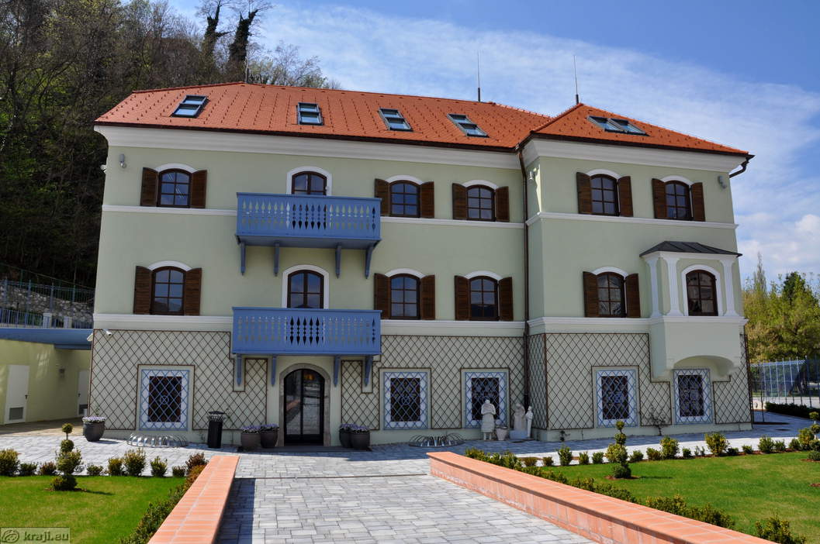

**Arrival to Velenje**

Velenje can be reached by various means of transport: : ***By car***

Velenje is 84 km (1-hour drive) away from Ljubljana, and just 15 km from motorway A1 (Ljubljana – Maribor). Chose the motorway exit Žalec/Dravograd/Slovenj Gradec/Velenje/Dobrna/Arja vas and turn left. Drive about 15 minutes and stay on the priority road. The GPS coordinates of the Tourist information centre: N: 46,3571 E: 15,1116

* ***By bus***

Regular bus connections allow you to arrive in Velenje from all parts of Slovenia.

* ***By train***

Velenje can be reached by train from Ljubljana or Maribor.

* **By plane**

We don't have an airport in Velenje. But you can fly with different airlines to Ljubljana Jože Pučnik international airport and continue your journey with other means of transport. Even airports in neighbouring countries (Austria, Italy, Hungary and Croatia) are relatively close and allow you a great platform to start your holiday adventures.

* [Ljubljana airport](http://www.lju-airport.si/) (SLO): 86 km, 1 hour
* [Klagenfurt airport](http://www.klagenfurt-airport.com/) (A): 105 km, 1.5 hours
* [Zagreb airport](http://www.zagreb-airport.hr/) (CRO): 180 km, 2 hours
* [Trieste airport](http://www.aeroporto.fvg.it/) (I): 207 km, 2 hours
* [Venice airport](http://www.veniceairport.it/en/)(I): 315 km, 3 hours

<http://www.velenje-tourism.si/en/velenje/arrival-to-velenje>

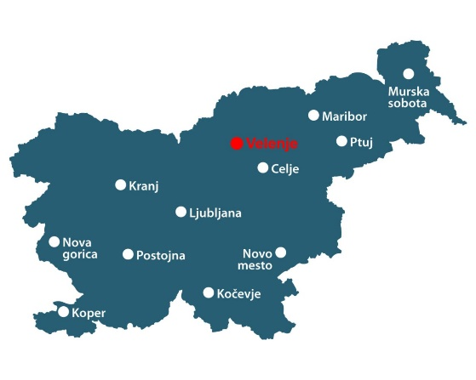

Velenje lies at the heart of nature at an altitude of 396 metres. It is encircled by the hills of the Šalek valley, the Kamniško-Savinjske Alps to the west and Pohorje to the east. The valley alongside the river Paka is where the city centre lies. According to the number of inhabitants, Velenje is the fifth largest town in Slovenia. Over the past 50 years, it has come to encompass the former hamlets and villages of Škale, Stara vas, Staro Velenje, Šalek and Šmartno. The town of Velenje, a very industrial town (Gorenje, the Velenje coal mine, Esotech), is at the heart of the municipality, which also comprises the regional centre of the Savinja and Šalek valleys with trade, administrative, educational and other activities.

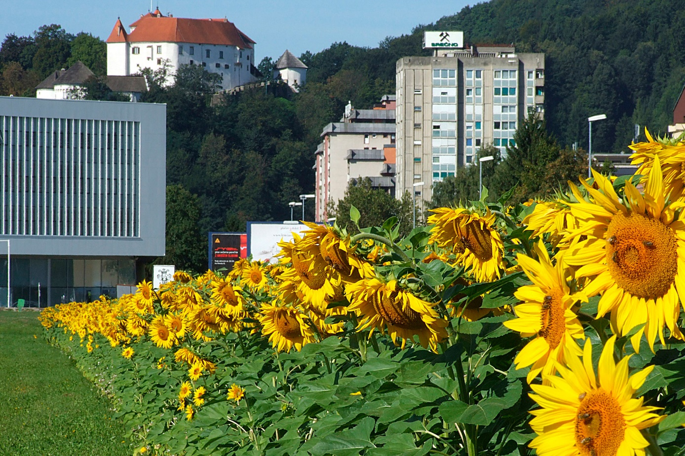

[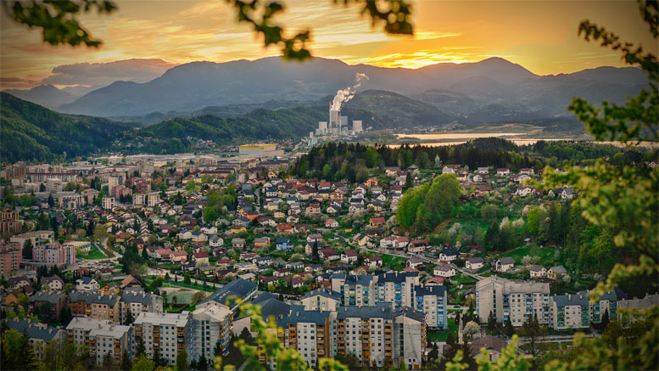](http://www.google.com/url?sa=i&rct=j&q=&esrc=s&source=images&cd=&cad=rja&uact=8&ved=2ahUKEwiq05-LlP_gAhXjN-wKHc5aCrIQjRx6BAgBEAU&url=http://www.nascas.si/anketa-turisticna-znamka-velenje/&psig=AOvVaw1N7GAn0I7UVvthFiTvWP01&ust=1552567806417886)

[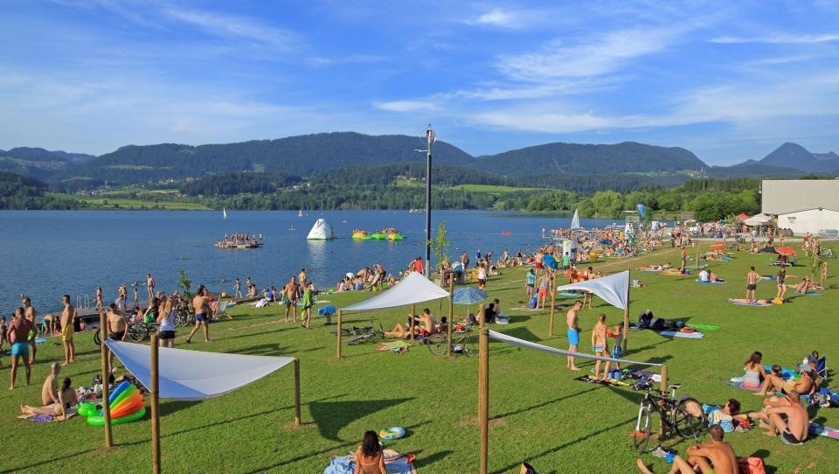](https://www.google.com/url?sa=i&rct=j&q=&esrc=s&source=images&cd=&cad=rja&uact=8&ved=2ahUKEwjP8eSZlP_gAhUC3aQKHQ8mAuIQjRx6BAgBEAU&url=https://manager.finance.si/8841839&psig=AOvVaw1N7GAn0I7UVvthFiTvWP01&ust=1552567806417886)