Integrated capacity building and training programme for DANUBE area labour and business support organisations, local industry, and entrepreneurs to enter innovative transnational value CHAINS
as PEER-level collaboration partners
DTP3-497-SO1.2

Mapping of 3 Transnational Value Chains within target industries

Deliverable D.T1.3.3
Lead Contractor of the Deliverable: PP7 CLUSTERO
February 2021

Content

Table of figures 3
Introduction 4
Methodology 6
Main findings of the analysis 8
Mechatronics & Electronics and Automation 8
Overview 8
Distribution of companies along the value chain 9
Labour Market Requirements and Company Development Needs 12
Mechanical Engineering 14
Overview 14
Distribution of the companies along the value chain 14
Labour Market Requirements and Company Development Needs 17
Wood and Furniture 19
Overview 19
Distribution of the companies along the value chain 19
Labour Market Requirements and Company Development Needs 22
Conclusions 24
Annex 1: Cluster Interview Template 26
Annex Eurostat Data for the selected value chains 32
Mechatronics 32
Mechanical Engineering 36
Wood and furniture 40

Table of figures
Figure 1 The Porterian Value Chain Definition, source (Porter, 1985) 4
Figure 2 Methodological Approach of Activity T.1.3 5
Figure 3 The value chain profile in case of Pro Wood, a more intense colour reflects a higher density of companies on the specific link of the value chain 6
Figure 4 A definition of mechatronics, source www.cbi.eu 8
Figure 5 Density of companies along the mechatrornics value chain in the analysed clusters 9
Figure 6 Distribution of companies along the mechatronics value chain 10
Figure 7 Relative regional strengths along the mechatrornics value chain 10
Figure 8 Foreign Trade between Danube Region and the Eu in mechatronics ; importers; Source: own calculation based in Eurostat data 11
Figure 9 Foreign Trade between Danube Region and the EU in mechatronics; exporters; Source: own calculation based on Eurostat data 11
Figure 12 Density of companies along the mechanical engineering value chain in the analysed clusters 15
Figure 10 Distribution of companies along the mechanical engineering value chain 15
Figure 13 Relative regional strengths along the mechanical egineering value chain 16
Figure 14 Foreign Trade between Danube Region and the EU in mechanical engineering; exporters s; Source: own calculation based in Eurostat data 16
Figure 15 Foreign Trade between Danube Region and the EU in mechanical engineering; importers; Source: own calculation based in Eurostat data 17
Figure 16 Distribution of companies along he wood&furniture value chain in the analysed regions 20
Figure 17 Distribution of companies along the wood & furniture value chain 20
Figure 18 Density of companies along the wood & furniture value chain in the analysed clusters 20
Figure 20 Foreign Trade between Danube Region and the EU in wood & furniture; exporters; Source: own calculation based in Eurostat data 21
Figure 19 Relative Regional Strengths along the wood & furniture value chain 21
Figure 21 Foreign Trade between Danube Region and the EU in wood & furniture; importers; Source: own calculation based in Eurostat data 22

Introduction
The mapping of the 3 selected transnational value chains is the main result of the Work Package T1 “Framework conditions for digital value chains”, Activity T1.3 “Value chains” in the frame of the DTP Project “Danube Peer Chains”. The Investigation of the 3 selected value chains aim 1) to describe these value chains as strategic target fields for positioning of companies from the project region and 2) identify labour market requirements and company development needs for successful target value chain entry. The mapping of Transnational Value Chains provides a visionary goal for the whole project regions that will guide all following project activities, particularly the development and piloting of a value-chain oriented capacity building and training programme and development of action plans for establishing labour-market relevant cooperation links.
The term of “value chains” has been introduced by Michael Porter in 1985 (Porter, 1985), as a fundamental concept in developing a strategy aimed at increasing the competitiveness level of a company by considering the system of activities involved in the production and consumption of products.
Rather than looking at departments or accounting cost types, Porter's Value Chain focuses on systems, and how inputs are changed into the outputs purchased by consumers. Using this viewpoint, Porter described a chain of activities common to all businesses, and he divided them into primary and support activities.
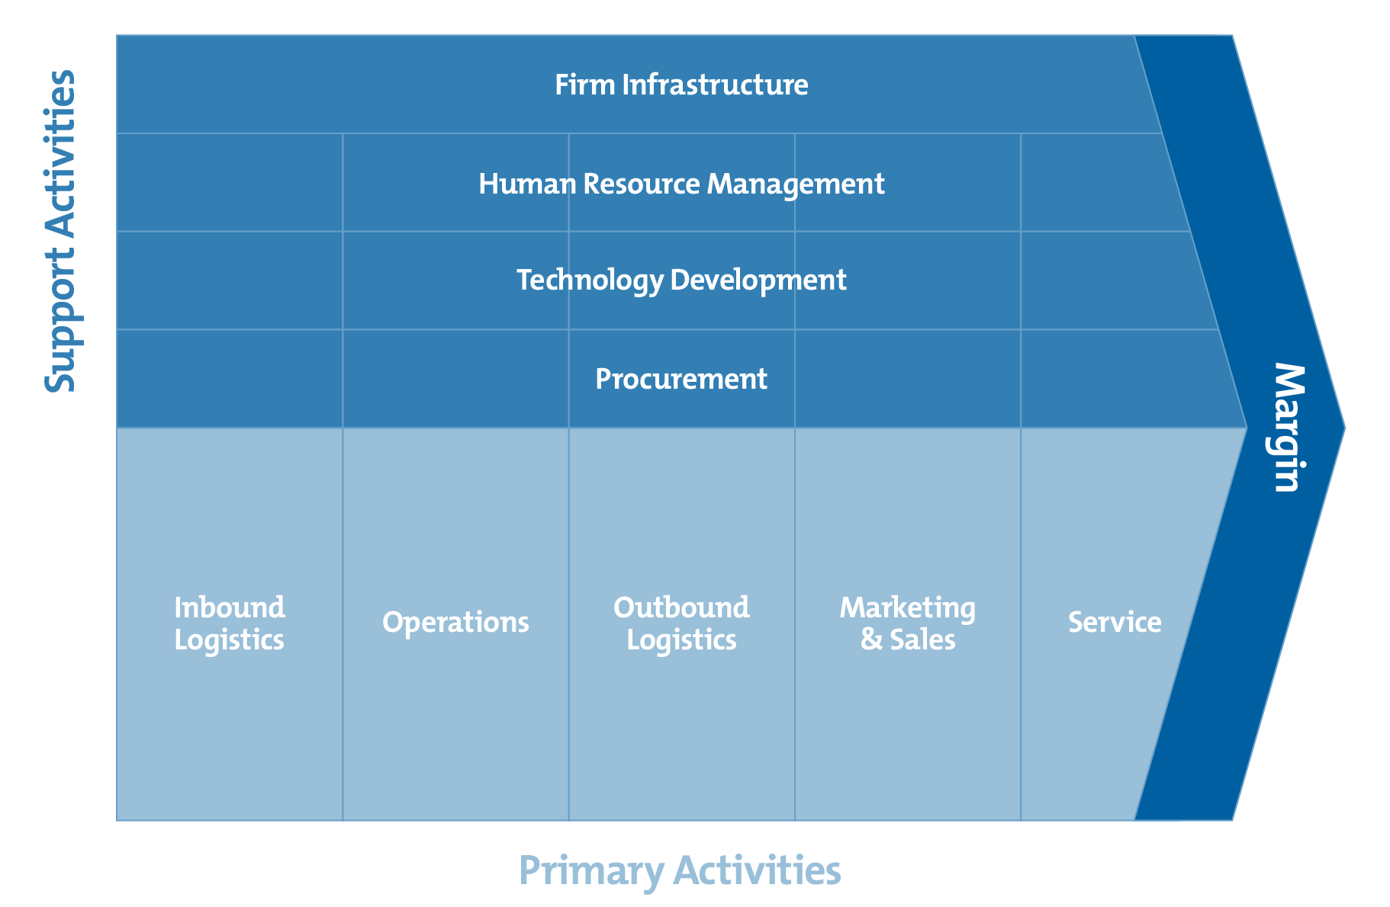
Figure 1 The Porterian Value Chain Definition, source (Porter, 1985)

The analysis and selection of the 3 selected value chains takes into consideration United Nations Industrial Development Organization (UNIDO)’s approach on value chain analysis, based on industrial cluster development, which assume that spatial organization, strategic firm alliances, and networking are sources of systemic competitiveness. Their analytical focus is often on a) how actors’ network to exchange goods, services, and information; b) institutional and political frameworks that promote building industrial clusters and the inclusion of small-to medium-sized firms; and c) the level of knowledge and technology used. (UNIDO, 2011).
The current analysis is based on previous results within Activity T.1.3 which led first to the identification of 6 potential target value chains out of which 3 have been selected for in depth analysis. From a methodological point of view a “funnel” approach was pursued, implying several steps:
- Mapping of relevant sectors according to criteria set by the European Secretariat for Cluster Analysis (ESCA) (in terms of number of clusters and their geographical distribution), European Commission (the 14 industrial eco-systems expected to contribute to a green, digital, and resilient economic recovery) and by DanubePeerChains itself (pre-identified sectors). The mapping resulted in a ranking of the sectors based on a composite index calculated taking into consideration the above-mentioned criteria.
- Profile of the 6 potential value chains, selected according to the ranking and the qualitative assessment of project partners, i.e., ICT, Mobility, Mechanical engineering, Mechatronics & Electronics & Automation, Plastics and Wood & furniture.
- Selection of the 3 target value chains, based on following criteria:
  - Industrial sectors being able to absorb digital solutions in terms of Industry 4.0 approaches.
  - The balance between innovative and more traditional sectors.
  - The geographic distribution.
Figure 2 Methodological Approach of Activity T.1.3
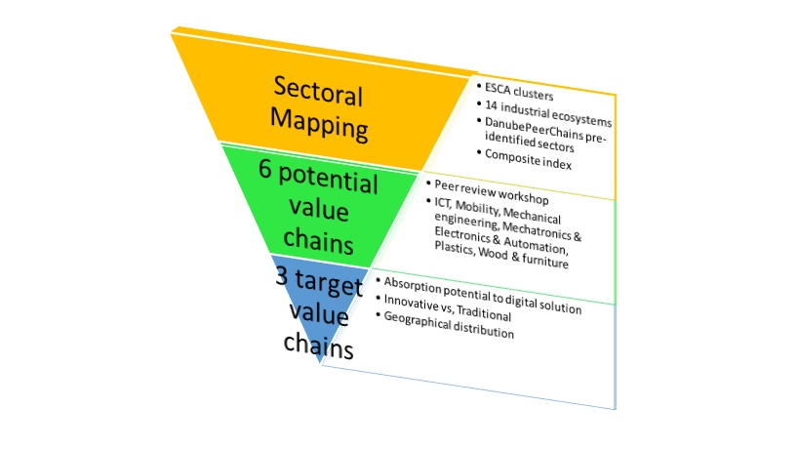
In the end the 3 selected value chains decided upon for in-depth analysis are:
- Mechatronics & electronics & automation.
- Mechanical engineering.
- Wood & furniture

Methodology
Both theoretic aspects and international best practice have proven value chain analyses to be very complex, requiring analytical data from national statistics or companies themselves. Hence, in accordance with the objectives of the Activity T1.3, our analysis took into consideration only the aspects enabling relevant conclusions on:
- Positioning of the companies along the selected value chain in the Danube Region to enhance trans-regional and cross-sectoral cooperation.
- Identification of development needs to support the access of companies to trans-national value chains.
Accordingly, several instruments have been developed and applied at the level of the identified clusters in the regions:
- A value chain profile, mapping the current positioning of existing companies in the cluster along the value chain.

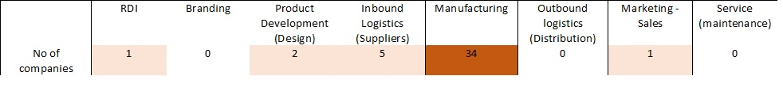
Figure 3 The value chain profile in case of Pro Wood, a more intense colour reflects a higher density of companies on the specific link of the value chain
- A cluster interview template, including following chapters
  - Cluster activity and business: no. of enterprises, no. of employees, turnover (EUR), exports (EUR), RDI expenditures, foreign markets (examples).
  - About the cluster: short description of the cluster.
  - Value chain: Firm positioning on the value chain.
  - Suppliers.
  - Related industries and logistics.
  - Support: Human Resources, research centres, associations.
  - Competition
  - Digitalisation
  - Market and trends
  - Business and cluster
  - Regional and institutional support
The templates have been filled in by project partners following an interview with the cluster managers in their regions and selected sectors. The Cluster interview template is to be found in annex to this report.
Following clusters have been interviewed:
Mechatronics
- Platform Automation Technology Styria (AT), www.atstyria.at
- Mechatronik Cluster Linz (AT), www.biz-up.at
- Mechatronik Kompetenz Netzwerk in Ostbayern (BY), https://www.mc-netz.de/
- Netzwerk Hochform (BW), https://www.hochform-pforzheim.de
- Profession Metal Industry and Vocational Cluster (HU), http://professio-gyor.hu
- Smart Factory Cluster within SRIP ToP – Strategic Research and Innovation Partnership of the Factories of the Future (SI) http://ctop.ijs.si/en/research-areas/smart-factory/
- Mechatrec Cluster (RO), https://www.clustermechatrec.ro/en/
Mechanical Engineering
- Cluster Mechatronik Tirol (AT), www.standort-tirol.at,
- Metall Dialog Heilbronn (BW), https://metalldialog.de/
- Southwest Hungarian Engineering Cluster (HU), www.pbkik.hu
- Indagro Pol (RO), http://www.inma.ro/indagropol/
- NICAT (RS), www.ni-cat.org
- TCS Cluster (SI), http://toolscluster.net/en/
- ACS GIZ Cluster (SI), https://www.acs-giz.si/en
- Vojvodina Metal Cluster (RS), http://www.vmc.rs/
Wood and furniture
- Möbel und Holzbau Cluster (AT), www.biz-up.at
- Panfa Accredited Innovation Cluster (HU), www.panfa.hu
- Association of Wood Processors Berane (ME),
- Pro Wood (RO), www.prowood.ro
- Transylvanian Furniture Cluster (RO), https://mobiliertransilvan.ro/
- Wood Industry Cluster (SI), https://www.lesarski-grozd.si/en/
- SRIP PSiDL – Strategic Research and Innovation Partnership, Smart Buildings and Home including Wood Chain (SI), http://intranet.teces.si
- Croatian Wood Cluster (HR), https://www.drvniklaster.hr/

In addition to that, macro-economic export/import data giving the overview on the selected sectors in the partner regions have been collected from national/regional statistical sources or the Eurostat.

Main findings of the analysis

Mechatronics & Electronics and Automation

Overview
Mechatronics is a combination of mechanical engineering, electrical engineering, telecommunications engineering, control engineering and computer engineering. In terms of products, mechatronic systems include a vast array of items ranging from servo motors, sensors, linear systems, and pneumatic products, to robotics, actuators, electrical products, and electronic control systems.
Figure 4 A definition of mechatronics, source www.cbi.eu
In our analysis we took into consideration the following NACE codes:

NACE rev. 2: 26
NACE rev. 2: 27

Distribution of companies along the value chain
Out of 1024 companies, members of 6 analysed clusters (Mechatronic Cluster Linz – AT, Mechatronik Kompetenznetz Ostbayern – BY, Netzwerk Hochform – BW, Professional Metal Industry and Vocational Training Cluster – HU, Smart Factory Cluster – SI, Mechatrec - RO), 34% are to be found on the Manufacturing link of the chain.
Figure 5 Density of companies along the mechatronics value chain in the analysed clusters
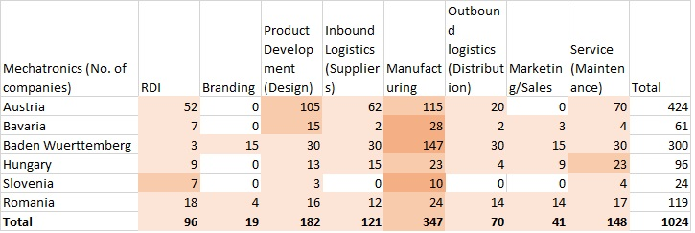
Relative weak points are to be found on the branding link (1,85% of the companies and missing in Austria, Bavaria, Hungary, and Slovenia), marketing/sales link (4% of the companies and missing in Austria and Slovenia), outbound logistics link (6,83% of the companies and missing in Slovenia) and inbound logistics link (11,81% of companies and missing in Slovenia).
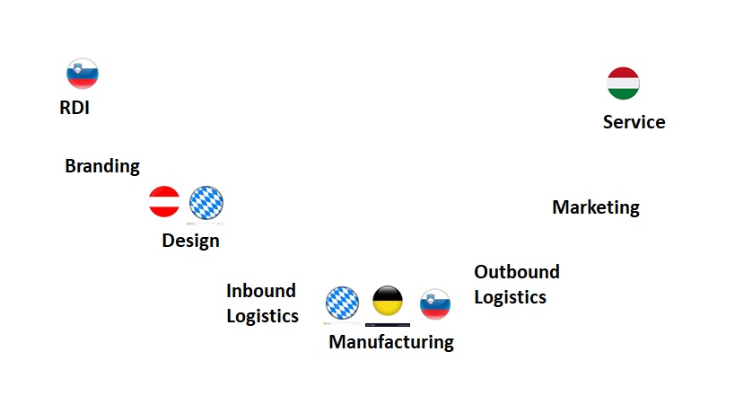
Relative strengths are to be found in Slovenia on RDI (29% of the companies); in Austria and Bavaria on Product development (24,76% and respectively 24,59% of the companies); Bavaria, Baden Wuerttemberg, and Slovenia on Manufacturing (45,90%; 49% and 41,67% of the companies, respectively) and in Hungary on Service (23,95% of the companies acting on the Service link of the value chain).
Figure 6 Distribution of companies along the mechatronics value chain
Figure 7 Relative regional strengths along the mechatronics value chain

Regarding the foreign trade of the Danubian countries within the EU in mechatronics, they are divided in
- Net exporters: Germany, Czechia, Hungary, Slovakia, and Slovenia. To be noted that Czechia overtook Germany in 2019 with an intra-regional foreign trade balance of 14 billion EUR
- Net importers: Bulgaria, Croatia, Austria, Romania, Bosnia and Herzegovina, Moldova, Montenegro, and Serbia. To be noted that in 2019 Austria turned from a net exporter to a net importer: a balance of -1 billion EUR 2019 against 600 mil EUR in 2018.
Figure 8 Foreign Trade between Danube Region and the Eu in mechatronics; importers; Source: own calculation based in Eurostat data
Figure 9 Foreign Trade between Danube Region and the EU in mechatronics; exporters; Source: own calculation based on Eurostat data

Labour Market Requirements and Company Development Needs
According to a recent article published on MCADCafe, the European mechatronics sector needs to overcome the following challenges
- Production, product development and research relocating to East Asia and the resulting shortage of engineers and high-skilled personnel in advanced technologies
- Loss of skilled labour due to cuts in production costs
- Access to credit from financial institutions
- Lack of progress in energy supply infrastructure
- Lack of progress in energy efficiency (buildings, transport networks and industrial production)
- Investments in research and development (R&D): crucial to compete with the USA, Japan, and China
- The development of smart technologies (smart grids, IoT, remote security, etc.)
- Unfair competition caused by non-compliant goods. Surveillance authorities have shown that compliance regulations need more effective enforcement. Especially in low-tech/low-cost market areas where compliance gets less attention due to price pressure

According to the interviewed cluster managers, several market trends could be observed in the recent period:
- A tendency towards customised production of building structures, hall structures, machine frames and light structures.
- Digital product development.
- Production boost of automation systems.
- Regarding the traditional clients, businesses from automotive and aerospace tend to migrate towards life sciences.
- Medical engineering is continuously gaining in importance over the last few years.
As to the level of digitalisation of companies, small companies have just begun the process, while larger ones have already adopted Industry 4.0 to a higher extent. A hindering factor is the old mindset of the management, in the Eastern part of the Danube Region. Concerning the digitalisation process, greatest challenges are seen in:
- Consistency of data.
- Data quality.
- Interface optimisation.
- Digitalisation of processes.
- Building up methodological competence.
- Consideration of the human factor
Companies complain about a shortage of skilled personnel, in the field of software application and development.
The lack of appropriate public financial support for the digitalisation processes in companies risk endangering the development process in the long-term perspective, in the Eastern part of the Danube Region.
Regarding the competition, China is considered the main competitor based on labour costs. Also, some intra-regional competition could be traced between Hungary and Austria, Hungarian labour force tends to migrate to Austria as wages are higher.

Mechanical Engineering

Overview
Mechanical engineering is one of the largest industrial sectors in the EU economy in terms of number of enterprises, employment, production, and the generation of added value. It employs around 3 million people. The sector is responsible for 9.5% of the entire production in the manufacturing industry and it is expected to grow at an annual average rate of 3.8% over the next 10 years.
In our analysis we took into consideration the following NACE codes
NACE rev. 2: 28

Distribution of the companies along the value chain
Out of the 1675 companies, members of 8 analysed clusters (Mechatronic Tirol – AT, Metaldialog Heilbronn – BW, Southwest Hungarian Engineering Cluster - HU, Indro Pol – RO, NICAT – RS, TCS, ACS GIZ-SI, Vojvodina Metal Cluster - RS), 37% are to be found on the Manufacturing link of the chain.
Relative weak points are to be found on the Branding link (3,80% of the companies and missing in Austria, Hungary, and Serbia), Marketing/Sales link (5,96% of the companies and missing in Austria), Product Development link (9,65% of the companies and missing in Hungary).
Relative strengths are to be found in Romania on RDI (24,06%of the companies, respectively); Austria and Baden Wuerttemberg on Inbound logistics (24,34% and 33,17% of the companies, respectively); Austria and Slovenia on Manufacturing (46.08% and 36,92% of the companies, respectively); Hungary and Serbia on Service (35,82% and 38,46% of the companies,
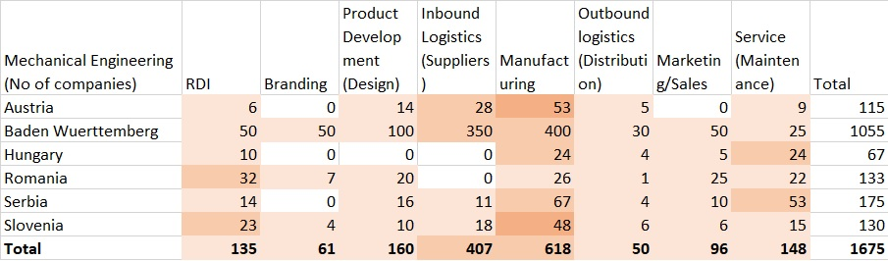
respectively).
Figure 11 Distribution of companies along the mechanical engineering value chain
Figure 10 Density of companies along the mechanical engineering value chain in the analysed clusters

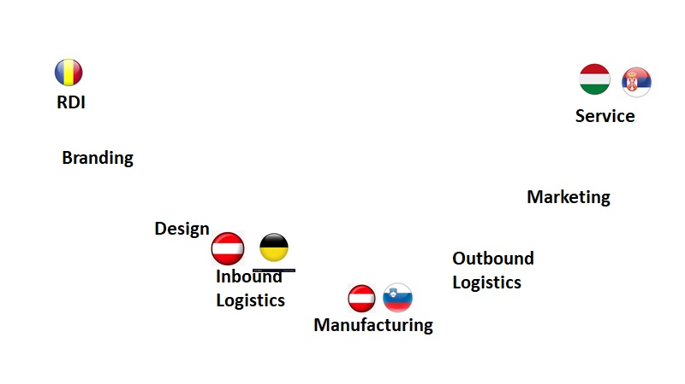
Figure 12 Relative regional strengths along the mechanical engineering value chain
Regarding the foreign trade of the Danubian countries within the EU in mechatronics, they are divided in
- Net exporters: Germany, Czechia, Slovakia, and Slovenia
- Net importers: Bulgaria, Croatia, Hungary, Austria, Romania, Bosnia and Herzegovina, Moldova, Montenegro, and Serbia.
Figure 13 Foreign Trade between Danube Region and the EU in mechanical engineering; exporters s; Source: own calculation based in Eurostat data

Labour Market Requirements and Company Development Needs
Figure 14 Foreign Trade between Danube Region and the EU in mechanical engineering; importers; Source: own calculation based in Eurostat data

According to the European Commission, the mechanical engineering sector faces the following challenges:
- Due to increases in manufacturing capacities world-wide, improved innovation and research is vital to the competitiveness of the sector.
- There is a strong demand from stakeholders for more effective market surveillance to protect businesses against unfair competition.
- There is also a need for a stable, predictable, and coherent regulatory environment that embraces 'smart' principles and is as straightforward as possible. The 'New Approach' legislative technique (where legislation establishes essential requirements, with detailed technical solutions laid down in standards) is generally well-regarded, particularly in respect to innovation.

According to the interviewed cluster managers, several market trends could be observed in the recent period:
- The need for production automation.
- The pressure for cost reduction coming from the automotive industry, main clients of the mechanical engineering sector.
As to the level of digitalization in companies, 50% of companies are in the middle of the process, 40% have just begun while the rest of 10% have fully adopted Industry 4.0 in their business model.
Lack of cooperation with between industry and RDI, the shortage of qualified personnel and the old mindset of the management represent major threats for the competitiveness of the companies in the mechanical engineering sector. In addition to that comes the competition from the online suppliers with endanger the traditional client – supplier relation.

Wood and Furniture

Overview
The EU woodworking industries include the production of sawn wood, wood-based panels, and wooden construction materials and products. About 70% of the wood in the EU is used in construction and furnishings. On the other hand, the furniture industry is a labour-intensive and dynamic sector dominated by small and medium-sized enterprises (SMEs) and micro firms. EU furniture manufacturers have a good reputation worldwide thanks to their creative capacity for new designs and responsiveness to new demands. The industry can combine new technologies and innovation with cultural heritage and style and provides jobs for highly skilled workers. . EU furniture manufacturers set global trends. About 12% of designs registered in the European Union Intellectual Property Office relate to this sector. the EU is a world leader in the high-end segment of the furniture market. Nearly two out of every three high-end furniture products sold in the world are produced in the EU.
In our analysis we took into consideration the following NACE codes:
NACE Rev. 2: 16

NACE Rev. 2: 31

Distribution of the companies along the value chain
Out of the 620 companies, members of 7 analysed clusters (MHC – Austria, Panfa – HU, Wood Processors Berane – ME, Pro Wood – RO, Transylvanian Furniture Cluster – RO, SRIP PSiDL – SI, Croatian Wood Cluster - HR), 51% are to be found on the Manufacturing link of the value chain.
Relative weak points are to be found on the Branding link (2,58% of companies and missing in Hungary, Montenegro, and Slovenia); Marketing/Sales (2,74% of companies and missing in Slovenia and Croatia); Service (5,32% of companies and missing in Montenegro and Slovenia); RDI (7,65% of companies and missing in Montenegro).
Relative strengths are to be found in Hungary on Product Development (23,77% of companies); in Austria on Inbound logistics (23,52% of companies), in Slovenia on Manufacturing (81,33% of companies) and in Hungary on Outbound logistics (20,49% of companies).
Figure 15 Distribution of companies along he wood&furniture value chain in the analysed regions
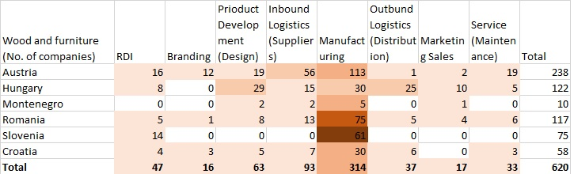
Figure 16 Distribution of companies along the wood & furniture value chain
Figure 17 Density of companies along the wood & furniture value chain in the analysed clusters

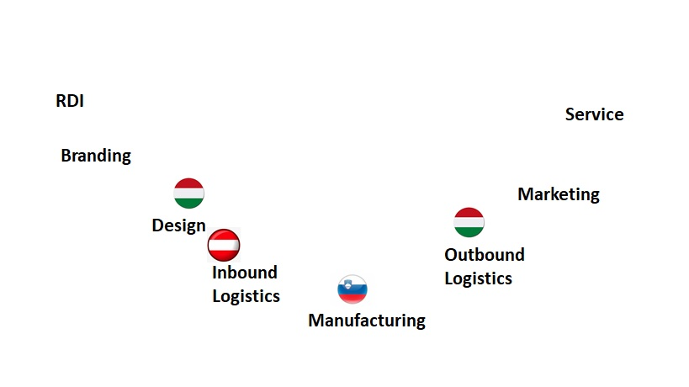
Regarding the foreign trade of the Danubian countries within the EU in wood & furniture, they are divided in
Figure 18 Foreign Trade between Danube Region and the EU in wood & furniture; exporters; Source: own calculation based in Eurostat data
Figure 19 Relative Regional Strengths along the wood & furniture value chain
- Net exporters: Bulgaria, Croatia, Czechia, Hungary, Austria, Romania, Slovenia, Bosnia and Herzegovina, Moldova, Serbia
- Net importers: Germany, Slovakia, and Montenegro. To be noted that Slovakia turned in 2016 from a net exporter to a net importer (127 mil EUR in 2015, -50 mil EUR in 2016).

Figure 20 Foreign Trade between Danube Region and the EU in wood & furniture; importers; Source: own calculation based in Eurostat data

Labour Market Requirements and Company Development Needs
According to the European Commission, main challenges faced by the wood & furniture sector are:
- Sustainability and legality - around 97% of the raw wood processed in the EU comes from sustainably managed EU forests; the rest is imported. Although not mandatory, evidence of sustainable forest management (SFM) is often provided on a voluntary basis through "chain-of-custody" certification schemes that link wood products back to sustainable sources. In line with the EU "Timber Regulation" (Regulation 995/2010), all wood and wood products placed on the EU market must come from verifiably legal sources.
- Wood supply - even if wood is legal and sustainable, it may not always be available to the woodworking or other forest-based industries at affordable prices. This is particularly so in places where there is subsidised competition for raw wood from the bio-energy industry. In the future, the emerging bio-based sector will also increase their demand for wood as its feed stock. Resource-efficient use, re-use, and recycling will be necessary to help meet all demand, following the "cascade" principle.
- Labour, skills, productivity, and ageing - like other EU forest-based industries (F-BI), European woodworking can only compensate for high material and energy costs through high labour productivity. However, the workforce is ageing, and young people are reluctant to enter this sector. To keep up productivity, new workers need to be attracted, equipped with existing skills, and updated with the new skills needed for novel high-tech processes and products.
- Formaldehyde - many wood-based materials, such as wood-based panels and wood-based building products, use adhesives. Many of these are based on compounds containing formaldehyde, which is becoming classified as a carcinogen. Replace these with safer but still affordable adhesives is a big challenge.
- Competition – the EU furniture sector faces enormous competition from countries having low production costs. China’s penetration into the EU market is growing rapidly and it is now the largest furniture exporter to the EU, accounting for over half of total furniture imports to the EU.
- Innovation - the reliance on innovation and design combined with an increase in global trade and digitalisation, makes the sector more vulnerable to weak protection of intellectual property rights. Boosting research and innovation also requires finance that is often inaccessible to SMEs.
- Structural problems - the ageing workforce combined with difficulties in attracting young workers may lead to disruptions in maintaining skilled workers and craftsmanship.
- Trade - protectionist measures on international markets create market distortions and decrease the sector’s competitiveness. EU furniture producers face both duties on imports of raw materials and tariffs on exports of finished products. Moreover, operational costs in the EU are higher due to high environmental, sustainability, and technical standards.

According to the interviewed cluster managers, several market trends could be observed in the recent period:
- A diversification of the market towards interior design, furnishing, wood protection and energetic counselling.
- Manufacturing of individualized products.
- Need for cross-sectoral cooperation (metal, textiles, plastics)
There is a general low level of digitalization in the wood & furniture companies: online shopping should be intensified as a priority.
Regarding the competition, China is considered the main competitor based on labour costs. Also, some intra-regional competition could be traced between Hungary and Austria, Hungarian labour force tends to migrate to Austria as wages are higher.
Lack of cooperation with between industry and RDI, the shortage of qualified personnel and inappropriate financial support from the banking system major threats for the competitiveness of the companies in the wood & furniture sector.

Conclusions
All three analysed sectors are highly important for the economic development of the Danube Region, measured in terms of the export/import intensity towards the European Union. In this regard, there is a quite antisymmetric positioning of the Danube countries, i.e., the high exporters in mechatronics and mechanical engineering are high importers in wood and furniture and vice-versa. Germany, Czechia, and Hungary are the first 3 exporters in mechatronics, while Romania, Croatia and Serbia are the first 3 importers; Germany, Czechia and Slovakia are the first 3 exporters in mechanical engineering while Romania, Hungary and Austria are the first 3 importers; Romania, Czechia and Austria are the first 3 exporters in wood & furniture, while Germany, Slovakia and Montenegro are the first 3 importers. This situation suggests a complementarity in regional specialisation, however this is accompanied by a technological divide, if we compare the “high skilled - high tech” mechatronics with the “medium skilled – medium tech” mechanical engineering and “low skilled low tech “wood & furniture sectors.
Regarding the distribution of companies along the value chains, all three value chains are manufacturing intensive. Very few companies are specialised in branding and marketing activities, both of them being relative high added value activities along the value chains; on the other hand there is a certain regional higher density of companies on specific links of the value chains (other than manufacturing) such as: RDI in Slovenia for mechatronics and in Romania, and Serbia for mechanical engineering; Product Development in Austria and Bavaria for mechatronics and in Hungary for wood & furniture; Suppliers in Austria and Baden Wuerttemberg for mechanical engineering and in Austria for wood & furniture; Distribution in Hungary for wood & furniture; Service in Hungary and Serbia for mechanical engineering and in Hungary for mechatronics. These competences may represent a solid base for an enhanced cooperation along the value chain.
Regarding digitalisation, the process is still at the beginning. In the mechatronics sector, which is the most advanced, only 10% have already fully implemented the industry 4.0 processes while 50% are only at the beginning. Nevertheless, digitalisation of processes and of marketing are seen as development opportunities also given the competition threats from China and the change in the activity spectrum of the main clients (automotive, aviation industry migrating towards life sciences).

The main findings of the analysis may be summed up in the form of the following SWOT.

Strengths | Opportunities
- Relevance of the selected sectors for the European economy  - High intensity of the foreign trade  - Complementarity of sectors in the Danube Region | - Enhancing cooperation between Danube regions based on existing competences on specific parts of the value chain.  - Digitalisation of production and marketing  - Cross sectoral cooperation (e.g., wood and metal, plastics, textiles)
Weaknesses | Threats
- East West technology divide  - Few companies acting on branding and marketing along the analysed value chains.  - Digitalisation level of companies in the beginning | - Migration of traditional clients towards completely new market niches (e.g., automotive to life science)  - Competition from China based on costs.  - Online suppliers disrupting traditional supply chains

Annex 1: Cluster Interview Template
Cluster Interview Template

Cluster name ……………………………….………………………………….……………… Address …………………………………………………………………………….……….……. Phone number …………………………………………………………………………………….

Cluster Representative (Manager)

Surname …………………...…………...... Name.……………………………………. Email ……….……………………………. Role …….…………….………………….

CLUSTER ACTIVITY and BUSINESS

Data
No of enterprises
No of employees
Turnover (EUR)
Exports (EUR)
RDI expenditures (EUR)
Foreign markets (examples)

ABOUT the CLUSTER: Short description
Cluster origins, products & brands, % R&D over revenues, production procedures, organization, international recognition...

VALUE CHAIN: Definition of the value chain, firm positioning
Description of the value chain, positioning of the firms, members of the cluster, margins in the value chain

SUPPLIERS of the cluster
Types of suppliers, geographic localization of suppliers (which ones are locally based, and which ones are not, and why), has their presence led to the emergence of other firms or activities? Other

RELATED INDUSTRIES and LOGISTICS
What other industries/ know-how are necessary to develop the activity? Difficulties for the development: infrastructure, transport, logistics...?

SUPPORT: Human resources, research centers, associations
Difficulties to find employees/ workers, training needs, existence of R&D centers, role of supporting associations, financial partners, local academia, other partnerships...

COMPETITION and REFERENCE AREAS
Where are the competitors (regional, national, international)? Substitute products? Strong entry barriers? Best in class: who are the leading firms, countries, world most sophisticated clients?

DIGITALIZATION
What is the state-of-the-art of the level of digitalization in your member companies? There is a trend to the adoption of Industry 4.0 concept?

MARKET and TRENDS
Local or global demand, existence of sophisticated demand, trends, demand evolution, margins evolution, distribution channels, market share...

BUSINESS and CLUSTER
Is the business/ industry strong in the region, is the region considered a leading area for the business? Do local firms have the feeling of belonging to a cluster?

REGIONAL and INSTITUTIONAL SUPPORT
Region advantages & disadvantages/ strengths & weaknesses? Why is the firm based in this region, are they going to stay or leave? Public interventions to support the industry: were they useful?

Annex Eurostat Data for the selected value chains

Mechatronics
Source of data | Eurostat | EU trade by CPA 2.1(Classifications of Products by Activity)
PARTNER | EU 28 countries
PRODUCT | Computer, electronic and optical products (NACE rev2.:26)
FLOW | IMPORT
INDICATORS | VALUE_IN_EUROS
REPORTER/PERIOD | 2012 | 2013 | 2014 | 2015 | 2016 | 2017 | 2018 | 2019
Bulgaria | 1,449,805,507 | 1,182,611,020 | 1,218,709,066 | 1,297,017,152 | 1,280,290,211 | 1,386,061,065 | 1,496,791,486 | 1,668,206,233
Croatia | 337,361,574 | 528,253,234 | 839,863,852 | 993,760,217 | 1,011,612,209 | 1,105,806,442 | 1,197,245,170 | 1,275,287,118
Czechia | 9,487,183,140 | 9,127,267,094 | 10,466,180,768 | 11,353,429,616 | 11,042,225,577 | 13,731,029,687 | 14,212,068,594 | 15,374,042,419
Germany | 45,101,203,320 | 42,237,948,693 | 45,601,908,806 | 49,735,443,613 | 50,713,431,533 | 56,190,077,189 | 59,194,047,089 | 61,288,803,332
Hungary | 5,555,958,826 | 5,354,095,999 | 5,663,204,130 | 6,447,494,998 | 6,951,353,944 | 7,742,008,136 | 7,858,574,942 | 9,064,595,805
Austria | 7,167,352,938 | 7,038,609,213 | 7,001,903,713 | 7,532,587,796 | 7,956,432,486 | 8,342,683,387 | 8,821,948,272 | 9,009,501,713
Romania | 3,389,977,387 | 3,734,354,344 | 3,877,687,889 | 4,412,378,234 | 4,591,140,850 | 5,107,538,290 | 5,776,273,841 | 6,109,746,086
Slovenia | 886,804,718 | 854,510,326 | 953,692,787 | 1,076,345,604 | 1,068,655,236 | 1,187,513,303 | 1,240,669,482 | 1,226,475,677
Slovakia | 6,303,685,117 | 7,364,355,843 | 7,491,012,553 | 8,522,667,381 | 8,369,728,325 | 8,936,133,731 | 8,884,405,385 | 8,788,517,489
Bosnia and Herzegovina | 165,419,648 | 179,127,023 | 174,470,714 | 177,202,309 | 183,541,051 | 190,634,677 | 204,366,436 | 231,656,990
Moldova | 122,847,139 | 98,355,497 | 96,929,656 | 86,197,611 | 80,296,637 | 92,176,535 | 114,768,611 | 109,401,943
Montenegro | 43,499,664 | 61,152,362 | 66,142,591 | 61,422,686 | 53,206,942 | 52,498,544 | 63,744,368 | 63,138,167
Serbia | 540,490,429 | 621,933,135 | 593,072,924 | 633,088,742 | 644,939,733 | 717,874,413 | 792,063,315 | 898,238,012
PARTNER | EU 28 countries
PRODUCT | Computer, electronic and optical products (NACE rev2.:26)
FLOW | EXPORT
INDICATORS | VALUE_IN_EUROS
REPORTER/PERIOD | 2012 | 2013 | 2014 | 2015 | 2016 | 2017 | 2018 | 2019
Bulgaria | 401,183,237 | 421,611,772 | 439,573,849 | 508,322,577 | 537,345,021 | 679,340,718 | 770,444,889 | 902,135,897
Croatia | 124,941,717 | 247,004,753 | 210,067,289 | 299,403,934 | 313,412,959 | 315,513,520 | 360,911,836 | 357,278,312
Czechia | 15,575,946,286 | 13,817,931,941 | 15,356,186,173 | 17,038,741,599 | 16,741,428,219 | 19,797,078,658 | 24,086,090,157 | 26,343,061,159
Germany | 46,808,784,227 | 45,680,098,608 | 48,893,979,161 | 54,237,706,372 | 56,371,098,053 | 63,738,425,658 | 66,449,459,684 | 66,105,633,618
Hungary | 10,695,621,248 | 9,813,471,757 | 9,653,491,932 | 9,954,195,290 | 10,486,622,351 | 11,625,925,358 | 11,688,179,176 | 13,279,662,965
Austria | 6,442,274,879 | 7,637,734,129 | 7,933,183,094 | 7,847,562,518 | 7,702,497,030 | 8,565,409,733 | 8,946,098,542 | 8,191,738,291
Romania | 2,382,732,770 | 2,117,874,985 | 2,301,170,614 | 2,383,919,775 | 2,536,925,616 | 3,239,757,074 | 3,602,209,358 | 3,944,970,130
Slovenia | 614,491,107 | 666,514,183 | 796,793,033 | 1,024,942,680 | 790,961,354 | 865,263,307 | 929,403,006 | 1,028,012,523
Slovakia | 9,112,074,749 | 9,880,824,031 | 10,197,396,845 | 10,318,280,230 | 10,557,045,510 | 11,620,394,505 | 10,926,008,320 | 10,201,696,222
Bosnia and Herzegovina | 12,505,374 | 15,191,397 | 17,182,664 | 15,169,734 | 13,223,484 | 16,384,638 | 18,898,892 | 22,189,312
Moldova | 18,307,533 | 22,202,981 | 17,729,084 | 17,314,202 | 19,042,271 | 16,199,824 | 14,822,686 | 13,783,054
Montenegro | 3,299,557 | 2,805,586 | 2,854,924 | 3,686,984 | 6,743,444 | 5,990,320 | 4,271,321 | 4,618,065
Serbia | 37,185,860 | 47,276,256 | 52,353,691 | 50,970,918 | 53,207,929 | 76,797,570 | 88,178,641 | 93,320,990
PARTNER | EU 28 countries
PRODUCT | Electrical equipment (NACE rev2.:27)
FLOW | IMPORT
INDICATORS | VALUE_IN_EUROS
REPORTER/PERIOD | 2012 | 2013 | 2014 | 2015 | 2016 | 2017 | 2018 | 2019
Bulgaria | 865,729,260 | 795,648,905 | 827,420,604 | 931,988,383 | 959,929,023 | 1,056,805,309 | 1,223,033,286 | 1,341,187,483
Croatia | 456,805,108 | 534,694,438 | 615,428,371 | 689,707,851 | 751,152,054 | 836,133,959 | 942,316,278 | 1,004,115,516
Czechia | 6,138,268,256 | 6,158,484,118 | 6,501,611,741 | 7,229,316,892 | 7,680,739,317 | 8,606,608,782 | 9,165,756,397 | 9,518,484,811
Germany | 26,533,936,607 | 27,201,404,730 | 29,098,977,163 | 31,498,513,682 | 33,533,574,333 | 36,619,760,558 | 39,060,208,599 | 39,925,224,906
Hungary | 3,947,725,395 | 4,250,541,464 | 4,619,695,548 | 5,040,348,162 | 5,505,127,898 | 6,134,869,158 | 6,420,718,145 | 6,885,857,096
Austria | 5,854,768,960 | 5,883,340,987 | 5,920,016,945 | 6,062,384,164 | 6,098,351,553 | 6,663,390,666 | 7,375,999,874 | 7,811,429,709
Romania | 3,545,051,108 | 3,832,221,996 | 3,782,381,454 | 4,327,722,432 | 4,648,399,519 | 5,148,317,411 | 5,689,645,681 | 5,792,505,090
Slovenia | 945,604,440 | 993,758,492 | 968,564,686 | 1,023,769,990 | 1,091,771,631 | 1,211,407,589 | 1,330,444,831 | 1,373,204,860
Slovakia | 2,653,640,171 | 2,760,120,369 | 3,025,658,084 | 3,272,770,766 | 3,599,753,428 | 3,479,068,699 | 4,029,887,501 | 4,295,277,217
Bosnia and Herzegovina | 183,414,551 | 187,488,302 | 214,822,520 | 207,335,782 | 244,381,704 | 275,187,943 | 287,672,322 | 306,301,511
Moldova | 158,923,288 | 181,324,119 | 148,225,103 | 159,191,628 | 173,618,467 | 194,627,535 | 253,004,604 | 245,035,749
Montenegro | 38,873,706 | 37,824,380 | 36,373,049 | 38,795,366 | 52,540,214 | 59,829,686 | 52,223,833 | 55,745,143
Serbia | 581,935,760 | 663,355,379 | 678,014,333 | 796,910,848 | 924,857,452 | 1,058,424,306 | 1,224,417,331 | 1,301,147,177
PARTNER | EU 28 countries
PRODUCT | Electrical equipment (NACE rev2.:27)
FLOW | EXPORT
INDICATORS | VALUE_IN_EUROS
REPORTER/PERIOD | 2012 | 2013 | 2014 | 2015 | 2016 | 2017 | 2018 | 2019
Bulgaria | 859,236,190 | 993,995,418 | 1,068,456,305 | 1,256,236,940 | 1,390,245,466 | 1,569,189,805 | 1,786,028,538 | 1,915,227,871
Croatia | 471,578,815 | 431,944,027 | 428,046,012 | 475,421,022 | 541,023,481 | 651,152,688 | 698,917,496 | 744,132,740
Czechia | 8,632,960,510 | 9,014,022,301 | 9,890,208,822 | 10,474,949,167 | 10,965,434,449 | 12,125,863,746 | 12,717,380,175 | 12,811,464,578
Germany | 34,712,870,517 | 34,921,872,943 | 36,243,980,341 | 38,575,234,348 | 40,756,415,359 | 44,830,055,933 | 47,885,485,632 | 48,654,440,178
Hungary | 5,939,194,239 | 6,122,850,311 | 6,428,238,615 | 7,466,920,199 | 8,104,096,233 | 8,934,565,677 | 9,602,813,762 | 10,628,661,164
Austria | 5,691,316,660 | 5,782,419,507 | 5,923,504,416 | 6,378,737,843 | 6,797,789,964 | 7,373,893,883 | 7,857,527,902 | 7,671,133,009
Romania | 2,979,942,504 | 3,164,917,822 | 3,806,941,687 | 4,569,201,980 | 5,395,407,484 | 5,732,709,864 | 6,368,080,013 | 6,693,705,739
Slovenia | 1,909,196,283 | 1,958,235,616 | 2,054,889,580 | 2,210,206,039 | 2,257,015,160 | 2,548,493,811 | 2,614,891,379 | 2,648,796,506
Slovakia | 2,610,033,800 | 2,724,469,702 | 3,027,921,406 | 3,297,975,986 | 3,532,441,268 | 3,684,996,560 | 4,111,023,741 | 4,302,084,226
Bosnia and Herzegovina | 127,733,193 | 130,703,206 | 147,523,898 | 170,004,123 | 194,998,861 | 261,584,683 | 309,268,618 | 339,455,065
Moldova | 16,244,971 | 17,588,032 | 40,523,283 | 46,490,851 | 47,320,520 | 78,461,442 | 107,841,115 | 115,857,228
Montenegro | 1,280,918 | 822,486 | 653,548 | 1,066,776 | 734,310 | 712,660 | 1,167,356 | 732,365
Serbia | 392,192,789 | 512,071,911 | 560,921,219 | 640,125,811 | 891,909,175 | 983,719,978 | 1,048,603,834 | 1,189,967,484
Balance
REPORTER/PERIOD | 2012 | 2013 | 2014 | 2015 | 2016 | 2017 | 2018 | 2019
Bulgaria | -1,055,115,340 | -562,652,735 | -538,099,516 | -464,446,018 | -312,628,747 | -194,335,851 | -163,351,345 | -192,029,948
Croatia | -197,646,150 | -383,998,892 | -817,178,922 | -908,643,112 | -908,327,823 | -975,274,193 | -1,079,732,116 | -1,177,991,582
Czechia | 8,583,455,400 | 7,546,203,030 | 8,278,602,486 | 8,930,944,258 | 8,983,897,774 | 9,585,303,935 | 13,425,645,341 | 14,261,998,507
Germany | 9,886,514,817 | 11,162,618,128 | 10,437,073,533 | 11,578,983,425 | 12,880,507,546 | 15,758,643,844 | 16,080,689,628 | 13,546,045,558
Hungary | 7,131,131,266 | 6,331,684,605 | 5,798,830,869 | 5,933,272,329 | 6,134,236,742 | 6,683,613,741 | 7,011,699,851 | 7,957,871,228
Austria | -888,530,359 | 498,203,436 | 934,766,852 | 631,328,401 | 445,502,955 | 933,229,563 | 605,678,298 | -958,060,122
Romania | -1,572,353,221 | -2,283,783,533 | -1,551,957,042 | -1,786,978,911 | -1,307,207,269 | -1,283,388,763 | -1,495,630,151 | -1,263,575,307
Slovenia | 691,278,232 | 776,480,981 | 929,425,140 | 1,135,033,125 | 887,549,647 | 1,014,836,226 | 973,180,072 | 1,077,128,492
Slovakia | 2,764,783,261 | 2,480,817,521 | 2,708,647,614 | 1,820,818,069 | 2,120,005,025 | 2,890,188,635 | 2,122,739,175 | 1,419,985,742
Bosnia and Herzegovina | -208,595,632 | -220,720,722 | -224,586,672 | -199,364,234 | -219,700,410 | -187,853,299 | -163,871,248 | -176,314,124
Moldova | -247,217,923 | -239,888,603 | -186,902,392 | -181,584,186 | -187,552,313 | -192,142,804 | -245,109,414 | -224,797,410
Montenegro | -77,792,895 | -95,348,670 | -99,007,168 | -95,464,292 | -98,269,402 | -105,625,250 | -110,529,524 | -113,532,880
Serbia | -693,047,540 | -725,940,347 | -657,812,347 | -738,902,861 | -624,680,081 | -715,781,171 | -879,698,171 | -916,096,715

Mechanical Engineering
Source of data | Eurostat | EU trade by CPA 2.1(Classifications of Products by Activity).
PARTNER | EU (28 countries)
PRODUCT | Machinery and equipment N.E.C. (NACE rev2.:28)
FLOW | IMPORT
INDICATORS | VALUE_IN_EUROS
REPORTER/PERIOD | 2012 | 2013 | 2014 | 2015 | 2016 | 2017 | 2018 | 2019
Bulgaria | 1,425,557,138 | 1,665,084,585 | 1,625,431,358 | 1,761,252,135 | 1,657,605,012 | 1,836,046,081 | 2,055,173,536 | 2,126,863,237
Croatia | 876,016,532 | 947,624,961 | 1,019,398,264 | 1,161,161,002 | 1,368,470,209 | 1,545,838,805 | 1,554,295,011 | 1,684,976,022
Czechia | 8,453,424,122 | 8,408,657,686 | 9,632,472,099 | 10,351,399,232 | 10,108,417,247 | 10,810,256,680 | 11,837,084,415 | 12,081,695,743
Germany | 43,203,437,945 | 43,573,931,513 | 45,705,652,875 | 48,025,043,112 | 49,646,788,223 | 53,149,342,964 | 57,198,799,902 | 56,588,227,243
Hungary | 6,920,523,066 | 7,155,472,119 | 8,015,202,244 | 8,411,325,263 | 8,794,590,237 | 8,805,297,755 | 8,744,631,714 | 9,093,453,347
Austria | 12,232,110,699 | 12,360,287,871 | 12,868,117,704 | 13,453,775,543 | 13,529,637,366 | 14,360,858,932 | 15,215,616,764 | 15,498,246,843
Romania | 4,671,042,649 | 4,742,921,606 | 4,952,569,048 | 5,247,716,474 | 5,132,806,984 | 5,749,044,006 | 7,044,558,180 | 6,880,383,862
Slovenia | 1,306,723,718 | 1,490,958,814 | 1,444,727,897 | 1,520,039,768 | 1,609,935,750 | 1,860,904,483 | 2,061,070,490 | 2,135,890,850
Slovakia | 3,691,572,766 | 3,787,552,898 | 3,983,137,893 | 4,521,485,626 | 4,696,767,699 | 4,930,737,971 | 5,181,270,830 | 5,365,104,026
Bosnia and Herzegovina | 343,370,776 | 330,406,318 | 383,507,324 | 382,262,561 | 406,462,199 | 483,310,102 | 459,567,779 | 501,587,110
Moldova | 161,885,818 | 187,310,325 | 191,577,233 | 156,565,985 | 153,885,924 | 193,495,111 | 225,759,011 | 250,386,052
Montenegro | 41,147,515 | 48,564,330 | 49,478,221 | 52,175,955 | 98,493,237 | 91,528,532 | 81,591,249 | 90,451,947
Serbia | 1,014,733,495 | 870,253,642 | 1,051,241,328 | 1,065,925,447 | 1,196,618,647 | 1,368,861,952 | 1,659,212,526 | 1,645,301,022
PARTNER | EU (28 countries)
PRODUCT | Machinery and equipment N.E.C. (NACE rev2.:28)
FLOW | EXPORT
INDICATORS | VALUE_IN_EUROS
REPORTER/PERIOD | 2012 | 2013 | 2014 | 2015 | 2016 | 2017 | 2018 | 2019
Bulgaria | 902,621,123 | 1,014,151,598 | 1,156,308,855 | 1,219,038,433 | 1,250,837,447 | 1,387,723,357 | 1,560,811,855 | 1,612,582,238
Croatia | 447,588,307 | 454,696,680 | 518,003,092 | 534,485,127 | 560,247,520 | 615,710,831 | 670,827,977 | 646,272,986
Czechia | 10,165,675,740 | 10,612,067,427 | 11,255,006,761 | 12,354,655,816 | 13,571,801,786 | 14,739,011,101 | 15,836,464,832 | 16,287,332,425
Germany | 72,826,125,241 | 73,481,836,974 | 77,100,373,834 | 82,196,948,215 | 84,433,752,874 | 90,981,123,278 | 96,062,227,522 | 97,705,957,459
Hungary | 5,097,936,296 | 5,010,365,646 | 5,566,339,457 | 5,950,217,584 | 6,492,924,175 | 7,157,220,878 | 7,044,842,737 | 7,360,982,109
Austria | 10,009,901,775 | 10,181,526,994 | 10,652,089,510 | 11,014,354,347 | 11,769,402,272 | 12,635,325,793 | 12,873,912,530 | 13,075,184,736
Romania | 2,384,239,388 | 2,670,141,409 | 2,980,080,449 | 3,207,139,541 | 3,618,689,137 | 3,984,718,479 | 4,548,254,857 | 4,958,294,170
Slovenia | 1,595,250,622 | 1,664,463,015 | 1,720,185,281 | 1,793,666,473 | 1,899,347,836 | 2,165,426,748 | 2,365,518,192 | 2,444,737,683
Slovakia | 3,876,324,919 | 3,977,790,732 | 4,220,808,795 | 4,525,457,556 | 4,912,780,622 | 5,390,769,004 | 5,770,502,535 | 6,091,738,285
Bosnia and Herzegovina | 220,628,814 | 240,834,334 | 255,442,262 | 257,833,107 | 269,809,888 | 301,904,065 | 340,317,123 | 356,077,881
Moldova | 5,722,645 | 8,193,438 | 8,006,636 | 12,918,365 | 9,397,970 | 10,589,604 | 13,712,151 | 17,379,743
Montenegro | 9,700,692 | 9,067,752 | 6,867,195 | 7,417,197 | 5,197,248 | 6,857,543 | 10,385,563 | 11,511,224
Serbia | 263,731,896 | 266,401,686 | 307,560,377 | 347,550,637 | 387,465,448 | 453,812,578 | 602,370,549 | 747,062,271
Balance (own calculation)
REPORTER/PERIOD | 2012 | 2013 | 2014 | 2015 | 2016 | 2017 | 2018 | 2019
Bulgaria | -522,936,015 | -650,932,987 | -469,122,503 | -542,213,702 | -406,767,565 | -448,322,724 | -494,361,681 | -514,280,999
Croatia | -428,428,225 | -492,928,281 | -501,395,172 | -626,675,875 | -808,222,689 | -930,127,974 | -883,467,034 | -1,038,703,036
Czechia | 1,712,251,618 | 2,203,409,741 | 1,622,534,662 | 2,003,256,584 | 3,463,384,539 | 3,928,754,421 | 3,999,380,417 | 4,205,636,682
Germany | 29,622,687,296 | 29,907,905,461 | 31,394,720,959 | 34,171,905,103 | 34,786,964,651 | 37,831,780,314 | 38,863,427,620 | 41,117,730,216
Hungary | -1,822,586,770 | -2,145,106,473 | -2,448,862,787 | -2,461,107,679 | -2,301,666,062 | -1,648,076,877 | -1,699,788,977 | -1,732,471,238
Austria | -2,222,208,924 | -2,178,760,877 | -2,216,028,194 | -2,439,421,196 | -1,760,235,094 | -1,725,533,139 | -2,341,704,234 | -2,423,062,107
Romania | -2,286,803,261 | -2,072,780,197 | -1,972,488,599 | -2,040,576,933 | -1,514,117,847 | -1,764,325,527 | -2,496,303,323 | -1,922,089,692
Slovenia | 288,526,904 | 173,504,201 | 275,457,384 | 273,626,705 | 289,412,086 | 304,522,265 | 304,447,702 | 308,846,833
Slovakia | 184,752,153 | 190,237,834 | 237,670,902 | 3,971,930 | 216,012,923 | 460,031,033 | 589,231,705 | 726,634,259
Bosnia and Herzegovina | -122,741,962 | -89,571,984 | -128,065,062 | -124,429,454 | -136,652,311 | -181,406,037 | -119,250,656 | -145,509,229
Moldova | -156,163,173 | -179,116,887 | -183,570,597 | -143,647,620 | -144,487,954 | -182,905,507 | -212,046,860 | -233,006,309
Montenegro | -31,446,823 | -39,496,578 | -42,611,026 | -44,758,758 | -93,295,989 | -84,670,989 | -71,205,686 | -78,940,723
Serbia | -751,001,599 | -603,851,956 | -743,680,951 | -718,374,810 | -809,153,199 | -915,049,374 | -1,056,841,977 | -898,238,751

Wood and furniture

Source of data | Eurostat | EU trade by CPA 2.1(Classifications of Products by Activity).
PARTNER | EU (28 countries)
PRODUCT | Wood and of products of wood and cork, except furniture; articles of straw and plaiting materials (NACE rev2.:16)
FLOW | IMPORT
INDICATORS | VALUE_IN_EUROS
REPORTER/PERIOD | 2012 | 2013 | 2014 | 2015 | 2016 | 2017 | 2018 | 2019
Bulgaria | 89,663,214 | 90,316,364 | 90,388,270 | 102,611,369 | 111,108,707 | 122,827,800 | 133,894,751 | 139,490,733
Germany | 3,947,899,214 | 4,123,197,090 | 4,404,370,753 | 4,529,344,745 | 4,744,243,680 | 4,920,570,942 | 5,271,672,332 | 5,214,112,385
Croatia | 122,631,334 | 127,332,156 | 162,209,744 | 192,205,342 | 205,777,175 | 235,846,464 | 265,986,238 | 277,715,998
Czechia | 555,709,184 | 537,475,474 | 580,076,914 | 615,491,145 | 653,689,458 | 726,449,409 | 785,099,189 | 816,144,527
Hungary | 270,834,930 | 305,695,382 | 325,343,118 | 352,090,275 | 395,654,754 | 410,699,254 | 451,154,426 | 450,701,835
Austria | 1,545,230,309 | 1,597,509,369 | 1,546,604,800 | 1,558,393,653 | 1,751,147,731 | 1,971,465,844 | 2,064,238,990 | 1,974,448,898
Romania | 227,859,954 | 232,179,083 | 241,363,061 | 273,312,410 | 316,349,491 | 357,223,256 | 399,230,182 | 404,063,972
Slovenia | 312,868,805 | 335,366,596 | 321,367,424 | 343,535,958 | 375,443,712 | 373,143,978 | 440,901,178 | 409,002,175
Slovakia | 383,129,676 | 393,807,565 | 359,461,317 | 388,040,952 | 408,950,931 | 427,072,752 | 461,916,961 | 479,020,327
Bosnia and Herzegovina | 57,223,820 | 60,768,224 | 72,010,925 | 76,698,146 | 85,479,736 | 90,886,367 | 96,841,769 | 97,640,498
Moldova | 30,328,725 | 32,469,145 | 32,137,505 | 27,807,832 | 27,694,593 | 35,169,532 | 29,473,307 | 29,615,941
Montenegro | 9,049,156 | 8,579,094 | 9,381,758 | 7,702,235 | 10,804,930 | 10,996,932 | 11,694,736 | 12,296,326
Serbia | 99,745,054 | 98,062,130 | 103,602,258 | 101,437,379 | 123,293,106 | 133,156,164 | 131,117,429 | 135,145,528
PARTNER | EU (28 countries)
PRODUCT | Wood and of products of wood and cork, except furniture; articles of straw and plaiting materials (NACE rev2.:16)
FLOW | EXPORT
INDICATORS | VALUE_IN_EUROS
REPORTER/PERIOD | 2012 | 2013 | 2014 | 2015 | 2016 | 2017 | 2018 | 2019
Bulgaria | 96,648,708 | 105,786,498 | 132,495,778 | 147,662,097 | 151,385,352 | 171,783,482 | 184,805,804 | 202,126,396
Germany | 4,167,903,105 | 4,129,337,912 | 4,374,725,206 | 4,456,254,851 | 4,560,849,244 | 4,844,825,631 | 5,147,334,558 | 5,080,342,904
Croatia | 268,728,041 | 322,943,742 | 344,609,239 | 373,799,123 | 410,092,409 | 437,352,571 | 490,037,310 | 471,353,503
Czechia | 1,103,898,016 | 1,140,091,421 | 1,204,478,517 | 1,244,583,271 | 1,271,735,237 | 1,338,400,097 | 1,492,659,772 | 1,443,393,766
Hungary | 366,683,494 | 381,558,719 | 417,344,854 | 446,133,481 | 462,100,591 | 502,385,730 | 489,584,887 | 478,770,245
Austria | 2,785,519,350 | 2,779,275,950 | 2,850,112,057 | 2,905,194,725 | 3,085,367,776 | 3,207,046,378 | 3,457,935,092 | 3,488,124,572
Romania | 626,008,720 | 727,213,677 | 725,270,794 | 711,361,955 | 701,512,759 | 700,078,709 | 807,228,840 | 821,288,326
Slovenia | 282,221,533 | 308,625,401 | 335,901,107 | 364,605,356 | 415,197,623 | 469,793,547 | 510,809,390 | 535,098,468
Slovakia | 515,523,212 | 499,801,095 | 513,169,193 | 556,418,152 | 590,866,086 | 668,049,199 | 744,300,731 | 726,399,671
Bosnia and Herzegovina | 140,273,909 | 176,864,419 | 198,349,334 | 211,602,115 | 236,235,729 | 244,138,793 | 248,429,896 | 237,729,711
Moldova | 3,677,982 | 2,885,349 | 2,257,899 | 3,461,982 | 4,732,160 | 3,651,649 | 4,890,309 | 4,440,712
Montenegro | 4,726,180 | 5,348,956 | 5,392,987 | 5,937,456 | 5,344,739 | 4,534,760 | 6,276,807 | 5,434,500
Serbia | 81,889,283 | 97,216,624 | 114,003,201 | 114,567,122 | 128,185,278 | 135,629,386 | 144,233,032 | 151,624,612
PARTNER | EU28
PRODUCT | Furniture (NACE rev.2: 31)
FLOW | IMPORT
INDICATORS | VALUE_IN_EUROS
REPORTER/PERIOD | 2012 | 2013 | 2014 | 2015 | 2016 | 2017 | 2018 | 2019
Bulgaria | 82,396,400 | 81,556,464 | 83,772,415 | 89,190,767 | 94,627,056 | 102,941,656 | 119,921,075 | 132,068,413
Germany | 7,006,696,656 | 7,351,243,446 | 8,228,059,858 | 8,762,772,346 | 9,193,105,372 | 9,214,200,367 | 9,323,471,678 | 9,467,283,919
Croatia | 137,484,311 | 137,409,027 | 161,396,655 | 184,662,993 | 192,700,785 | 217,644,169 | 242,592,768 | 258,844,262
Czechia | 897,782,418 | 1,036,394,574 | 1,300,753,562 | 1,614,412,890 | 1,924,934,816 | 2,208,064,658 | 2,257,602,875 | 2,298,786,914
Hungary | 270,705,878 | 347,922,334 | 465,035,889 | 528,758,507 | 578,262,610 | 591,614,022 | 624,017,847 | 726,736,218
Austria | 1,756,648,012 | 1,729,459,495 | 1,718,348,996 | 1,707,970,697 | 1,771,626,956 | 1,781,352,127 | 1,699,005,287 | 1,794,519,378
Romania | 239,968,320 | 267,707,992 | 277,737,247 | 312,143,711 | 382,441,356 | 398,856,071 | 506,742,872 | 575,159,532
Slovenia | 266,726,331 | 214,884,562 | 191,712,882 | 189,070,808 | 204,384,570 | 240,427,100 | 250,215,274 | 261,467,986
Slovakia | 666,435,853 | 655,983,688 | 702,080,848 | 971,780,527 | 1,239,283,023 | 1,294,184,106 | 1,585,957,343 | 1,780,481,594
Bosnia and Herzegovina | 42,175,327 | 36,723,953 | 46,360,469 | 44,895,198 | 54,753,863 | 54,499,739 | 55,623,798 | 58,106,002
Moldova | 40,869,879 | 35,808,802 | 24,612,180 | 21,179,737 | 20,915,279 | 22,333,182 | 25,397,096 | 22,467,308
Montenegro | 14,625,931 | 14,827,662 | 19,433,808 | 17,358,887 | 18,816,388 | 19,223,827 | 22,355,387 | 24,471,034
Serbia | 62,702,264 | 109,987,413 | 107,655,826 | 102,534,383 | 101,852,392 | 117,898,093 | 122,719,597 | 121,199,405
PARTNER | EU28
PRODUCT | Furniture (NACE rev.2: 31)
FLOW | EXPORT
INDICATORS | VALUE_IN_EUROS
REPORTER/PERIOD | 2012 | 2013 | 2014 | 2015 | 2016 | 2017 | 2018 | 2019
Bulgaria | 182,250,797 | 193,330,367 | 213,799,393 | 240,529,981 | 265,993,250 | 284,324,900 | 313,071,044 | 335,955,690
Germany | 5,941,687,923 | 5,748,800,527 | 6,104,177,535 | 6,625,054,613 | 7,034,500,044 | 7,124,621,087 | 7,392,211,982 | 7,590,144,578
Croatia | 211,305,474 | 239,724,871 | 285,483,592 | 318,746,121 | 317,387,454 | 292,757,761 | 236,600,677 | 226,060,050
Czechia | 1,698,942,973 | 1,966,551,080 | 2,157,024,545 | 2,381,555,315 | 2,609,070,541 | 3,006,990,972 | 2,965,006,612 | 2,966,877,999
Hungary | 805,793,627 | 852,485,728 | 880,697,062 | 945,631,019 | 939,142,927 | 905,956,291 | 899,892,781 | 883,524,800
Austria | 879,277,076 | 789,242,241 | 794,510,717 | 820,990,858 | 876,295,952 | 904,582,492 | 927,106,038 | 917,748,489
Romania | 1,197,098,421 | 1,368,636,522 | 1,590,796,080 | 1,731,118,944 | 1,823,124,045 | 1,825,424,562 | 2,007,061,507 | 2,113,779,484
Slovenia | 717,476,082 | 718,650,073 | 672,811,941 | 680,105,605 | 721,234,077 | 756,826,646 | 721,076,334 | 639,251,779
Slovakia | 742,193,071 | 811,551,862 | 838,931,719 | 930,741,594 | 1,006,612,044 | 1,050,134,338 | 1,181,534,798 | 1,106,003,798
Bosnia and Herzegovina | 356,880,266 | 389,385,180 | 395,278,273 | 409,490,635 | 449,463,714 | 481,508,206 | 450,129,835 | 381,660,414
Moldova | 46,707,607 | 53,912,261 | 67,963,872 | 82,722,903 | 101,141,550 | 106,842,653 | 127,692,835 | 120,962,980
Montenegro | 100,414 | 54,498 | 96,313 | 140,880 | 329,683 | 506,040 | 496,442 | 282,098
Serbia | 114,953,635 | 125,119,717 | 174,648,623 | 247,580,062 | 298,692,158 | 347,401,130 | 384,276,373 | 423,102,309
Balance (own calculation)
REPORTER/PERIOD | 2012 | 2013 | 2014 | 2015 | 2016 | 2017 | 2018 | 2019
Bulgaria | 106,839,891 | 127,244,037 | 172,134,486 | 196,389,942 | 211,642,839 | 230,338,926 | 244,061,022 | 266,522,940
Germany | -845,004,842 | -1,596,302,097 | -2,153,527,870 | -2,210,807,627 | -2,341,999,764 | -2,165,324,591 | -2,055,597,470 | -2,010,908,822
Croatia | 219,917,870 | 297,927,430 | 306,486,432 | 315,676,909 | 329,001,903 | 276,619,699 | 218,058,981 | 160,853,293
Czechia | 1,349,349,387 | 1,532,772,453 | 1,480,672,586 | 1,396,234,551 | 1,302,181,504 | 1,410,877,002 | 1,414,964,320 | 1,295,340,324
Hungary | 630,936,313 | 580,426,731 | 507,662,909 | 510,915,718 | 427,326,154 | 406,028,745 | 314,305,395 | 184,856,992
Austria | 362,918,105 | 241,549,327 | 379,668,978 | 459,821,233 | 438,889,041 | 358,810,899 | 621,796,853 | 636,904,785
Romania | 1,355,278,867 | 1,595,963,124 | 1,796,966,566 | 1,857,024,778 | 1,825,845,957 | 1,769,423,944 | 1,908,317,293 | 1,955,844,306
Slovenia | 420,102,479 | 477,024,316 | 495,632,742 | 512,104,195 | 556,603,418 | 613,049,115 | 540,769,272 | 503,880,086
Slovakia | 208,150,754 | 261,561,704 | 290,558,747 | 127,338,267 | -50,755,824 | -3,073,321 | -122,038,775 | -427,098,452
Bosnia and Herzegovina | 397,755,028 | 468,757,422 | 475,256,213 | 499,499,406 | 545,465,844 | 580,260,893 | 546,094,164 | 463,643,625
Moldova | -20,813,015 | -11,480,337 | 13,472,086 | 37,197,316 | 57,263,838 | 52,991,588 | 77,712,741 | 73,320,443
Montenegro | -18,848,493 | -18,003,302 | -23,326,266 | -18,982,786 | -23,946,896 | -25,179,959 | -27,276,874 | -31,050,762
Serbia | 34,395,600 | 14,286,798 | 77,393,740 | 158,175,422 | 201,731,938 | 231,976,259 | 274,672,379 | 318,381,988

https://www.cbi.eu/market-information/motion-drives-control-automation/mechatronics/competition
https://www10.mcadcafe.com/nbc/articles/view_article.php?articleid=895656&page_no=2
https://ec.europa.eu/growth/sectors/mechanical-engineering_en
ibidem
https://ec.europa.eu/growth/sectors/raw-materials/industries/forest-based/woodworking_en
https://ec.europa.eu/growth/sectors/raw-materials/industries/forest-based/furniture_en
https://ec.europa.eu/growth/sectors/raw-materials/industries/forest-based/woodworking_en
https://ec.europa.eu/growth/sectors/raw-materials/industries/forest-based/furniture_en

