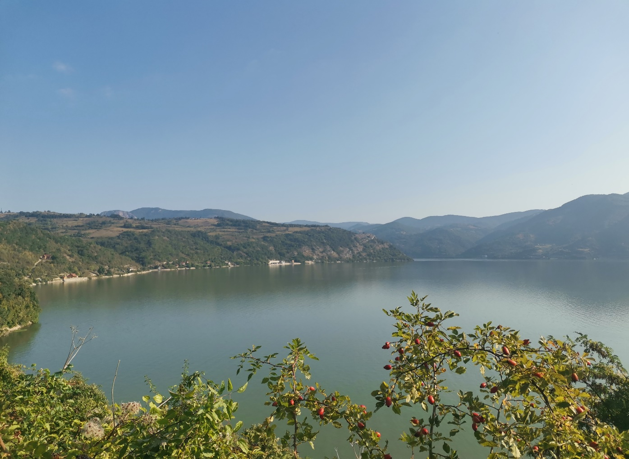

REPORT ON THE MEASUREMENT CAMPAIGN IN THE IRON GATE RESERVOIR
D.6.1.2

Project title
Sediment-quality Information, Monitoring and Assessment System to support transnational cooperation for joint Danube Basin water management.
Acronym
SIMONA
Project duration
1st June 2018 to 1st December 2021, 42 months
Date of preparation
29/03/2021

Authors:
Serbia
Marko Marjanović (RS-JCWI), Prvoslav Marjanović (RS-JCWI), Dragica Vulić (RS-JCWI)

(The list follows the alphabetic order of countries and names.)
Responsible(s) of the deliverable: Prvoslav Marjanović (RS-JCWI)
Co-responsible(s) of the deliverable: Meta Dobnikar (SL-GEOZS)

Editing and preparation for printing: Katalin Mária Dudás (HU-NARIC)

For further information on the project, partnership and the Danube Transnational Programme:
www.interreg-danube.eu/simona

FIND SIMONA PROTOCOLS ON THE WEBSITE!

Contents

1. INTRODUCTION 4
2. DESCRIPTION OF THE SAMPLING METHODOLOGY 6
3. SAMPLING TIMELINE 9
4. SAMPLING SITES 10
ANNEX 1 21

INTRODUCTION

The objective of the Sampling campaign in the Iron Gate reservoir was to test, verify and further develop the SIMONA Sampling Protocol. The specific objective is to test and compare various sampling methods (sampling systems) for actual sample collection. The final sampling methods tested and developed and selected for the Protocol were also demonstarted and a training session held during the Training Event. These methods were also used for sample collection at the two National Sampling Points.
A total of 12 sampling sites were sampled during the sampling field campaign. 10 sampling points for WP6 Large lakes and reservoirs, 2 national sampling points and 1 for the purpose of training and demonstration. All of the samples collected from the Iron Gate reservoir were collected from a boat. Suspended sediment samples were also collected.
One originally planned sites had to be replaced by a new site. Table 1 shows the original plan of the 13 sampling sites. Replacement is indicated in the comments column.
Table 1: List of the originally planned sampling sites
Nr. | Name of  the site | WGS Long  N | WGS Lat  E | Owner of water monitoring data | Owner of sediment monitoring data | Responsible for sampling | Existent archive  water, sediment monitoring data | Comments
1. | Ledinci | 45°13'02.9" | 19°48'18.2" | RS-JČWI | SIMONA | RS- JCWI | W
2. | Novi Sad | 45°15'30.8" | 19°53'16.4" | SIMONA | SIMONA | RS- JCWI | W, S
3. | Stari Banovci | 44°59'24.9" | 20°17'41.3" | SIMONA | SIMONA | RS- JCWI | W, S
4. | Zemun | 44°51'42.0" | 20°22'52.7" | SEPA | SIMONA | RS- JCWI | W | Replaced
5. | Ritopek | 44°44'25.1" | 20°39'30.7" | SIMONA | SIMONA | RS- JCWI | W, S
6. | Smederevo | 44°42'15.0" | 20°58'29.9" | SIMONA | SIMONA | RS- JCWI | W, S | -
7. | Ram | 44°49'10.7" | 21°20'22.5" | SIMONA | SIMONA | RS- JCWI | W, S | New National point
8. | Veliko Gradište | 44°46'07.1" | 21°31'28.6" | SIMONA | SIMONA | RS- JCWI | W, S
9. | Donji Milanovac | 44°27'56.6" | 22°08'09.9" | SIMONA | SIMONA | RS- JCWI | W, S
10. | Tekija | 44°41'05.7" | 22°24'25.9" | SIMONA | SIMONA | RS- JCWI | W, S
11. | Kladovo | 44°37'17.2" | 22°35'42.1" | SIMONA | SIMONA | RS- JCWI | W, S
12. | Kusjak | 44°19'11.9" | 22°32'45.9" | SIMONA | SIMONA | RS- JCWI | W, S

One national point sampling site (Zemun) was replaced due to the fact that no sediment was present at the time of sampling.

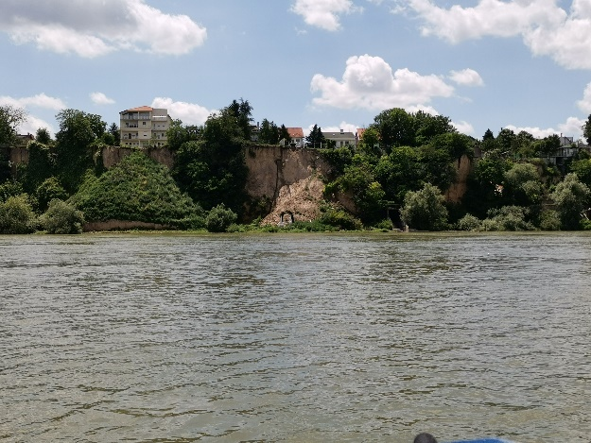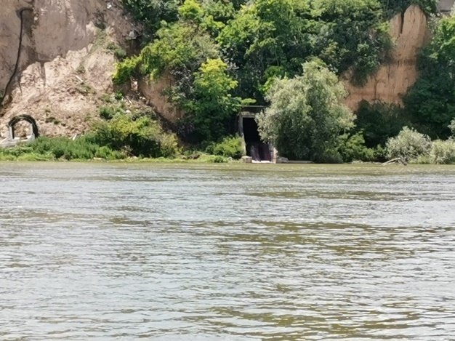
Landscape photo of the sampling site (Zemun).

New national point was chosen at the location near Ram.
Table 2: List of the final sampled sites
Nr. | Sample ID | Name of  the river/reservoir | Name of  the site | WGS Long,  N | WGS Lat,  E
1. | WP6_LE_BS | Danube, Iron Gate | Ledinci | 45°13'02.9" | 19°48'18.2"
2. | WP6_NS_BS | Danube, Iron Gate | Novi Sad | 45°15'30.8" | 19°53'16.4"
3. | WP6_SB_BS | Danube, Iron Gate | Stari Banovci | 44°59'24.9" | 20°17'41.3"
4. | WP6_RT_BS | Danube, Iron Gate | Ritopek | 44°44'25.1" | 20°39'30.7"
5. | WP6_SD_BS | Danube, Iron Gate | Smederevo | 44°42'15.0" | 20°58'29.9"
6. | WP6_RA_BS | Danube, Iron Gate | Ram | 44°49'10.7" | 21°20'22.5"
7. | WP6_VG_BS | Danube, Iron Gate | Veliko Gradište | 44°46'07.1" | 21°31'28.6"
8. | WP6_DM_BS | Danube, Iron Gate | Donji Milanovac | 44°27'56.6" | 22°08'09.9"
9. | WP6_TE_BS | Danube, Iron Gate | Tekija | 44°41'05.7" | 22°24'25.9"
10. | WP6_KL_BS | Danube, Iron Gate | Kladovo | 44°37'17.2" | 22°35'42.1"
11. | WP6_KU_BS | Danube, Iron Gate | Kusjak | 44°19'11.9" | 22°32'45.9"

Throughout the sampling field activities within the Iron Gate Test Area, and during the entire sampling campaign, constant and constructive discussions were held between all those present about fluvial sediment sampling and long-term Surveillance Monitoring of water bodies under the EU WFD requirements. These ideas, experience gained and some preliminary suggestions are summarised below. The most fundamental conclusion was that the SIMONA Sampling Protocol provides a solid basis for fluvial sediment sampling and monitoring.

DESCRIPTION OF THE SAMPLING METHODOLOGY

(1) Sample TYPE and Sampling SYSTEM. The following sample types were collected during the Iron Gate sampling campaign for the purposes of testing various sampling procedures as well as for the purposes of comparison of the reuslts obtained via various sample collection methodologies.

Sample type | Sampling system
Bottom sediment 0-5 cm | gravity core sampler
Bottom sediment 5-10 cm | gravity core sampler
Bottom sediment 10-15 cm | gravity core sampler
Bottom sediment 0 – 15cm | Grab sampler
suspended sediment | Vacuum pump and sampling bottle

(2) All sample types were collected as composite samples (suspended sediment is a natural composite so it can be collected at a single location in the flowing stream water).

(3) Sampling location selection of the sampling locations within the Iron Gate reservoir was conducted taking into account various factors to ensure that the sampling locations and samples collected from these locations were representative.

(4) Bottom Sediment: 5 sub-samples collected from within a 2500 m² square patch (‘Sampling section’) located at equal distances (50 m). If only a shorter stretch/ smaller patch was accessible only, the distance between sampling points for the sub-samples was smaller.

(5) Suspended Sediment: Water from the reservoir was pumped from the water column into a 30 L barrel. Depending on the width of the reservoir at the sampling location, a number of vertical profiles were sampled with that number increasing with an increase in the width of the reservoir.

(6) Field measurements. Portable multiparameter probes were used to measure in-situ water quality parameters:
- Water chemistry: Electroconductivity, T °C, pH, redox potential, dissolved oxygen, turbidity

More specifically Hach HQ40d and YSI ProDSS multiparameter probes were used.

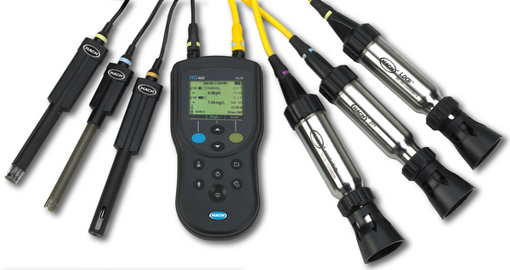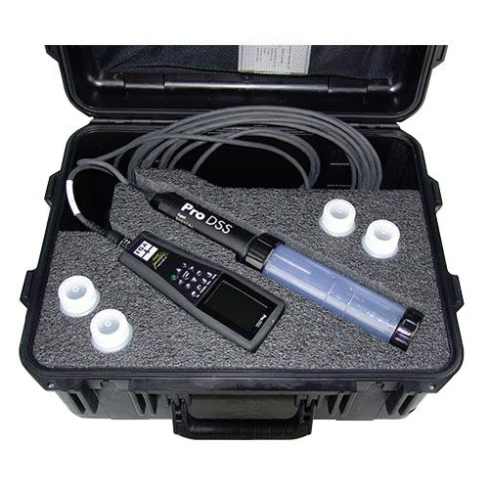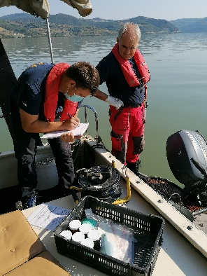

Multiparameter probes used and the measurement of in-situ water quality parameters.

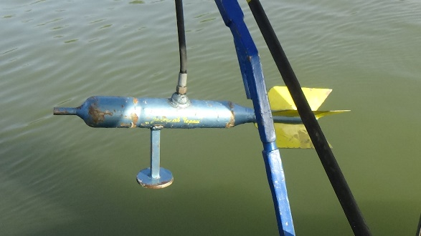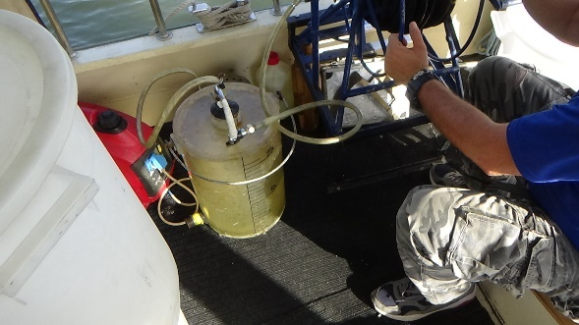
Collection of suspended sediment samples.

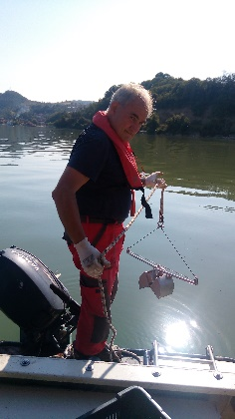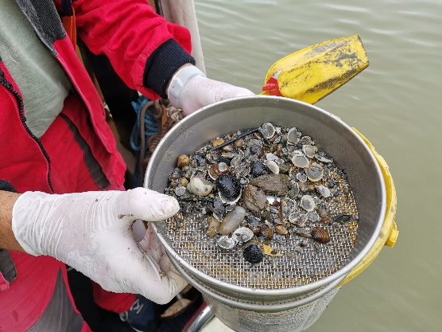
Bottom sediment sample collection and sieving in the field.

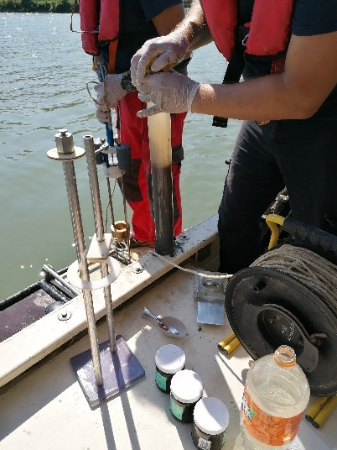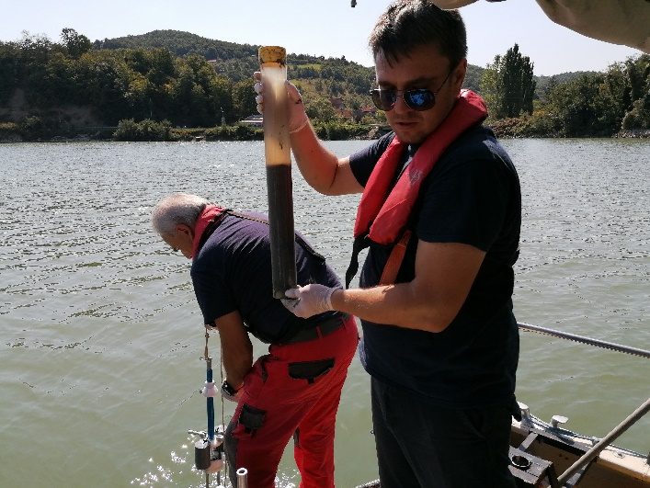
Bottom sediment sample collection using a gravity corer.

(7) Field documentation. Four types of field documentation were performed:
- Field photos: First photo taken on the site ID, then each sampling activity and sampling locations were photographed using mobile phones with geo-tagging.
- Field videos: Videos were taken on all sampling activities using mobile phones and handheld video cameras.
- Field sheet: SIMONA Sampling Protocol field sheets were completed on site.
- Field notes: abundant extra notes were taken to document sampling conditions and expert comments and conclusions.

(8) Sample handling. Bottom sediment samples and suspended sediment samples were collected into glass jars, suspended sediment samples were collected into 30 L plastic barrels, while stream (bottom) sediment replicate samples (3-5) collected for site homogeneity test were stored in plastic bags. Samples were put into electrically powered samlpe refrigators (4-8 C°) immediately after collection on site and transported cooled to the laboratory.

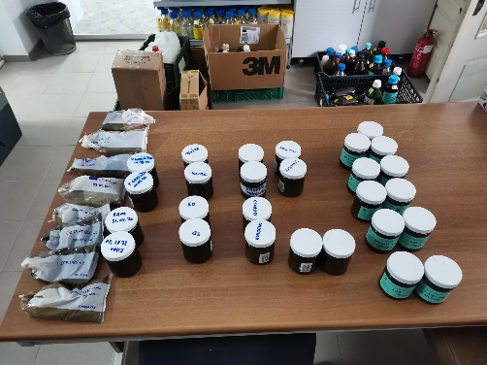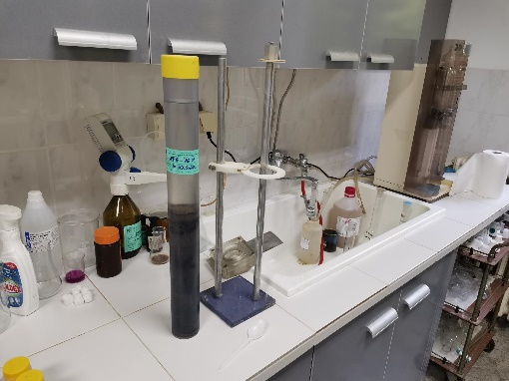
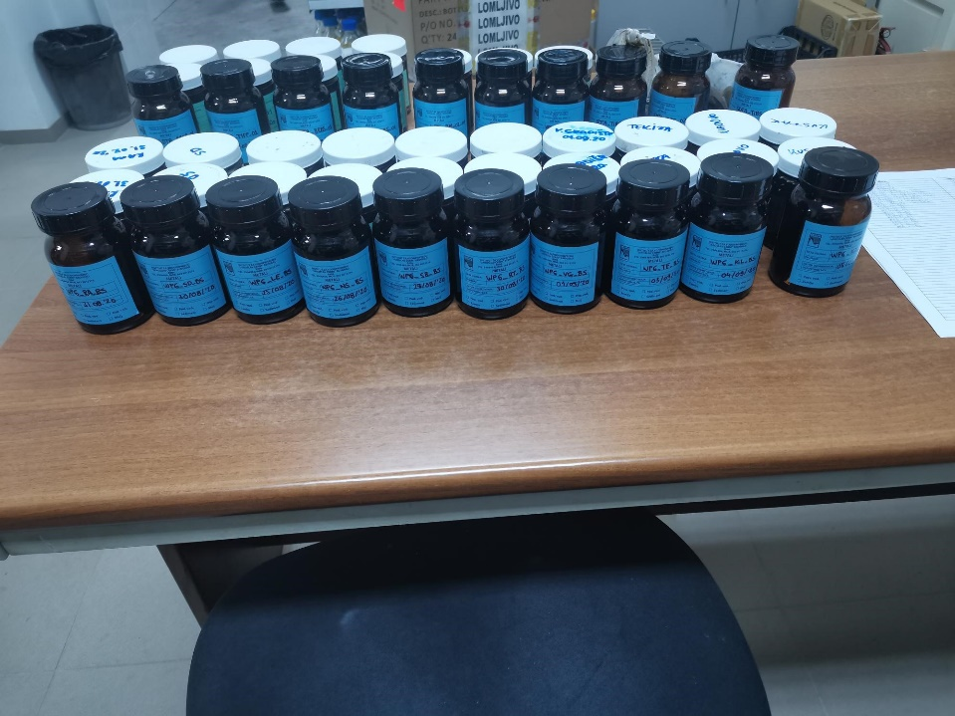
Collected sampls in the laboratory

(8) Field safety. Due to the situation with the Covid-19 pandemic special measures were taken to protect all present during the sampling campaign in addition to the safety measures and precautions envisaged by ISO standards.

SAMPLING TIMELINE

Date | Temperature | Wind speed | Precipitation | Travelled distance and sampled locations
25-08-2020 | 16°C– 24°C | 0 -30 km/h | Intermittant rainfall | Ledinci
26-08-2020 | 16°C– 28°C | 0 -17 km/h | Intermittant rainfall | Novi Sad
27-08-2020 | 16°C– 28°C | 0 -22 km/h | None | Stari Banovci
30-08-2020 | 23°C– 35°C | 0-28 km/h | None | Ritopek, Smederevo
31-08-2020 | 20°C– 33°C | 0-31 km/h | None | Ram
01-09-2020 | 17°C– 26°C | 0-35 km/h | None | Veliko Gradište
03-09-2020 | 16°C– 25°C | 0-24 km/h | None | Tekija
04-09-2020 | 15°C– 28°C | 0-20 km/h | None | Kladovo
05-09-2020 | 15°C– 28°C | 0-20 km/h | None | Kusjak
09-09-2020 | 17°C– 30°C | 0-19 km/h | None | Donji Milanovac

SAMPLING SITES

NAME OF THE SITE: Ledinci
NAME OF THE RIVER: Danube

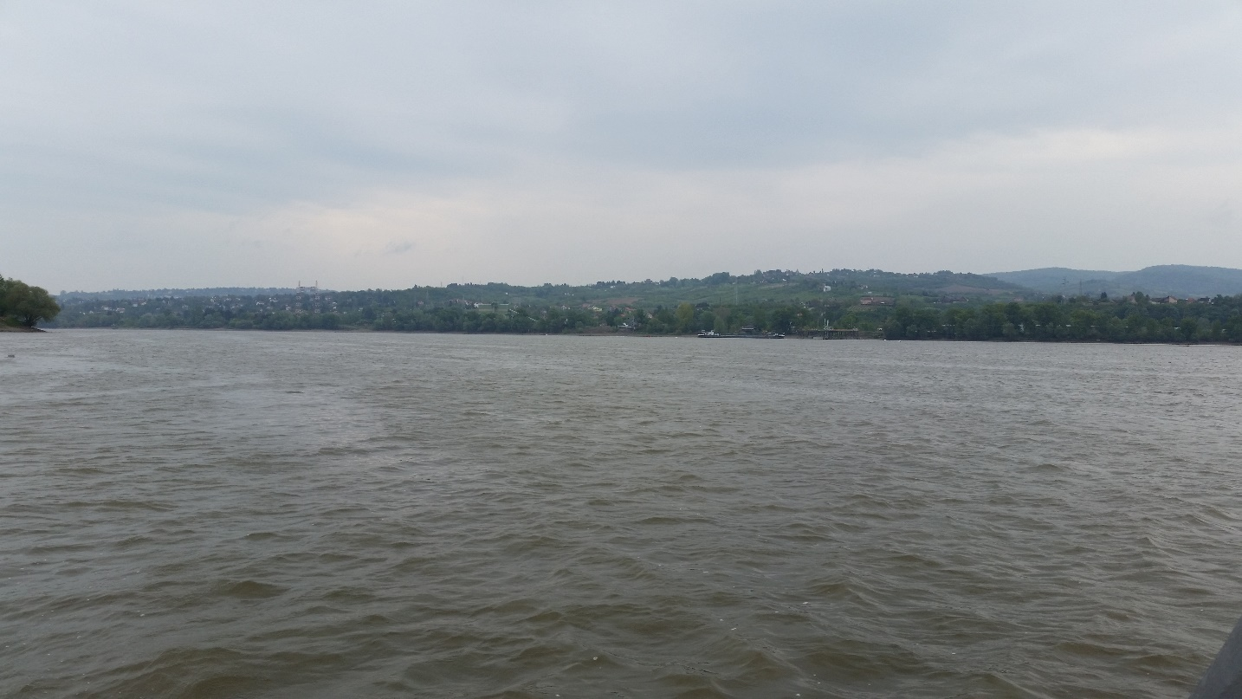
Sampling profile Ledinci

Field parameters | Unit | Surface water
Temperature | °C | 23.7
pH |  | 7.88
Electrical Conductivity | µS/cm | 334.8
Turbidity (measured) | NTU | 16.2
Dissolved Oxygen; DO | mg/l | 7.35
Oxygen Saturation; DO | % | 77.5

NAME OF THE SITE: Novi Sad
NAME OF THE RIVER: Danube

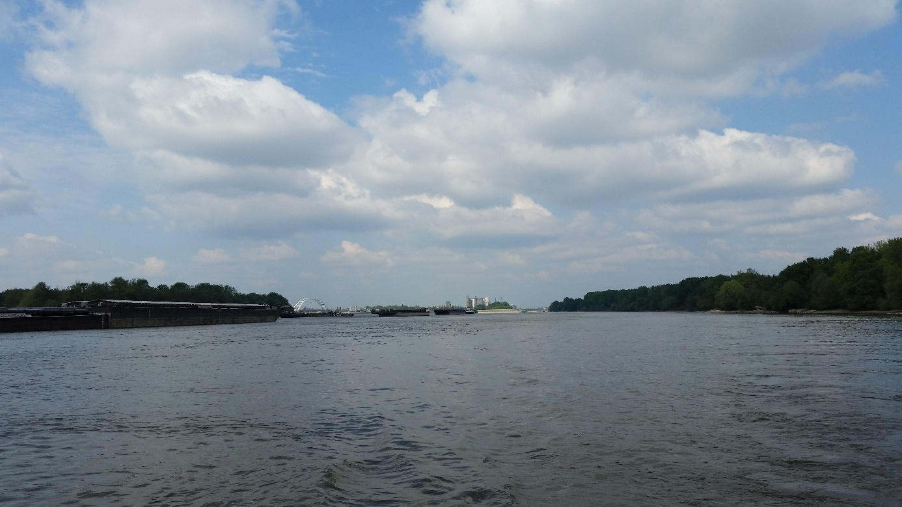
Sampling profile Novi Sad

Field parameters | Unit | Surface water
Temperature | °C | 23.7
pH |  | 7.89
Electrical Conductivity | µS/cm | 334
Turbidity (measured) | NTU | 16.1
Dissolved Oxygen; DO | mg/l | 7.3
Oxygen Saturation; DO | % | 86.9

NAME OF THE SITE: Stari Banovci
NAME OF THE RIVER: Danube
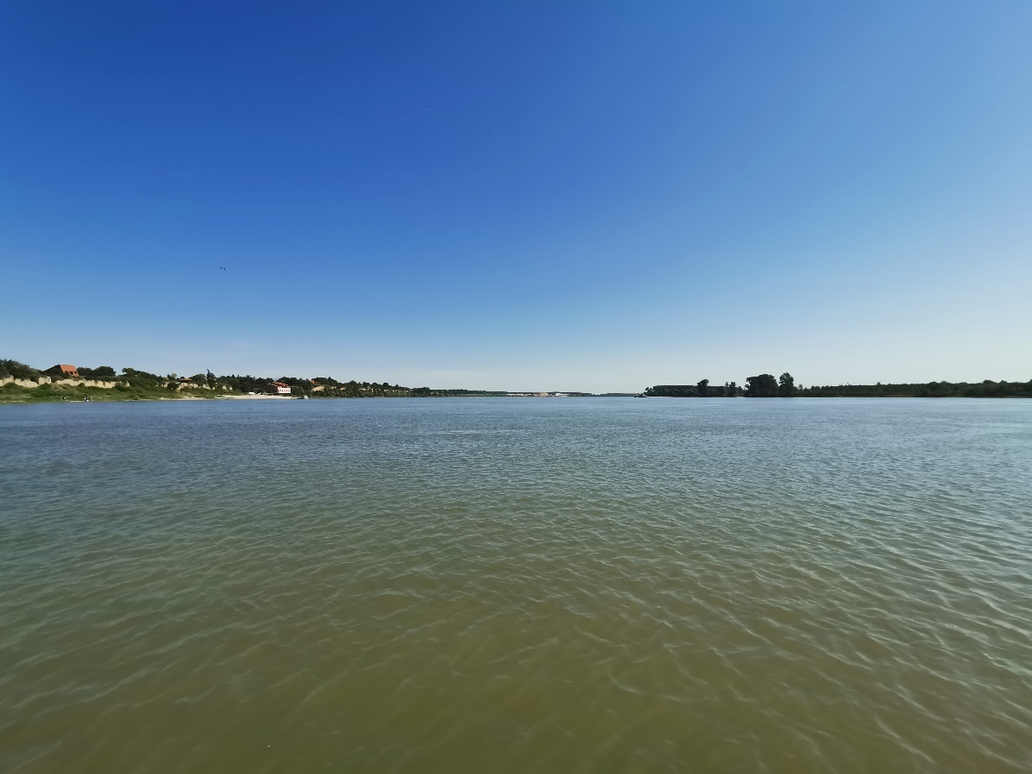
Sampling profile Stari Banovci

Field parameters | Unit | Surface water
Temperature | °C | 23.7
pH |  | 7.94
Electrical Conductivity | µS/cm | 337.7
Turbidity (measured) | NTU | 11
Dissolved Oxygen; DO | mg/l | 7.57
Oxygen Saturation; DO | % | 90.3

NAME OF THE SITE: Ritopek
NAME OF THE RIVER: Danube

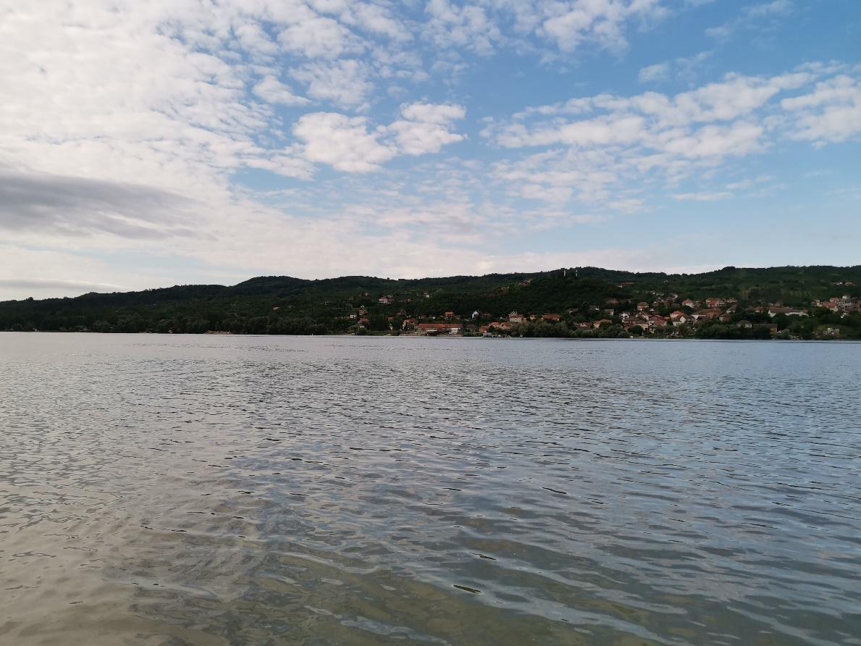

Sampling profile Ritopek

Field parameters | Unit | Surface water
Temperature | °C | 24.0
pH |  | 7.82
Electrical Conductivity | µS/cm | 352
Turbidity (measured) | NTU | 10.1
Dissolved Oxygen; DO | mg/l | 6.57
Oxygen Saturation; DO | % | 79.4

NAME OF THE SITE: Smederevo
NAME OF THE RIVER: Danube

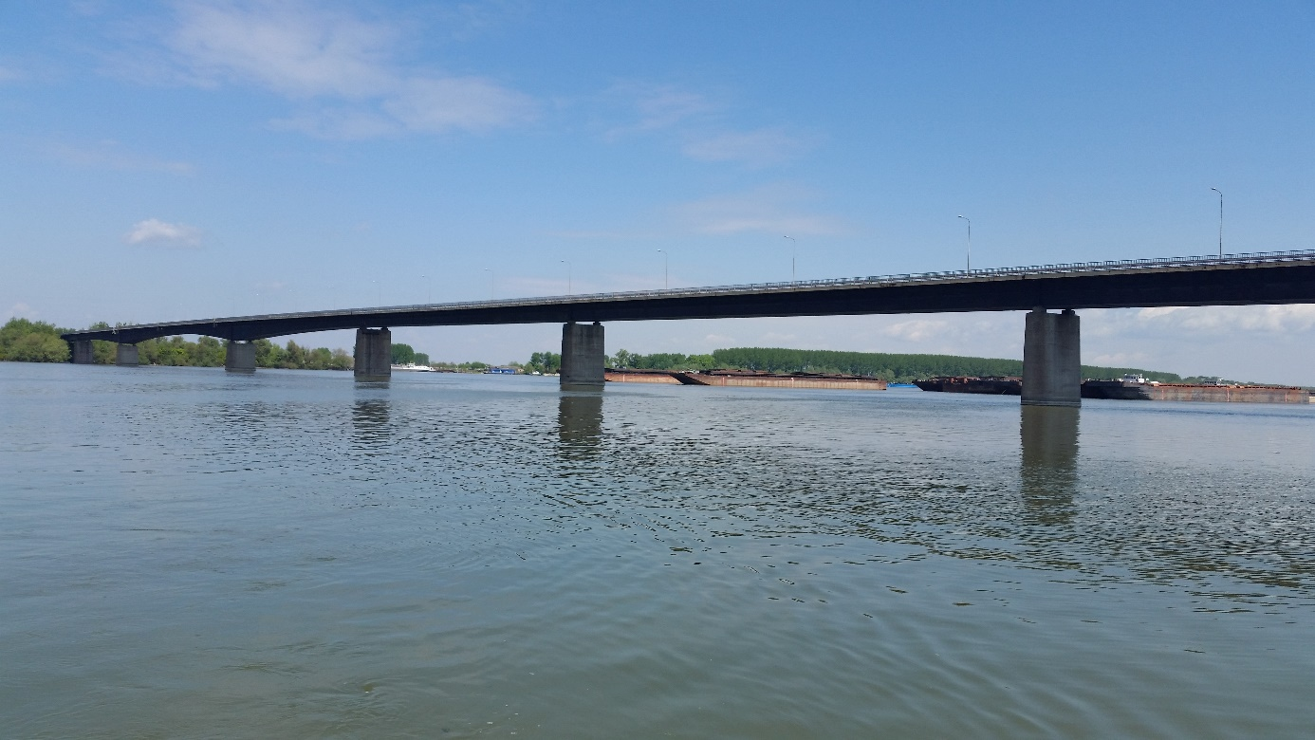
Sampling profile Smederevo

Field parameters | Unit | Surface water
Temperature | °C | 24.2
pH |  | 7.84
Electrical Conductivity | µS/cm | 367
Turbidity (measured) | NTU | 8.5
Dissolved Oxygen; DO | mg/l | 6.59
Oxygen Saturation; DO | % | 80

NAME OF THE SITE: Ram
NAME OF THE RIVER: Danube

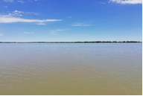
Sampling profile Ram

Field parameters | Unit | Surface water
Temperature | °C | 25.0
pH |  | 7.79
Electrical Conductivity | µS/cm | 370.2
Turbidity (measured) | NTU | 6.3
Dissolved Oxygen; DO | mg/l | 6.6
Oxygen Saturation; DO | % | 81.7
NAME OF THE SITE: Veliko Gradište
NAME OF THE RIVER: Danube

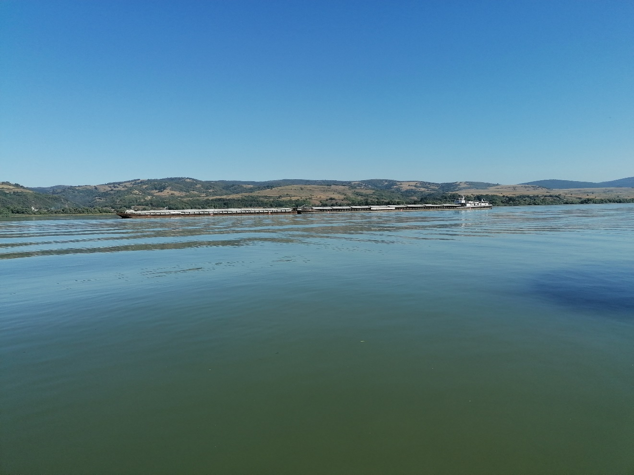
Sampling profile Veliko Gradište

Field parameters | Unit | Surface water
Temperature | °C | 25.3
pH |  | 7.93
Electrical Conductivity | µS/cm | 373.5
Turbidity (measured) | NTU | 14
Dissolved Oxygen; DO | mg/l | 6.9
Oxygen Saturation; DO | % | 88

NAME OF THE SITE: Donji Milanovac
NAME OF THE RIVER: Danube

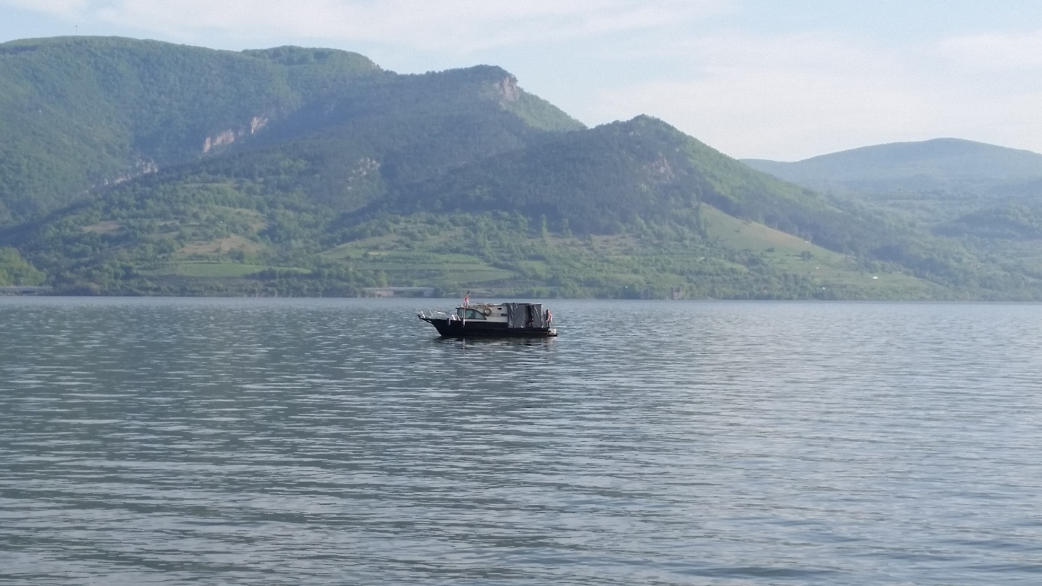
Sampling profile Donji Milanovac

Field parameters | Unit | Surface water
Temperature | °C | 24.1
pH |  | 7.87
Electrical Conductivity | µS/cm | 365
Turbidity (measured) | NTU | 7.4
Dissolved Oxygen; DO | mg/l | 6.94
Oxygen Saturation; DO | % | 83.2

NAME OF THE SITE: Tekija
NAME OF THE RIVER: Danube

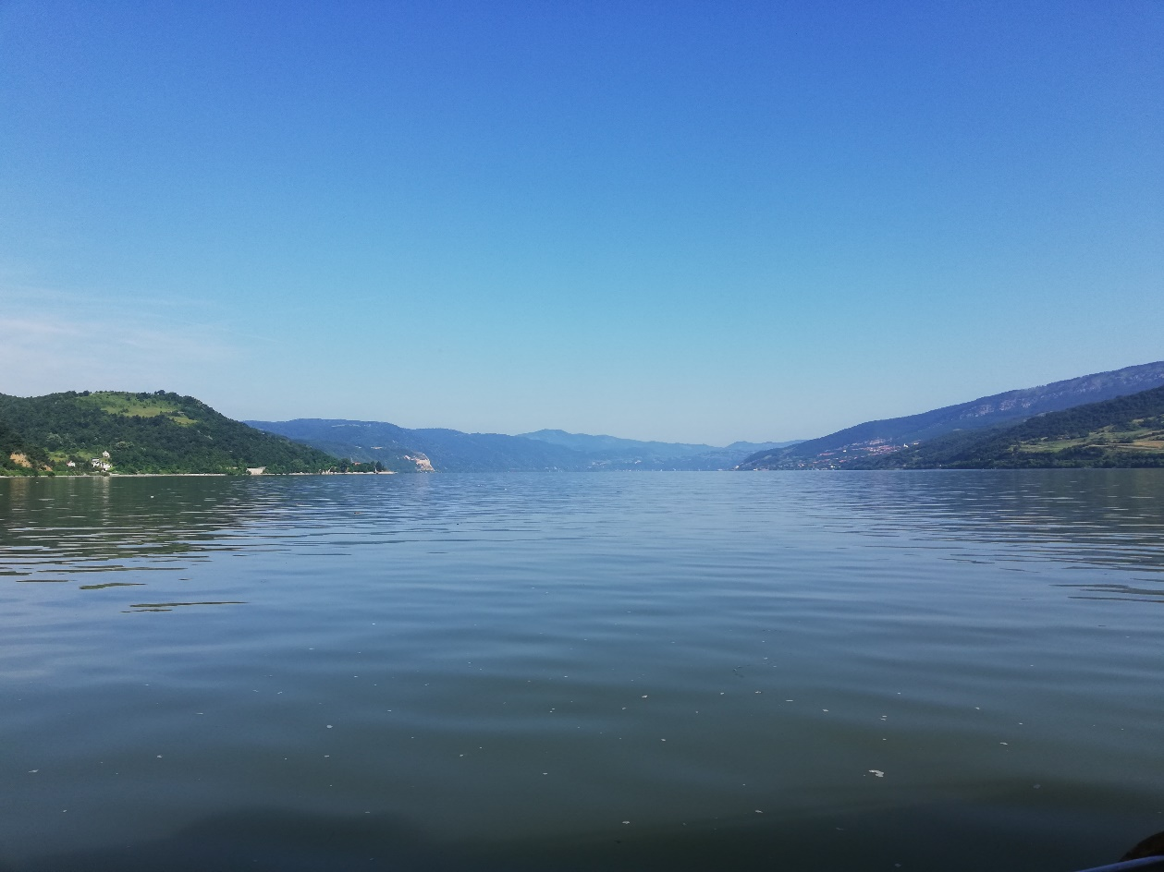
Sampling profile Tekija

Field parameters | Unit | Surface water
Temperature | °C | 24.4
pH |  | 7.83
Electrical Conductivity | µS/cm | 358.3
Turbidity (measured) | NTU | 4.9
Dissolved Oxygen; DO | mg/l | 6.62
Oxygen Saturation; DO | % | 8.1

NAME OF THE SITE: Kladovo
NAME OF THE RIVER: Danube

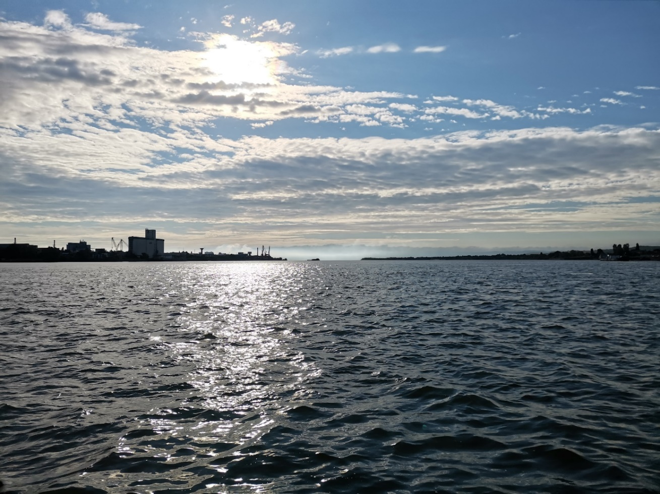
Sampling profile Kladovo

Field parameters | Unit | Surface water
Temperature | °C | 23.8
pH |  | 7.82
Electrical Conductivity | µS/cm | 360.3
Turbidity (measured) | NTU | 5.1
Dissolved Oxygen; DO | mg/l | 6.54
Oxygen Saturation; DO | % | 77.6

NAME OF THE SITE: Kusjak
NAME OF THE RIVER: Danube

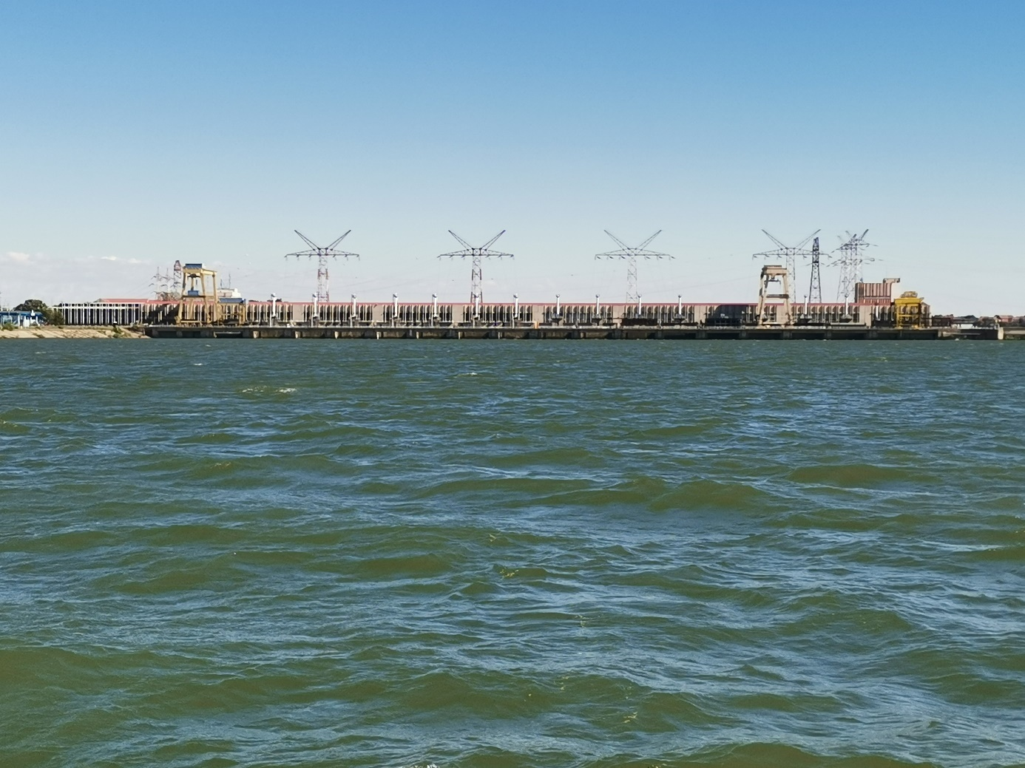
Sampling profile Kusjak

Field parameters | Unit | Surface water
Temperature | °C | 23.6
pH |  | 7.91
Electrical Conductivity | µS/cm | 346.4
Turbidity (measured) | NTU | 4.8
Dissolved Oxygen; DO | mg/l | 7.1
Oxygen Saturation; DO | % | 83.9

ANNEX 1

(1) PARTICIPANTS (confirmed)

- Marko Marjanović
- Igor Ljumović
- Dragan Aleksić
- Prvoslav Marjanović
- Dragica Vulić

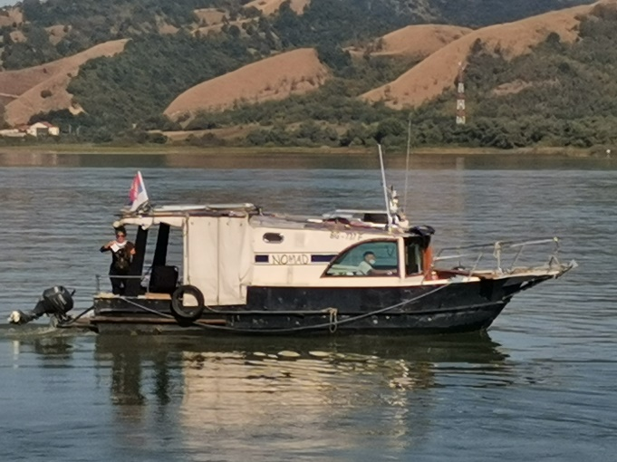 | 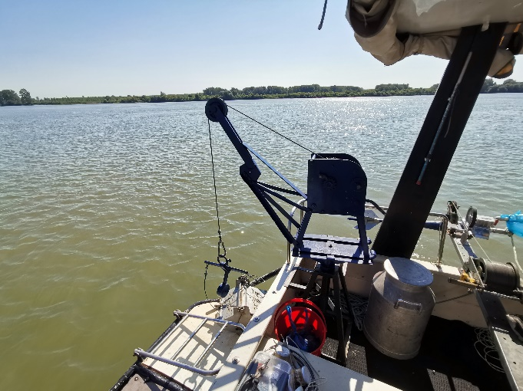
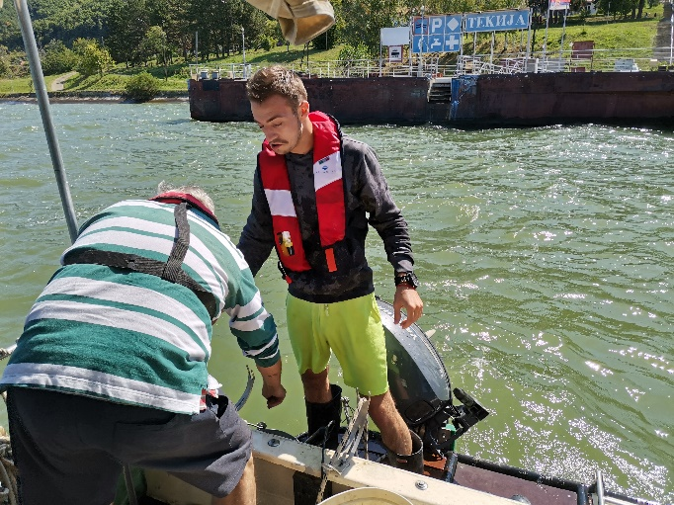 | 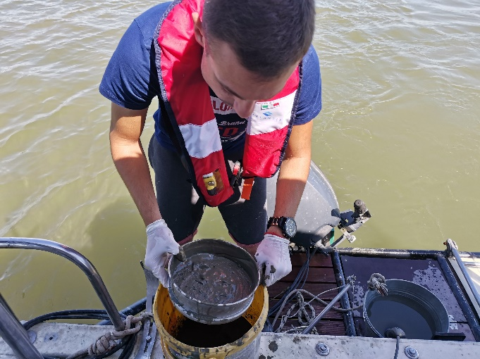
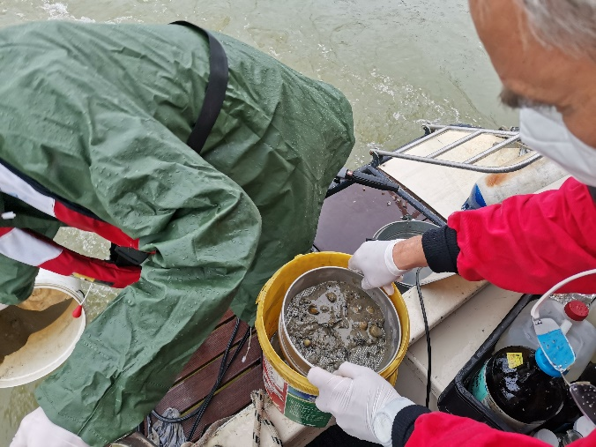 | 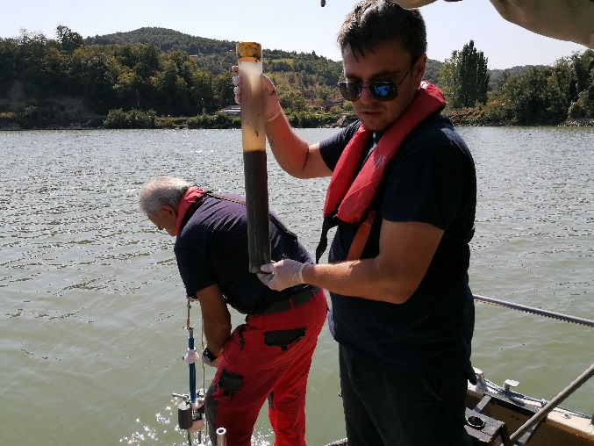
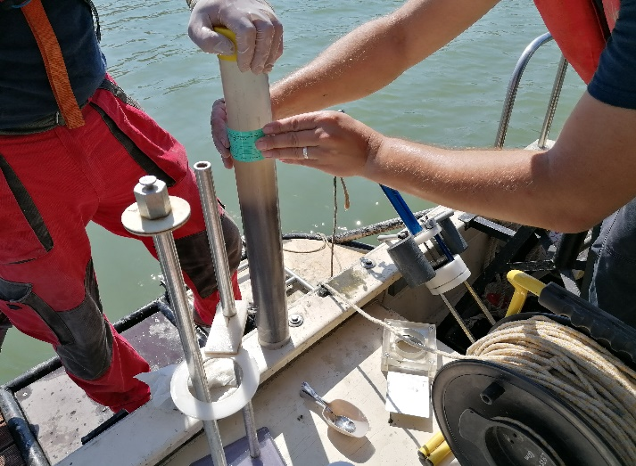 | 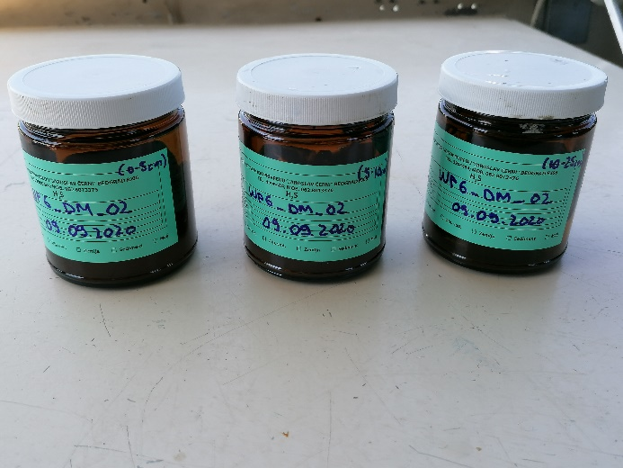
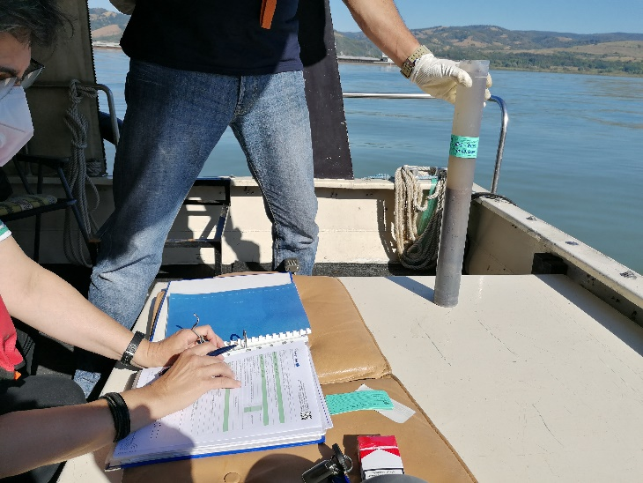 | 