REPORT

PARTNER: | Civitta slovakia
EVENT: | Report from regional case study in slovakia
DELIVERABLE: | D.C.2.2
DATE: | 30.10.2020

DANUBE ENERGY+ SLOVAK REGIONAL CASE STUDY
“STORY OF YOUNG INNOVATORS STRIVING FOR SUSTAINABLE FUTURE”
- General description
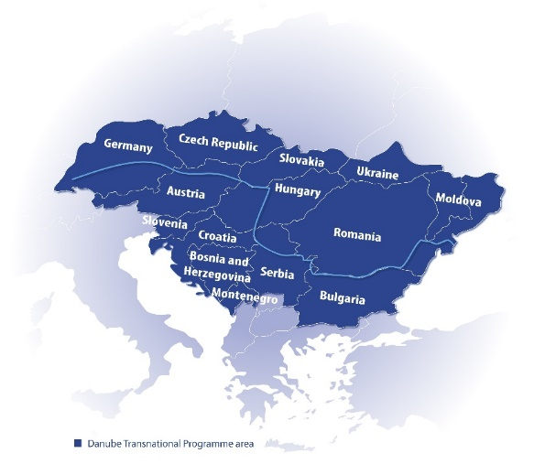
The entrepreneurship environment and culture in the Danube macro-region is weaker and less developed comparing to other EU countries. Young innovators (YIs) in the region often fail to turn their ideas into marketable solutions for variety of reasons, including lack of experience and knowledge, inadequate business support and information, or insufficient funding.
The Danube Energy+ project’s general objective is to create an enabling environment that will support Young innovators to pioneer a change in the energy efficiency area by setting up highly innovative start-ups in the Danube macro-region.
Main activities envisaged for implementation under the project to achieve the set goal
1. Danube Energy+ Ecosystem package – development of an innovative learning system for key actors of regional ecosystems (Public administration, Universities, Business Supporting Actors, SMEs) to advance their knowledge in industry challenges, models and practices for identification, motivation and connection of YIs.
2. Danube Energy+ Tool – establishment of a pre-seed / pre-acceleration learning system for Young innovators (YIs) to support their highly innovative idea in the energy efficiency field.
3. Mutual learning process at transregional level - carrying out of 2 physical and 8 virtual workshops to increased knowledge of project partners (PPs) and indirectly support also YIs through expert knowledge-based Tool and Package.
4. Learning package for regional ecosystem actors – development for advancing their knowledge during the Pilot of Danube Energy+ Package on regional level through their participation in several regional activities aside of project partners.
5. Pilot of Danube Energy+ Package in all regions – development and implementation of Package to build capacities of ecosystem actors to create enabling environment for Young innovators + facilitate further cooperation inside ecosystem.
6. Training scheme for Young innovators – development and implementation of training scheme in which the Young innovators are taking part in the Pilot of Danube Energy+ Tool which will directly benefit from learning process within the pre-acceleration scheme.
7. Mutual learning during implementation of Pilots - Partners and ASPs will learn mutually from each other on transregional level through joint Package Pilot implementation, monitoring and impact measurement process.
Expected Results: Intensity of cooperation of key actors in the programme area in order to increase competences for business and social innovation (survey based composite indicator)
Expected Outputs: Danube Energy+ will result in establishment of enabling environment for Young innovators to further strengthen innovation ecosystem and entrepreneurial spirit, especially in area of energy efficiency. This enabling environment will be built on three key elements achieved by the project, each relevant to one specific objective: to advance knowledge of key regional stakeholders in boosting Young innovators (Specific Objective 1), to boost Young innovators towards successful ventures (Specific Objective 2) and to set-up sustainable structures in regional ecosystems to create long-term enabling environment (Specific Objective 3).
Project will intensify cooperation of stakeholders through their engagement in the Danube Energy + ecosystem Package by joint design, pilot monitoring, evaluation and by the development of Action plans. It will engage 9 regional public administrations, 90 Young innovators who were selected for Danube Energy+ Tool Pilot, 9 Regional Alliances, 9 Regional Hubs & 2 working groups (responsible for content of the learning scheme).
Young innovators will benefit from strengthened competences gained through pre-acceleration learning scheme, which will further develop their general business knowledge (business development, marketing, sales, finance) & specific industry knowledge in the energy efficiency sector.
Through improved enabling environment, participating territories will benefit from strengthened entrepreneurial spirit resulting in new business ventures oriented towards the sustainable energy in long-term period.
Project partners
Lead Partner:  KIC InnoEnergy Germany GmbH  Address: Albert-Nestler-Str 26, D-76131 Karlsruhe, Germany  Legal status: public  Website: www.innoenergy.com/office/germany/ | Partner’s Name:  SEE ICT  Address: Savska 5/1, 11000 Beograd, Serbia  Legal status: private  Website: www.startit.rs | Partner’s Name:  E-KLASTR Czech Republic a.s.  Address: Bohdalecká, Michle 1460/8, 101 00 Praha 10, Czech Republic  Legal status: private  Website: www.e-accelerator.cz
Partner’s Name:  Asociatia Centrul Start-up Transilvania  Address: Pitesti Street 19/2Cluj-Napoca, Romania  Legal status: private  Website: www.start-uptransilvania.ro | Partner’s Name:  Фондация ‘Клийнтех България’  Address: TsarigradskoShousse, Sofia Tech Park, Business Incubator building, ground floor 111 B, 1784, Sofia, Bulgaria  Legal status: private  Website: www.cleantech.bg | Partner’s Name:  ABC Accelerator, razvoj start-upov in mladih podjetij, d.o.o  Address: Šmartinska cesta 152, 1000 Ljubljana, Slovenia  Legal status: private  Website: https://abc-accelerator.com/slovenia/
Partner’s Name:  Optimizacija  Address: Istarska ulica 47, 10 000 Zagreb, Croatia  Legal status: private | Partner’s Name:  Центр європейських ініціатив  Address: Shvabskaya street, 71a, 88018 Uzhhorod, Ukraine  Legal status: public  Website: www.iardi.org/partners/tsentr-evropejskyh-initsiat | Partner’s Name:  Civitta SIovakia, a.s.  Address: Ilkovičova 2, 842 16 Bratislava, Slovakia  Legal status: private  Website: www.neulogy.com

Danube Energy+ Ecosystem Package (Package)
The Package including a Tool is designed with the aim to tackle the aforementioned challenges and is piloted in 9 regions. Thus, engaging Young innovators (YIs) in this region and unlocking their potential to address the energy efficiency specific challenges in the region is a top priority for innovation ecosystem actors.
The Package is developed through learning interaction among project partners and inclusive design process involving key actors of regional ecosystems - regional public authorities, universities, BSOs, SMEs and industry representatives. The Package is composed of two main elements:
- best practices, models and experiences in identification, motivation and connection of YIs to ecosystem actors
- Danube Energy+ Tool development as a pre-acceleration learning scheme for YIs boosting their competences to start successful ventures.
The Package helps create an enabling environment for innovation by guiding ecosystem actors in:
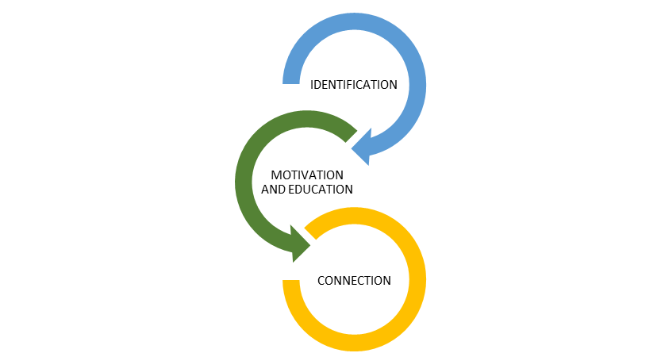
1) Identification of YIs in their ecosystems
2) Motivation of YIs to further develop their disruptive ideas to marketable solutions
3) Implementation of the Danube Energy+ Tool to boost knowledge of YIs to scale-up their ideas to ventures
4) Connection of YIs with other key stakeholders in regional ecosystems

- Objective of this document
The primary goal of the Regional case studies is to give users opportunity to see the partner’s step-by step approaches and lessons learned during the implementation of the project for creating an enabling entrepreneurship environment to unlock YIs potential in Danube macro-region.
- Management summary
This case study shows how regional ecosystem actors gain first-hand experience and knowledge from the whole process of implementation of the Tool based on the Danube Energy+ Ecosystem Package presented in the following structure:
          - General description of the pilot in 9 partner countries (identification, motivation and connection process of Young innovators and boost regional ecosystem cooperation)
          - Outcomes:
- Effectiveness of applied methods for reaching out to YIs (lessons learned, cooperation with, traps)
- Lessons learned from the pilot from different perspectives
- Success stories and regional impact
The imposed restrictive measures on the spread of the coronavirus pandemic in the partners’ countries reflected on the implementation of the Tool based on Danube Energy+ Ecosystem Package. The degree of readiness of the individual project partners to address these challenges led to a scenario in which these Tool Pilots were taken at two ‘speeds’ or in two time periods as follows:
January - July 2020: Germany, Bulgaria, Romania, Croatia, Serbia and the Czech Republic
January - October 2020: Slovenia, Ukraine and Slovakia
The partners decided to develop the Regional case studies as an open document. The information has to be supplemented periodically according to the implementation of the Pilot’s steps per each of the individual project partners.

- Pilot description in Slovakia
The implementation of the pilot in Slovakia was built upon Danube Energy+ Ecosystem Package and Tool, providing guidance for the organization of the scheme and a firm basis serving for further adjustments to the regional specifics. These were supplemented with the expertise of the Civitta Slovakia team that has a longtime and substantial experience in delivering accelerator programs for innovation leaders and enthusiasts who want to develop their entrepreneurial ideas and transform their projects into real-life success. The pilot implementation in Slovakia was significantly marked by the Covid-19 pandemic. The implementation schedule was postponed by several months to gain time to adapt to such unprecedented circumstances and ensure smooth proceedings. Additionally, the pandemic and accompanying safety measures resulted in a decision to move the pilot training program online.

Identification and motivation phase
The identification and recruitment of young innovators were organized in various directions, and motivation to participate was disseminated through different channels.
- University visits
  - 2 visits at the CS Lewis high school for the students of entrepreneurship course; the presentation was delivered by a Civitta representative
  - 1 visit at the Slovak Agriculture University (SPU) in Nitra; the presentation was delivered by our recruitment partner SIEA
  - 1 visit – online – at the Leaf Academy pitching day

- Networking events
  - Demo Day of the pre-accelerator program Primer served as the networking event, allowing for drawing the attention of potential participants

- Collaborative efforts with RA members
  - RA members most exposed to the young innovators were identified with adequate channels of communication
  - Emails were sent to the representatives of several faculties at the Comenius University, to the Slovak Technical University, the University of Economics, the Technical University of Kosice as well as to the Slovak academy of sciences
  - Slovak Innovation and Energy Agency (SIEA) representing a recruitment partner was actively supporting our effors on social media

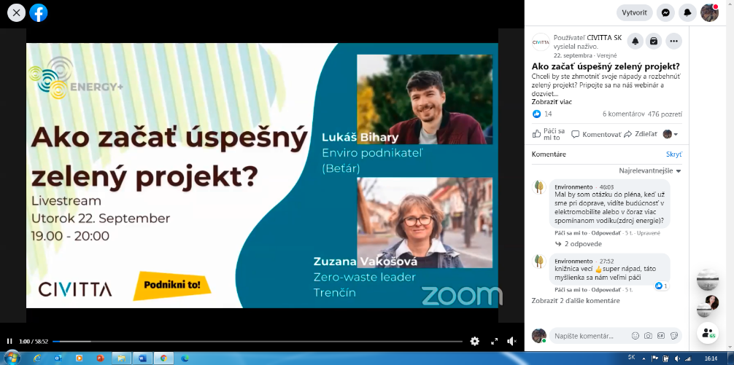
- Motivational workshop

Motivational workshop was delivered in a form of an online webinar (Accessible at https://www.facebook.com/watch/?v=1504800809712507 ). The webinar streamed on Facebook tackled the question of how to start a successful green project and provided insights into the project and entrepreneurial opportunities in the sectors of sustainability, energy and green solutions. The webinar delivered a discussion with a successful green entrepreneur Lukáš Bihary, running a taxi start-up with electric cars; and Zuzana Vakošová, a sustainability activist raising awareness of zero-waste lifestyle. The discussion touched upon the topics of sustainability and entrepreneurship, commenting on the benefits and opportunities as well as obstacles and threats attached to green activism and entrepreneurship. The event had more than 450 views.

- Social Media campaign
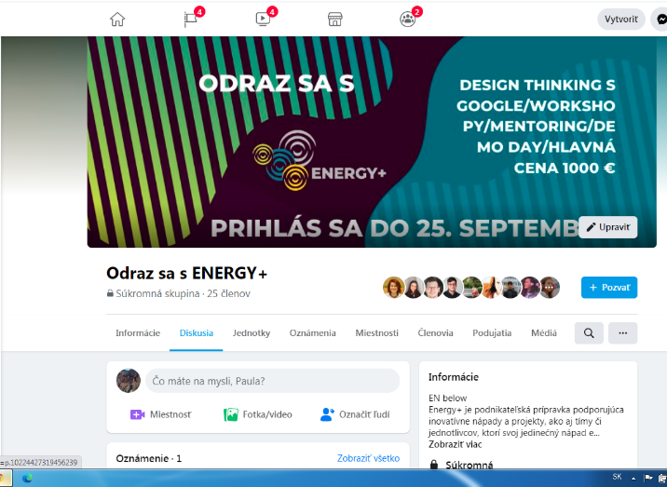
Facebook was used as a main platform for the social media campaign, and a communication channel targeting potential young innovators, informing them about the benefits of the program and reasons to apply. The public Facebook group was created to gather interested individuals and provide them with the necessary information. The promotional material such as the Energy+ video and program-related messages were posted in several Facebook groups and pages, particularly targeting student, innovation and green communities.
Application phase
The Slovak Call for Young Innovators was initially opened in January 2020 and was meant to last until beginning of March 2020. Due to the pandemic, however, the Pilot was pushed forward to the Fall of 2020 while the call remained open until September 28th, 2020. The applications were collected through the F6S platform which represented a useful and easily accessible tool to consequently assess the received applications. The Open Call for mentors and experts ran in two rounds and followed the Slovak national rules of public procurement, which also meant a new set of Call documents had to be produced to be in line with the rules. First one, for the common workshops, was launched in July with a winner – Podnikni.to - being selected in August. A second call, for 3 individual mentors was launched in the end of August and closed in September. Both the mentors and experts were also asked to act as the selection jury for the applications. Out of the 37 applications started on F6S, 23 were finalized by the deadline and 19 were approved by the evaluation committee. This number represent both teams and individuals, so the total number of applied participants was somewhat higher. The 19 participants and teams invited into the program, settled in 9 teams representing 9 ideas. At Demo Day, 8 ideas (in total 14 individuals) pitched their ideas with the focus on following fields: waste management, circular economy, green consumer products and services, water management, arboriculture and home planting.
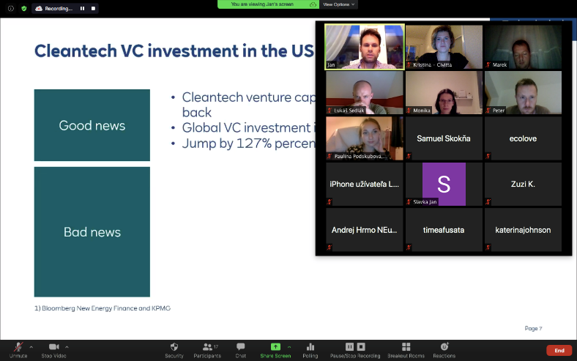
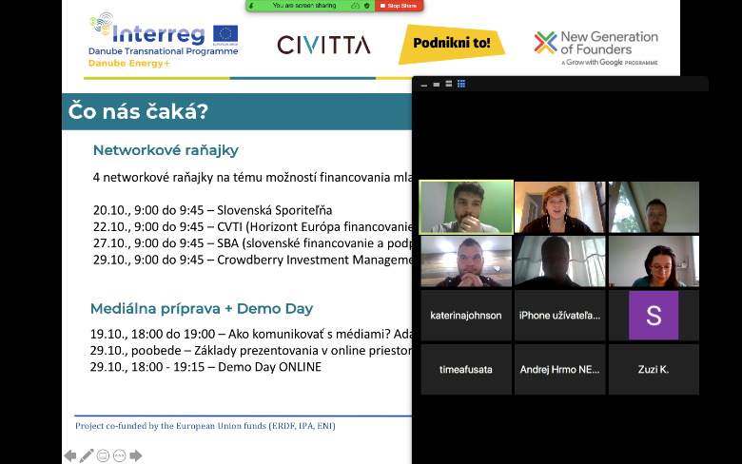
Training phase

The Slovak Pilot program “Energy+” was carried out in collaboration with the Czech company Podnikni.to that specializes in the organization of programs for young entrepreneurs. The whole program was implemented virtually through weekly Zoom meetings and the communication took place in the dedicated Facebook group. Energy+ Slovakia was kicked-off by the Creative Thinking Workshop delivered by Google New Generation of Founders. The workshop ushered the participants into the field of sustainability, energy efficiency and green solutions and guided them through the method of Design Thinking. Consequently, the participants got on board of the 8-weeks-long program composed of weekly entrepreneurship sessions, individual mentoring sessions, special workshops with experts, communication workshop and Demo Day.
Despite 1 participant (representing 1 idea) dropping out during the process, the program was met with a great success. The rest of YIs dutifully attended the weekly entrepreneurship sessions, guiding them through ideation, problem and solution validation, business planning, pitching etc. On top of the weekly sessions, participants had a chance to attend special online workshops with experts from different fields. These included a workshop with Jan Porvaznik – an energy expert providing insights into the energy sector, energy efficiency, renewables and alternative energy sources; and the communication workshop with actress Lucia Hurajova who helped the participants with communication styles in order to perfect their pitching skills. Furthermore, YIs discussed their ideas with a mentor during 1-on-1 sessions, to become fully prepared for the Slovakia Energy+ Demo Day.
Slovakia Energy+ Demo Day took place online on October 29 via Zoom platform and was live-streamed to Facebook. The session was initiated with an introduction of Danube Energy+ Project and welcoming the 14 YIs representing 8 ideas as well as 3 jury members. YIs pitched their ideas within 5-minute slots (3-minute pitching and 2-minute Q&A) which were consequently assessed by the jury to identify the best idea.
8 ideas that were pitched:
- StromECO – Sustainable and efficient way to arboriculture.
- Nature online – virtual tool for exploring the national nature.
- Veggie Town – zero-waste fastfood
- EnviroLEGAL – legal consultancy for efficient and sustainable waste management
- EcoLove – special reusable cups
- Neuteč – rain garden for smart water management
- Cultiva – hydroponics systems for growing at home
- Pomoduomo – wooden geodetic greenhouse with automatic functions

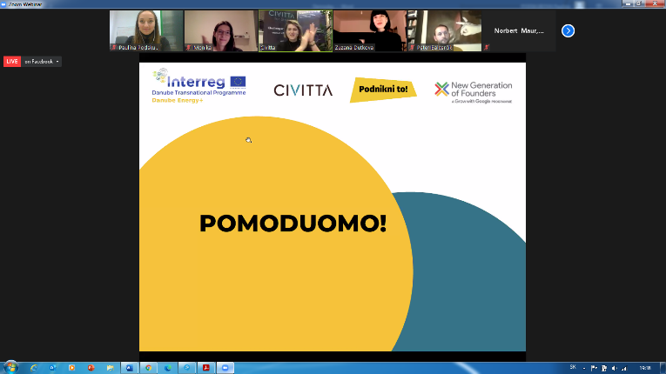
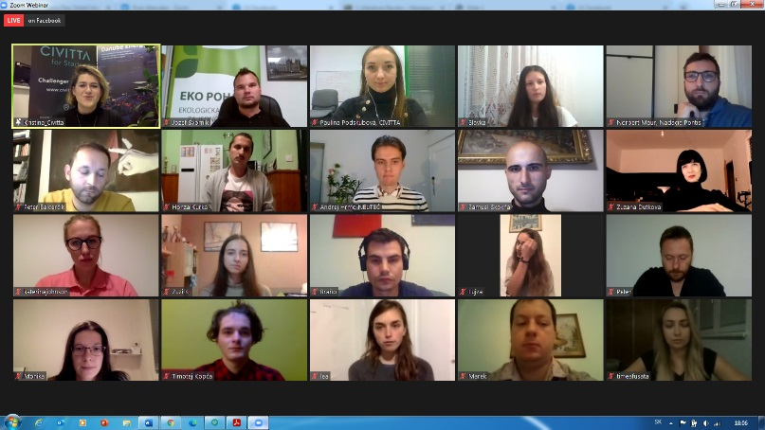
The event was concluded with revealing the leading idea and final remarks. Overall, Slovakia Energy+ Demo Day was viewed positively not only by the participants but also resonated with the public which was demonstrated by more than 360 stream views.

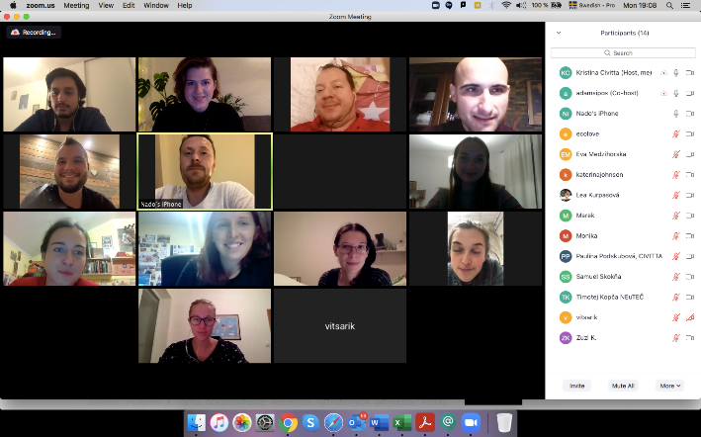
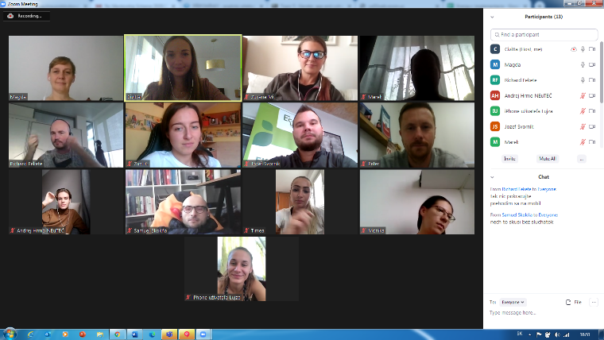
Connecting events

Program was accompanied by 5 connecting events with members of the RA and the representatives of considerable ecosystem entities. Due to the pandemic, all connecting events took place online in a form of 1-hour casual meetings. During these, YIs were presented with useful information about the entrepreneurship sector and had a chance to ask questions or discuss the relevant matters with the representatives. First connecting event was a session with Adam Sipos – a media expert providing information about the right ways to approach media and to establish credible media presence. Second connecting event represented an opportunity to meet representatives from Slovenska Sporitelna and discover options for bank financing of the sustainability projects. Third connecting event with Centrum vedecko-technologickych informacii provided insights into the possibilities of financing from the EU resources. Next connecting event with Slovak Business Agency introduced the organization as well as the helpful services it has to offer. Final connecting event with the VC fond Crowdberry allowed for the familiarization with venture capital. All 5 connecting events, therefore, represented a valuable opportunity for YIs to gain more knowledge and skills from the entrepreneurial world, and to get worthwhile contacts.

- Outcomes
- Effectiveness of applied methods for reaching out to YI
The implementation of the pilot scheme of the project was organized in early 2020 in compliance with the project schedule. However, the actual implementation was suspended and carried out in autumn, due to the Covid-19 pandemic. Despite all the difficulties brought about the pandemic and governmental measures, the team of Civitta Slovakia managed to choose the right approach to reach out to YIs and motivate them to apply. The employment of methods that would appealingly claim the program benefits was essential for persuading YIs to join the program. Therefore, Civitta Slovakia exerted significant effort and used various channels to appeal to Slovak YIs so that their potential for the region could be unlocked. The activities involved:
- Using the well-established contacts with leading universities for program promotion;
- Closer collaboration with the entrepreneurial-focused high-school LEAF Academy
- Delivering a motivational online webinar
- Networking with local ecosystem
- Communicating the program on social media, particularly posting on several Facebook pages and in relevant Facebook groups
Only part of these activities (2 visits to CS Lewis High School, Primer Demo Day, visit to SPU) was carried in person since they happened before the implementation of the country preventative measures. However, the following online activities proved to be similarly successful and engaging. Especially the motivational webinar with almost 500 views helped to generate awareness of the program and alongside the other activities represented a successful call to action.
Some a priori promising methods, such as a close collaboration with student unions of technical disciplines – BEST or IAESTE – proved to be less effective as the representative of these organizations were not convinced of the entrepreneurial education benefits.

- Lessons learned from the pilot from different perspectives
- General – from the perspective of the PPs – organizer
Application phase: The F6S platform proved to be a useful and efficient tool for receiving applications. It is true that there were some minor problems attached to the use of F6S platform. Particularly, some of the registration questions were unnecessary, especially in the case of very early-stage ideas, and some applications were received from ineligible regions since F6S is an open platform. However, this platform allowed for straightaway assessment of the applications and enabled the mentors to easily choose the program participants.
Training phase: The decision to organize the training sessions in collaboration with Podnikni.to was a great choice to make. The program they delivered was based on the developed Danube Energy+ Tool document, was structured in a meaningful way and accommodated all ideas. Despite the fact that YIs joined the program with their ideas being on different levels, the sessions were equally useful for everyone and all ideas recorded some progress. Additionally, the workshops with external experts represented an appreciated contribution to the program that enlivened the structure and broadened participants’ knowledge.
The main positive and negative points concluded from Demo Day are as follows:
- All participants successfully pitched their ideas.
- All teams managed to answer the questions relating to their idea, thus demonstrating a good basis for further development.
- All teams recorded significant progress, picked up entrepreneurial skills and gained valuable connections.
- Due to the pandemic, teams were not able to meet the experts in person or experience the atmosphere of physical Demo Day
- Feedback from YIs (general)
Application phase. The opportunity to participate in the program drew interest of younger cohort. However, their decision to join the program was often hindered by the concerns about lack of expertise or creativity, lack of time and unwillingness to commit for a longer time.
Training phase included several highlights as noted by YIs:
  - Teams appreciated the sessions which provided insights into media and pitching techniques as many of the teams were not used to public presenting
  - Particularly the session on business modeling and the one on validation were evaluated very positively – YIs appreciated the new perspectives on how validation can be done without large funds spent
  - All teams highlighted connecting events and associated opportunities to network with experts from the business world
The following general feedback from the participants was collected (good and bad):
- The sessions and gradual development of their ideas helped them to overcome their fears
- They had a chance to discover new ideas and broaden their horizons
- They learn about funding options directly from the relevant entities responsible for the management of such funds

- YIs perceived that often there was not enough time
- The possibility to meet in person and experience some of the workshops physically would be welcomed
- Teams would appreciate more opportunities for individual work

Connecting events: These sessions enabled YIs to meet representatives from 5 business and entrepreneurship-related entities. Besides gaining valuable contacts, YIs also gained insights into these organizations and deepened their knowledge of existing opportunities to further develop and finance their projects.
- Feedback from other stakeholders (incl. mentors)
Connecting events: The representatives of RA institutions and mentors providing individual mentoring sessions concluded that
- YIs had well-prepared ideas demonstrating a lot of passion
- YIs managed to do big leaps forward with little feedback – they were indeed taking the feedback to heart and showing willingness to learn
- YIs behaved proactively, were curious and open-minded

- Success stories and regional impact
As Slovakia finished the programe just one week before this material was compiled, it is too early to describe any additional success stories
- Impact on other stakeholders (e.g. learning)
RA members and their representatives present at the connecting events also benefited from the sessions. Thanks to the events they acquainted themselves with a new generation of young innovators. They had a chance to explore the areas of their focus and interest, to understand their needs and motivations, and to reveal the potential problems.

- Interviews with participating YI and their short idea “pitches” –
Young innovators from Slovakia made following remarks on their participation in the Danube Energy + program:
StromECO: Project delivering a solution for efficient and sustainable arboriculture.
“Energy+ helped us to use the Grow with Google method to find an idea that would suit our diverse team.”
Nature online: Virtual tool navigating people through and helping them explore the natural wonders in Slovakia.
“As a non-etrepreneur, I struggled with finding a business model but I think now I am on the right track!”
Veggie Town: Zero-waste fast-food selling baked vegetables in edible boxes.
“Thanks to the program, I found the courage to test my idea on a small scale.”
EnviroLEGAL: Legal consultancy helping companies to adopt smart waste management.
“We were able to add another layer to our business idea.”
EcoLove: Special reusable plastic cups that are further recyclable.
“It was difficult to present the idea publicly but we’re glad we have the experience.”
Neuteč: Non-profit project delivering the concept of rain gardens for sustainable water management.
It made us discover what we are lacking and that we can’t be sure of anything.”
Cultiva: Smart hydroponics system for growing greens and vegetables at home.
“I finally found the right message I could deliver to my clients.”
Pomoduomo: Wooden geodetic greenhouse with automatic systems for ventilation and irrigation.
“ Energy+ helped me to discover the funding options that I had little idea about before.”

