A.1 Template for scenario analysis
Project Number | DTP1-1-037-3.1
Project Name | CompreHensive Elaboration of STrategic plaNs for sustainable Urban Transport
Project Acronym | CHESTNUT
Work package | WP3 - Transnational strategy
Activity | Activity 3.2 – Elaboration of Transnational Strategy (based on mobility scenarios)
Title of Working Document | Analysis Methodology for Concequences
WP responsible partner | Pannon Business Network - PP8
Dissemination Level | Public
Date of Preparation | 15.11.2017.
This document must be referred to as
Author | Miklos Radics
Contributors | Viktor Merker, Ors Szokolay

Document History
Version | Date | Note
Template | 02.10.2017 | Template by Takeru Shibayama (VUT)
Scenario | 15.11.2017 | by Miklos Radics

1. Information about this test scenario
FUA Name | Budapest 14
Scenario Name | Scenario 01 - Business-as-usual scenario
Date | 15.11.2017.
Policy target year | 2030
Contributor | Viktor Merker, Ors Szokolay

2. Describe this scenario
- Max. in 10 lines
In this test scenario, it is assumed that Zuglo follows Budapest’s SUMP (Balazs Mor Plan, BMT). BMT set up overarching goals and targets for a livable capital city and for a sustainable transport system. The district will follow the directions of Budapest’s SUMP. Every decision and measure will be made according to BMT.
Main focus areas of scenario 01 are:
- Better connection between different modes of transport, intermodality
- Better walking and cycling facilities
- More attractive PT services and vehicles
- More effective institutional background
- Continuous feedback analysis and monitoring

3. Assessment of consequences
How will the demographic structure of your FUA and the core city in it be in your planning horizon around 2025 to 2030? (No of population, age structure, etc.)
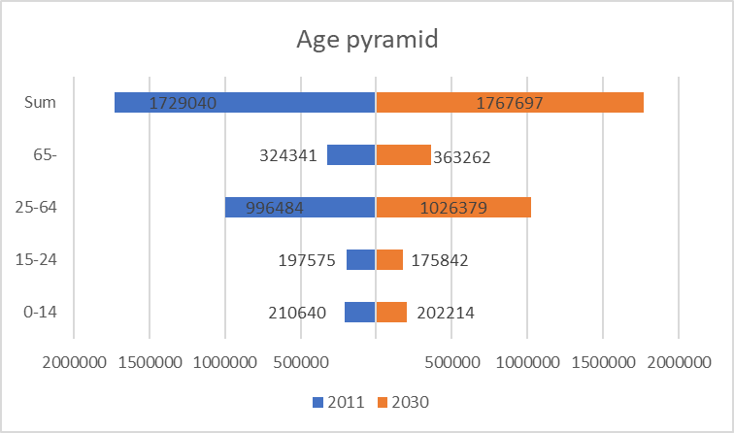
Source: KSH and Budapest 2030 strategy

Which types of transport technology will have been diffused or will disappear in your FUA in your planning horizon around 2025 to 2030?
According to Budapest’s SUMP by 2030 private car use will drop dramatically and bicycle use will increase. Five times more people will use bicycle for daily commuting than in 2014.

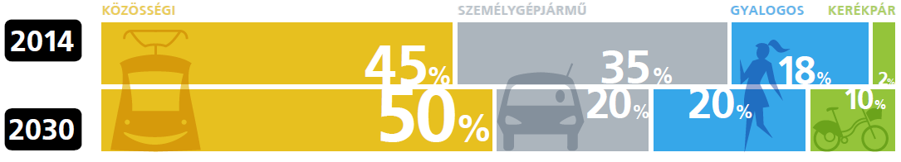

How will the share of transport mode change in your core city and FUA? Will there be higher share of journey with cars or less? Will it increase or decrease the share of public transport? Will there be more cyclists and walkers, or less?
Modal share in 2014 and 2030:

Which part of your future prediction is not in line with upper-level transport policy (of region, country and EU)?
This scenario is in line with upper-level strategic documents and policy on national and EU level as well.

Is the overall situation improving the living quality of your FUA?
As private car use will drop and cycling, walking and public transport use will increase the overall situation will improve by 2030.
The primary cause of noise pollution in Budapest is traffic. By reducing private car use our streets will be safer and quieter by 2030.

What are the effects on particular demographic groups, such as children, elderly, low-income group, foreigners and migrants, students, mobility-impaired people, etc.?
Facilities for walking and cycling will improve by 2030. Conditions will be better for children, elderly and mobility-impaired people as a result of developments for a walkable and bicycle-friendly Budapest and barrier-free access and PT vehicles.

How will the transport-related cost paid by each end user change? How will the transport-related cost paid by your municipalities or regional government change?
Costs of public transport should be attractive for users, especially for low-income demographic groups. Calculations are not available to forecast the exact costs that should be covered by the state or by passengers.

Will the overall change will lead to increase or decrease of transport-related energy consumption in your FUA?
Transport related energy consumption will drop by 2030 as a result of higher share of active modes of transport and more efficient PT and private vehicles.

Will the overall change will lead to increase or decrease of transport-related CO2 emission in your FUA?
Transport related CO₂ emission will decrease by 2030.

1. Information about this test scenario
FUA Name | Budapest 14
Scenario Name | Scenario 2 - Fostering “active” transport modes (walking and cycling)
Date | 15.11.2017.
Policy target year | 2030
Contributor | Vktor Merker, Ors Szokolay

2. Describe this scenario
- Max. in 10 lines
In this test scenario, it is assumed that Zuglo follows Budapest’s SUMP (BMT). Besides this, Zuglo fosters active transport modes such as walking and cycling based on Zuglo’s bike-friendly development plan. Instead of the targets of BMT, Zuglo will further increase the share of cycling and walking.
Main focus areas of scenario 02 are:
- More attractive streets for cycling and walking
- Traffic safety
- Continuous cycling network, green ways
- Better bike parking facilities
- Better conditions for elderly and mobility-impaired people, accessible streets
- Short-distance journeys will be promoted

3. Assessment of consequences
How will the demographic structure of your FUA and the core city in it be in your planning horizon around 2025 to 2030? (No of population, age structure, etc.)
We assume that the demographic structure will be the same by 2030 as in scenario 01.

Source: KSH and Budapest 2030 strategy

Which types of transport technology will have been diffused or will disappear in your FUA in your planning horizon around 2025 to 2030?
Private car use will drop radically and bicycle use and walking will increase.

How will the share of transport mode change in your core city and FUA? Will there be higher share of journey with cars or less? Will it increase or decrease the share of public transport? Will there be more cyclists and walkers, or less?
Modal share in 2014 and 2030:

Which part of your future prediction is not in line with upper-level transport policy (of region, country and EU)?
This scenario mostly is in line with upper-level strategic documents and policy on national and EU level as well. Zuglo will promote active modes of transport with a greater emphasis than it is required by upper-level policies.

Is the overall situation improving the living quality of your FUA?
As private car use will drop and cycling, walking will increase the overall situation will improve by 2030.
The primary cause of noise pollution in Budapest is traffic. By reducing private car use our streets will be safer and quieter by 2030.

What are the effects on particular demographic groups, such as children, elderly, low-income group, foreigners and migrants, students, mobility-impaired people, etc.?
Facilities for walking and cycling will improve by 2030. Conditions will be better for children, elderly and mobility-impaired people as a result of developments for a walkable and bicycle-friendly Budapest.

How will the transport-related cost paid by each end user change? How will the transport-related cost paid by your municipalities or regional government change?
Costs of public transport should be attractive for users, especially for low-income demographic groups. Calculations are not available to forecast the exact costs that should be covered by the state or by passengers.

Will the overall change will lead to increase or decrease of transport-related energy consumption in your FUA?
Transport related energy consumption will drop by 2030 as a result of higher share of active modes of transport and more efficient PT and private vehicles.

Will the overall change will lead to increase or decrease of transport-related CO2 emission in your FUA?
Transport related CO₂ emission will decrease by 2030.

1. Information about this test scenario
FUA Name | Budapest 14
Scenario Name | Scenario 3 - Optimization of road network for automobiles (GROUP 1)
Date | 15.11.2017.
Policy target year | 2030
Contributor | Viktor Merker, Ors Szokolay

2. Describe this scenario
- Max. in 10 lines
In this test scenario, it is assumed that Zuglo will focus on optimizing its road network. Technological progress will have a positive effect on traffic safety and capacity (e. g. ITS solution, autonomous vehicles). Promoting renewable energy and intelligent solutions will lead to environmentally clean urban traffic flow (e. g. air and noise pollution).
Main focus areas of scenario 03 are:
- Optimization of motorized traffic flow
- ITS solutions: capacity optimization, traffic management
- Electric mobility
- Better parking facilities
- Traffic safety

3. Assessment of consequences
How will the demographic structure of your FUA and the core city in it be in your planning horizon around 2025 to 2030? (No of population, age structure, etc.)
We assume that the demographic structure will have been the same by 2030 as in scenario 01.

Source: KSH and Budapest 2030 strategy

Which types of transport technology will have been diffused or will disappear in your FUA in your planning horizon around 2025 to 2030?
Private car use will have been increased a bit, just as cycling and walking. Public Transport will have been dropped as a result lack of developments.

How will the share of transport mode change in your core city and FUA? Will there be higher share of journey with cars or less? Will it increase or decrease the share of public transport? Will there be more cyclists and walkers, or less?
Modal share in 2014 and 2030:

Which part of your future prediction is not in line with upper-level transport policy (of region, country and EU)?
This scenario mostly is in contrary with upper-level transport policy. Instead of reducing car traffic and promoting sustainable modes car use will increase by 2030.

Is the overall situation improving the living quality of your FUA?
As private car use will increase the overall situation will be worse by 2030 than it is now.
Even if the share of e-vehicle will increase, noise and air pollution will be higher.

What are the effects on particular demographic groups, such as children, elderly, low-income group, foreigners and migrants, students, mobility-impaired people, etc.?
Wider and busier roads mean worse accessibility for mobility-impaired people. Private car use is an expensive mode of transport therefore low-income groups can’t afford it, they will have to use PT suffering from lack of resources and developments.

How will the transport-related cost paid by each end user change? How will the transport-related cost paid by your municipalities or regional government change?
Costs of public transport should be attractive for users, especially for low-income demographic groups. Calculations are not available to forecast the exact costs that should be covered by the state or by passengers.

Will the overall change will lead to increase or decrease of transport-related energy consumption in your FUA?
Transport related energy consumption will increase by 2030 as a result of higher share of private motorized vehicles.

Will the overall change will lead to increase or decrease of transport-related CO2 emission in your FUA?
Transport related CO₂ emission will increase by 2030.

1. Information about this test scenario
FUA Name | Budapest 14
Scenario Name | Scenario 4 - Very high cost of energy (fuel and electricity) (GROUP 2)
Date | 15.11.2017.
Policy target year | 2030
Contributor | Viktor Merker, Ors Szokolay

2. Describe this scenario
- Max. in 10 lines
This scenario differs from the other scenarios regarding its structure. It assumes that energy and fuel prices will increase and mobility will thus become more expensive. Whereas the other scenarios focus on particular modes, in this case the changing context conditions and the emerging adaptation strategies are in the foreground. The focal points of this test scenario are the support for electric mobility, inter- and multi-mobility and mobility management.
Main focus areas of scenario 03 are:
- Reduced private car use, increased car occupancy
- Longer journey: walking, cycling
- Mobility management

3. Assessment of consequences
How will the demographic structure of your FUA and the core city in it be in your planning horizon around 2025 to 2030? (No of population, age structure, etc.)
We assume that the demographic structure will have been the same by 2030 as in scenario 01.

Source: KSH and Budapest 2030 strategy

Which types of transport technology will have been diffused or will disappear in your FUA in your planning horizon around 2025 to 2030?
As fuel prices will dramatically increase by 2030 private motorized traffic will drop. Walking and cycling will increase. The government at local municipality will try to provide high level of service public transportation.

How will the share of transport mode change in your core city and FUA? Will there be higher share of journey with cars or less? Will it increase or decrease the share of public transport? Will there be more cyclists and walkers, or less?
Modal share in 2014 and 2030:

Which part of your future prediction is not in line with upper-level transport policy (of region, country and EU)?
The results of this test scenario are mostly in line with upper-level transport policy: reducing car trips and increasing PT, walking and cycling.

Is the overall situation improving the living quality of your FUA?
The primary cause of noise pollution in Budapest is traffic. By reducing private car use our streets will be safer and quieter by 2030.

What are the effects on particular demographic groups, such as children, elderly, low-income group, foreigners and migrants, students, mobility-impaired people, etc.?
Facilities for walking and cycling will improve by 2030. Conditions will be better for children, elderly and mobility-impaired people as a result of developments for a walkable and bicycle-friendly Budapest.
Mobility related costs will be higher than low-income people can afford therefore municipality will have to introduce special prices for them.

How will the transport-related cost paid by each end user change? How will the transport-related cost paid by your municipalities or regional government change?
Costs of public transport should be covered by the government, especially for low-income demographic groups because of the high cost of mobility.

Will the overall change will lead to increase or decrease of transport-related energy consumption in your FUA?
Transport related energy consumption will drop by 2030 as a result of higher share of active modes of transport and more efficient PT and private vehicles.

Will the overall change will lead to increase or decrease of transport-related CO2 emission in your FUA?
Transport related CO₂ emission will decrease by 2030.

