Creative Danurban Competition
Second stage application form

Table of Contents

1 Table of Contents 2
2 Introduction 4
3 Information on the application 5
3.1 Category 5
4 Problem description – up to 10 points 5
5 Resolving the problem – up to 15 points 6
6 Activities to resolve the problem – up to 25 points 7
6.1 Business canvas 7
6.1.1 Key partners 7
6.1.2 Key activities 7
6.1.3 Key resources 7
6.1.4 Key propositions 7
6.1.5 Customer relationships 7
6.1.6 Channels 7
6.1.7 Customer segments 7
6.1.8 Cost structure 7
6.1.9 Revenue Streams 7
6.2 Project proposal canvas 8
6.2.1 Key partners/consortium 8
6.2.2 Key activities 8
6.2.3 Key resources 8
6.2.4 Value propositions 8
6.2.5 Urban dimension 8
6.2.6 Impact/exploitations 8
6.2.7 Stakeholders 8
6.2.8 Financing / budgeting 8
6.2.9 Dissemination 8
6.3 Event canvas 9
6.3.1 Key partners of the event, stakeholders and early adopters 9
6.3.2 Key activities 9
6.3.3 Key resources 9
6.3.4 Value propositions 9
6.3.5 Urban dimension 9
6.3.6 Impact/exploitations 9
6.3.7 Attendees 9
6.3.8 Financing / budgeting 9
6.3.9 Dissemination 9
7 Conclusions 10

Introduction
This document is the 2nd stage template for the contestants of the Creative Danurban Competition. The competitors of the 2nd stage are to fill in the chapters below.

Information on the application

Title of the project:
Name of the contesting team:

Category

Category: (select one, the same as in EOI)
Urban regeneration
Spaces and places
Coming and going

Problem description – up to 10 points

Describe the problem you are addressing and its imporance for the city you are resolving it for: (max one full page)

Resolving the problem – up to 15 points

Describe the problem you are addressing and its imporance for the city you are resolving it for: (max one full page) – up to 10 points

Activities to resolve the problem – up to 25 points

Activities needed to resolve the problem: (select one, the same as in EOI) |  | If selected
Business canvas, for business idea |  | Fill in chapter 6.1
Project canvas, for project idea |  | Fill in chapter 6.3
Event canvas, for event idea |  | Fill in chapter 6.3

Based on the selected type of activities, the contestants fill in either subchaper 6.1 for business idea, either subchaper 6.2 for project idea, or subchaper 6.3 for event idea. Only one of the three is mandatory and core part of the application. Evaluators evaluate it with up to 25 points.

Business canvas
Chapter is not to exceed 3 pages in length.

Key partners

Key activities

Key resources

Key propositions

Customer relationships

Channels

Customer segments

Cost structure

Revenue Streams

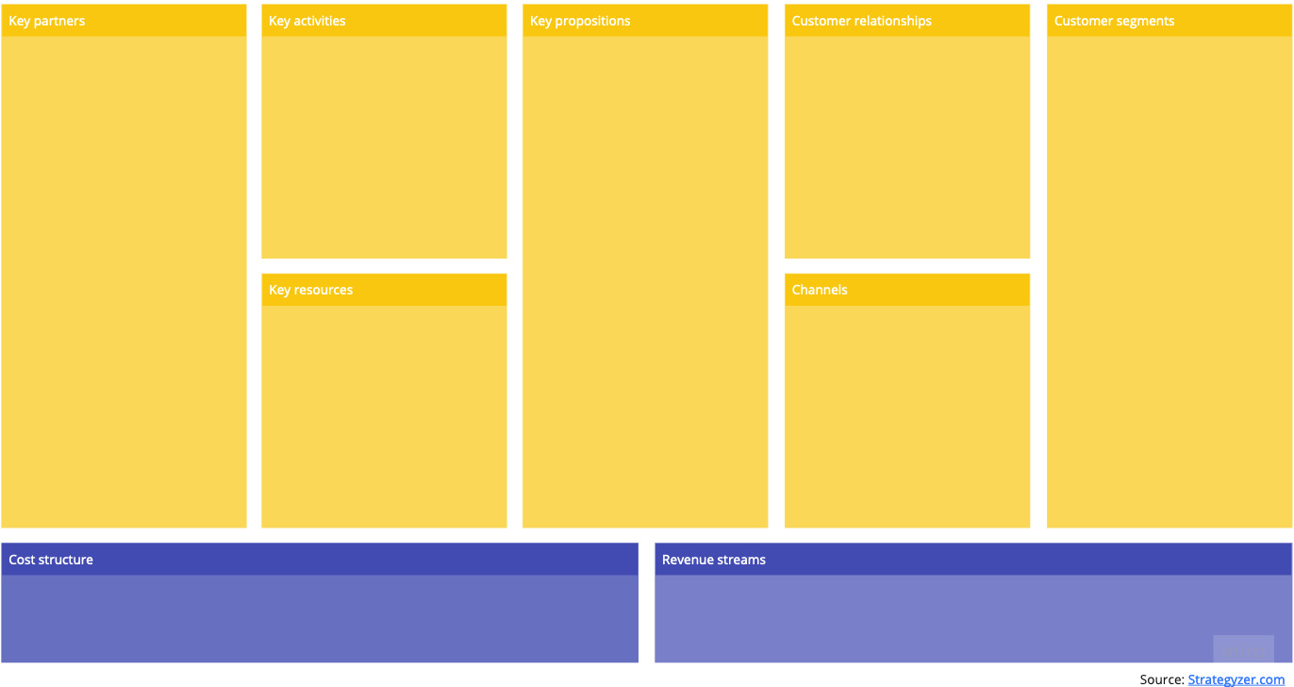

Project proposal canvas
Chapter is not to exceed 3 pages in length.

Key partners/consortium

Key activities

Key resources

Value propositions

Urban dimension

Impact/exploitations

Stakeholders

Financing / budgeting

Dissemination

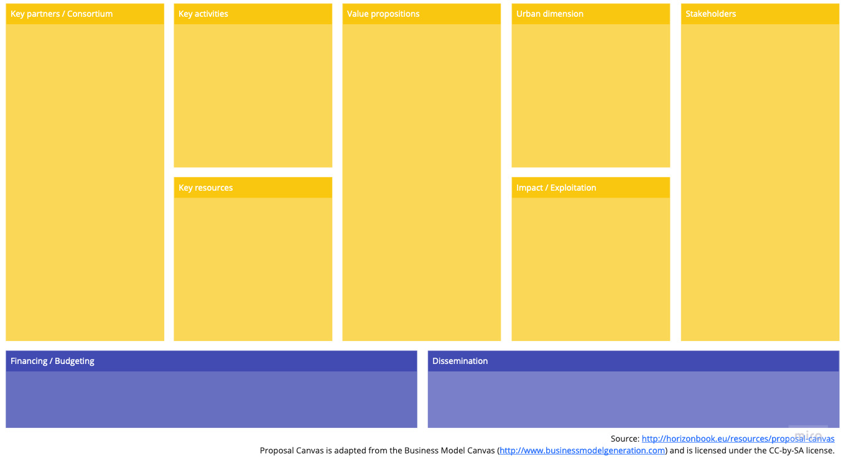

Event canvas
Chapter is not to exceed 3 pages in length.

Key partners of the event, stakeholders and early adopters

Key activities

Key resources

Value propositions

Urban dimension

Impact/exploitations

Attendees

Financing / budgeting

Dissemination

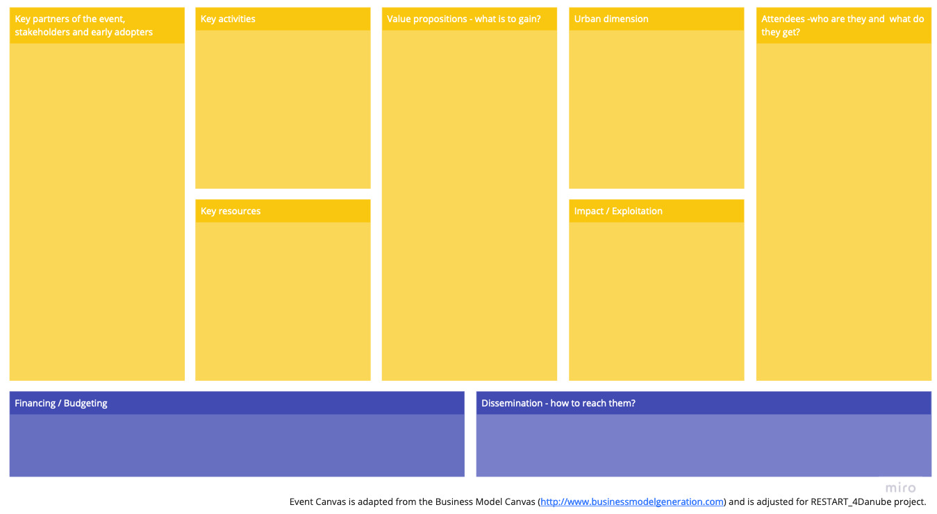

Conclusions

The content of this document is to be submitted to restart.4danube@fuds.si by 1. 7. 2022.

