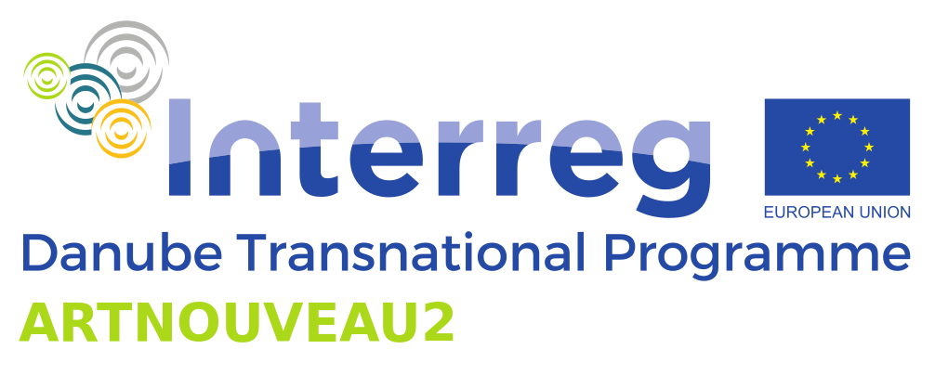

ARTNOUVEAU2

Strengthening the cultural identity of the Danube region by building on common heritage of ART NOUVEAU

The present project ARTNOUVEAU2 Strengthening the cultural identity of the Danube region by building on common heritage of ART NOUVEAU is part of the European Union Interreg Danube Transnational Program which began in July 2020 as a continuation of the project ART NOUVEAU - Sustainable protection and promotion of Art Nouveau heritage in the Danube Region, which lasted from 2017 to 2019.
The leading partner is the City of Oradea (Oradea Municipality), and the other partners in the project are Oradea City Museum – Cultural Complex, (Romania) National Institute of Heritage, Bucharest, (Romania) IMM, Budapest, (Hungary), Museum of Arts and Crafts, Zagreb (Croatia), MAK, Vienna (Austria), Slovak University of Technology, Bratislava (Slovakia), Republic Institute for Protection of Cultural Monuments, Belgrade, (Serbia), and Kodolányi János University, Budapest (Hungary)

The aim of the project is to strengthen the cultural identity and heritage of Art Nouveau in the Danube region, and it will be implemented through an educational program, exhibitions, a series of online lectures, tourist guides, catalogues, short films and more.
Art Nouveau is certainly part of the history and everyday life of the cities in the Danube region and hopefully it will be an integral part of its future.
ARTNOUVEAU2 embarks on responsibly and sustainably using the AN cultural heritage as a vehicle for strengthening regional cultural identity and for stimulating economic growth in the Danube Region.
The partnership between partners involved in this project aims at achieving notable results in creating transnational professional cooperation in the field of Art Nouveau. Project also identifies challenges faced by the communities sharing AN cultural heritage.
Education activities (programs for children, exhibitions and online lectures) will increase the knowledge about the AN in the general public. The gained knowledge is instrumental in changing perception and adjusting attitude towards the AN heritage. Increased knowledge will incite and mobilize greater interest in these ancestral gifts.
It will prompt the general public to recognize, respect, appreciate, protect and take better care of the AN heritage. Ultimately, it will help them (re)define and expand their sense of belonging, showing them that they and their cultural heritage belong to a wider region. The educational experts will use their experience in approaching and maintaining the relationship with the educational institutions and general public. The project will also welcome recommendations of schools to maintain the interest of children and youth.
Also, using digital media, quizzes, social media contests, games, trailers and teasers will be encouraged.
Dissemination activities among professional organizations, local administration, urban planners and (national) policy setting institutions are aimed at increasing their knowledge about AN heritage in the region. Better informed professional community will better protect, manage and promote the AN. The target audience is the professional community. It comprises art historians, curators, urban planners, researchers, and other AN experts and practitioners within and outside the Danube region, local administration as well as national and international policy makers. As the target audience is diverse, project activities and outputs are specially designed to address and to ensure optimal engagement and contribution of each group. The information presented in the digital catalogue will be easily accessible and well-organized. Its promotion will include wide dissemination through partner's internet platforms, news and announcements, professional events and networks. Wide local, national and international promotion of the solutions for urban development will ensure their sustenance and result in high-quality rehabilitation of AN. It may also increase visibility and generate interest of prospective members to learn more or join AN professional community.

To ensure growing appreciation of the local public for the AN heritage and increase its attractiveness to the tourists, each partner will individually work on professionalizing tourist promotion of AN through involvement of the tourism industry, cooperating with tourist offices and services of the region, which can result in economic growth, generate income and stimulate job creation.
For example, every DR city has city tours but the aim of this project is to train tourist guides and to offer tourists and local population specialized tours on AN buildings and architects.
Activities that will contribute to this objective are trainings for tourist guides, surveys and studies of tourists' behavior, as well as promotional campaigns in the tourism industry. The aim of these activities is to change the behavior of the target groups by providing well-presented interesting and factual information and by increasing their knowledge about AN. As a result, tour operators may consider developing and including AN cultural route in their offer or adjusting the existing ones to include the AN monuments. Tourists, as they become more knowledgeable about AN, may initialize and increase the demand for AN cultural heritage tourist offer.
The success of the World Art Nouveau Day which is held on June 10 2021 largely depends on wide publicity and proper advertisement. Thus, a coordinated intensive campaign will be organized in order to ensure a large visibility for these crowning events.

Project co-financed by the European Union funds (ERDF, IPA II).
