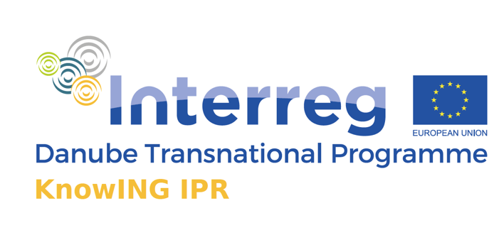

KnowING UXD eWorkshop

“Turning Patent Data into Business Intelligence”

30th of June, 2020

Chisinau, Moldova

_
Venue: Online session, State Agency on Intellectual Property (AGEPI), www.agepi.gov.md, Chisinau, Republic of Moldova

The KnowING IPR project targets the topic of technology transfer, with specific focus towards managing intellectual property rights in SMEs as a factor of innovation and competitiveness.

To this end, the project is developing an institutional platform (supported by an online hub, KnowING HUB) where various stakeholders will be able to access information on the importance of technology transfer, on the protection of intellectual property rights, on the opportunities afforded by the protection of intellectual property rights and on IPR management. In addition, the platform will facilitate and encourage cooperation with research organizations, as we seek to foster cooperation between SMEs and research institutions, while promoting the establishment of good practices in the field of intellectual property rights management. Special notion is given to policy recommendations since the online KnowING HUB will be a meeting point for policy makers to exchange good practices and experiences in implementing IPR in their policies.

The aim of the project is to improve cooperation between educational institutions and SMEs also through empowering actors to identify and exploit the effects of protection of intellectual property rights.

DRAFT AGENDA
08:45 - 09:00 | Registration and networking
09:00 – 09.15 | KnowING IPR project welcome word – AGEPI/Moldova
09:15 – 09:30 | What is KnowING IPR? – Faculty of Information Studies in Novo Mesto/Slovenia
09:30 – 09:45 | UXD workshops – What was the purpose of those UXD workshops? – Heiling und Schubert Softwer AG (H&S )/Austria
09:45 - 10:00 | Which data are retrieved within the web application – University of West Bohemia/ Czech Republic
10:00 – 10.15 | IPR Situation in the Republic of Moldova – AGEPI
10.15 – 10.30 | IPR Helpdesk - EU IP Helpdesk Ambassador, NARD/Moldova
10:30 – 10:40 | Coffee break
10:40 – 11:00 | KnowING IPR web application presentation - H&S
11:00 – 12:00 | Testing the scenarious - H&S
12:00 – 12:15 | Conclusions

The official language of the event is English.

Contact person:
Liliana Vieru, AGEPI
Tel.: +37369336351
E-mail: liliana.vieru@agepi.gov.md

