The INDEED project is launching today a free online learning platform for professional groups involved in the care of people with dementia

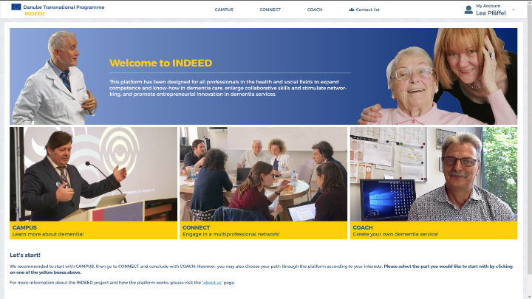
The quality of care for people with dementia and their family caregivers is subpar in many countries of the Danube Region. Often this is due to a lack of dementia-related knowledge and skills among health and social care professionals, insufficient cooperation and coordination between occupations, and shortage of dementia-related facilities and services such as day care centres or specialised nursing home units. In this context, the education of occupational groups working in dementia care is considered to be key for enhancing the quality of life of people with dementia and their carers.
On the INDEED online learning platform, professionals can easily access information about dementia
Since 2018, dementia experts from ten South Eastern European countries are teaming up with entrepreneurs and policy makers to develop a skill-building intervention that addresses all professions involved in dementia care including physicians, nurses, psychologists, social workers, occupational therapists, speech and physical therapists as well as pharmacists.
As a result of these efforts, the INDEED online learning platform “indeed-project.eu” is now freely accessible to all professionals involved in dementia care and all other interested parties.
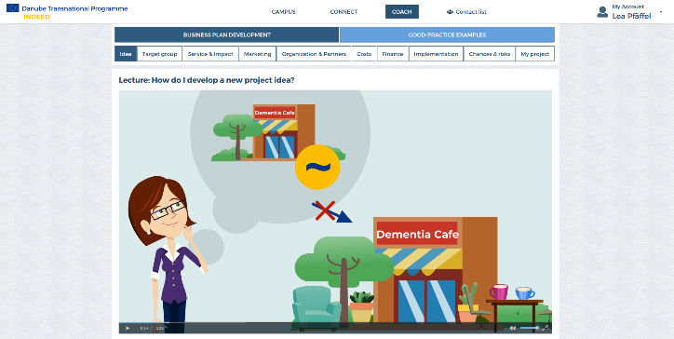
The newly launched INDEED online platform is novel to the Danube Region because it provides a joint knowledge base and a set of shared values in terms of a person-centred and holistic approach in dementia care and offers a toolbox for setting-up dementia-related businesses. The online platform complements existing or emerging dementia strategies in Danubian countries.
The content on the INDEED online platform focuses on person-centred approaches, collaborative care and dementia services

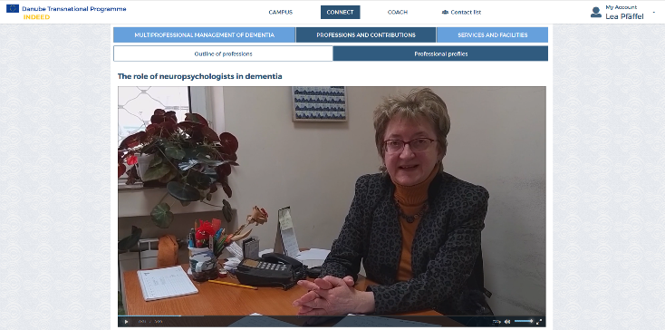
The platform and its educational content are tailored to complement occupation-specific trainings and is based on modern didactic concepts.

Interviews provide hands-on experience from healthcare experts and entrepreneurs

In particular, the online platform features various media including animated videos, interviews, quizzes, infographics, and charts to best meet the informational needs of medical and social care professionals as well as entrepreneurs.
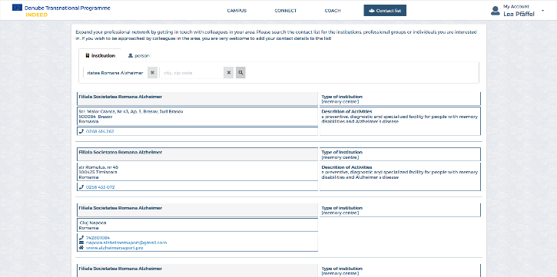
A searchable contact database offers users of the platform to engage with professionals and dementia services in their area.

The contact database facilitates interprofessional collaboration and networking

The online learning platform will subsequently be launched in Bulgarian, Slovenian, Slovakian and Romanian.
You can access the INDEED online plattform here: www.indeed-project.eu
On YouTube you will find two short screencast of the platform:
Screencast “How to use the platform”: https://www.youtube.com/watch?v=OYKY_chRM0o
Screencast “Content of the platform”:
https://www.youtube.com/watch?v=pzNelfIA8k8
Follow the INDEED project on:
Website: http://www.interreg-danube.eu/approved-projects/indeed
Facebook: https://www.facebook.com/MoglanMariaLebu/
Instagram: https://www.instagram.com/indeed_project/
Twitter: https://twitter.com/IndeedProject

