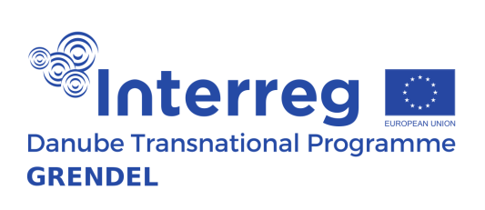
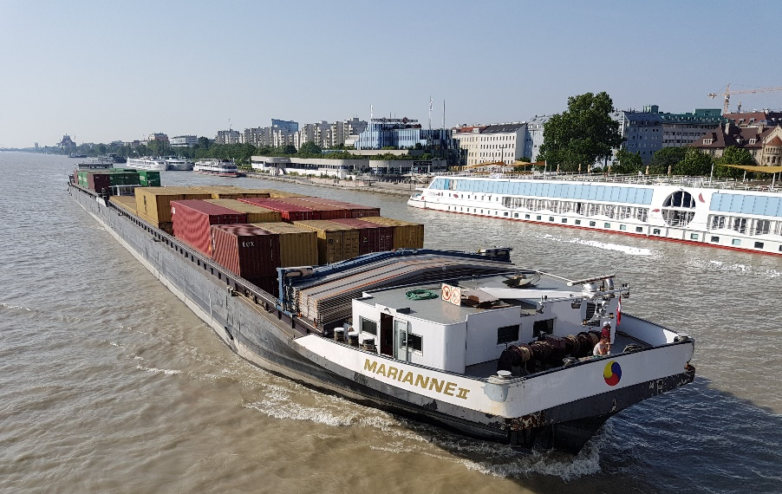

Know-how Transfer Event Modernisation of Danube Vessels Fleet
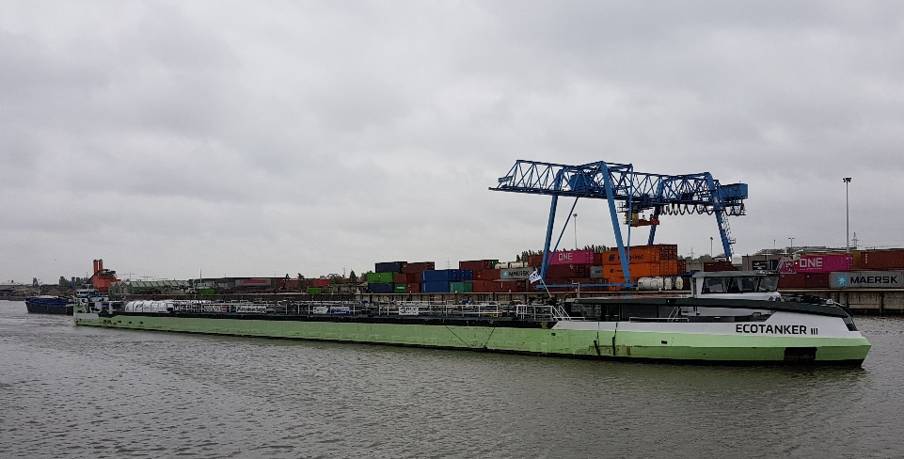

NO_{x}
SO_{x}
CO₂
MY SERVICES

Becoming the world’s first climate-neutral continent by 2050 is a greate challenge and opportunity for Europe. To achieve this, the European Commission presented the European Green Deal, the most ambitious set of measures that should enable European citizens and businesses to benefit from sustainable green transition.
Regarding emissions, a 90% reduction in transport emissions is needed by 2050 to achieve climate neutrality and all transport modes, including inland waterway transport (IWT), will have to contribute to the reduction. As a matter of priority, a substantial part of the 75% of inland freight carried today by road should shift onto rail and inland waterways.
The consortium of the project GRENDEL, together with the innovation centre INDanube and the host “Danube Commission” will organise a further edition of the Know-How Transfer Event for Modernisation of Danube inland vessels. The objective of this event is to raise awareness about technologies and fuels which have potential to reach ‘near zero-emission’ performance of IWT while addressing a carbon neutrality (GHG emissions) and technologies and fuels aiming to achieve at least NRMM Stage V emission performance on NOx and PM. Clean combustion engines using carbon neutral fuels for direct drive, advanced design and engine management technologies and after treatment technologies lead to improved environmental performance of inland vessels. Fuels will gradually convert from fossil fuels to carbon neutral fuels. Hybrid configurations using various technologies for the power generation & storage, is another option increasing environmental performance of inland vessels.
The event will bring together inland vessel operators from the Danube region with technology & innovation experts as well as technology suppliers to debate available technologies which could fit in the transition pathway towards (near) zero emission performance and future alternative solutions which still need further research. Besides technologies, insight into digitalisation aspects leading to paperless sailing and increasing efficiency of transport processes as well outlook to expected funding and financing will be provided.
KNOW-HOW TRANSFER EVENT ON MODERNISATION OF DANUBE VESSELS FLEET

DATE / TIME: Wednesday, 1 April 2020, 09:00 – 17:00
VENUE: Hotel Benczur, Benczur utca 35, 1068 Budapest, Hungary

REGISTRATION: Registration link to the event

By registering, participants agree that their details, name and institution, will be made available in a list of participants. Please note that photographs may be taken at the event. By attending this event, participants freely provide their agreement that they accept to be photographed. The participants also agree that the above-mentioned photos may be used, reproduced, distributed and communicated to the public for the purpose of disseminating the GRENDEL Project.

