

Patenting and IPR management

|  |  |
| --- | --- |
| Travel kit | 6 November 2019 |

***Location of the event:***

School of Advanced Social Studies / Fakulteta za uporabne družbene študije v Novi Gorici,

Gregorčičeva 19, 5000 Nova Gorica, Slovenia

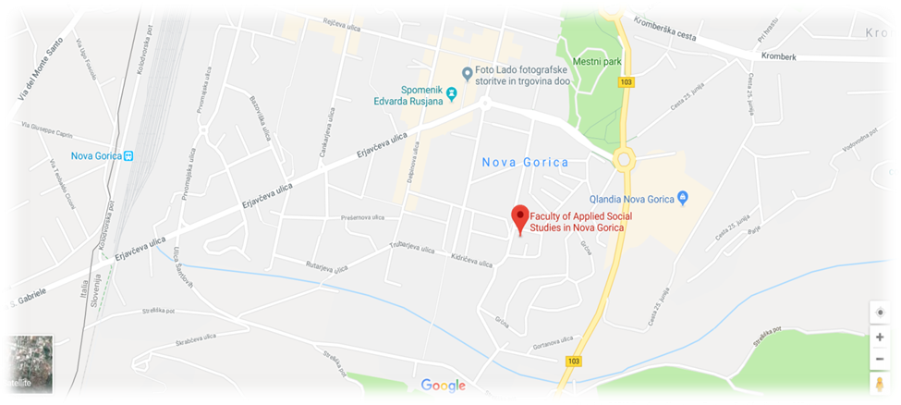

***Travelling to Nova Gorica***

At the border with Italy, Nova Gorica is an easily accessible destination to reach being at the crossroad of several important airports.

[**Ljubljana Airport**](https://www.fraport-slovenija.si/sl/Main) is the main airport in Slovenia with 23 direct connections to European cities. Public bus service no.28 operates to and from Ljubljana airport to Ljubljana Railway Station and runs about every hour. The journey takes 45 minutes, the cost is around 4 Euros and you buy your tickets directly from the driver. There is also a private shuttle service running less frequently, but it's a bit faster. The bus station in Ljubljana is small and situated immediately in front of the railway station. If you take a taxi from the taxi rank in front of the airport it will cost about 35 euros. Nevertheless, there is some private transfer service that can get you to Ljubljana cheaper. Transfer from Ljubljana to Nova Gorica can occur by train or bus. Average time travel is 2 hrs.

[**Venice Marco Polo**](https://www.veniceairport.it/en/) is the international airport for national and international flights with over 60 direct connections to European and international destinations, being the third Italian system after Rome and Milan. Transfer from Venice Marco Polo to Nova Gorica has an average duration of 3 hours and several means of transportation are available on the web page BUS RADAR.

[**Venice Treviso Airport**](https://www.trevisoairport.it/en/) is a secondary destination within the network of the Venice Marco Polo airport. Options for transfer to Nova Gorica are available www.suntransfers.com.

[**Trieste Ronchi dei Legionari**](https://triesteairport.it/sl/) is the closest airport to Nova Gorica (approx. 30 km). 9 destinations have direct connection to the Trieste airport (Rome, Naples, Munich, Frankfurt, Milan, London, Bari, Catania and Valencia).

For transfers from airports to Nova Gorica, you can use:

* [GoOpti](https://www.goopti.com/en/) is a service for shared and private airport transfers that covers all of the above airports at reasonable prices. The service provides comfortable, flexible and affordable transfers based on on-line bookings.
* [Nomago](https://shuttle.nomago.si/si/domov) shuttles.

***Getting around Nova Gorica and surroundings***

In Nova Gorica bus transport in the city area is free of charge. You can find information about timetables and bus lines on Avrigo. There is also an international bus line connecting Nova Gorica and Gorizia (Italy). The price for 1 trip is EUR 1.30.

**Taxi service in Nova Gorica:**

Taxi center 070 222 777 (they can also pick you up at the airport of Trieste)

From Gorizia Train station you can call a taxi from the numbers available on the spot.

**Inter-city travelling:**

To travel between cities, you can use bus or train services.

Bus services between cities:

For information about bus services and timetables of buses in Slovenia you can consult the [AP Ljubljana web page](https://www.ap-ljubljana.si/en/).

**Train services:**

* For more information about connections and prices check the [Slovenian Railways web page](https://www.slo-zeleznice.si/sl/).
* Also Gorizia (IT) is very close and you can use train service in Gorizia. Please refer to the [Trenitalia web page](https://www.trenitalia.com/).

***Accommodation in Nova Gorica***

Hotels in Nova Gorica:

**Hotel Park (the closes to the meeting venue – 5 min walk offering a special price for FUDŠ)**

Hotel Perla

Hotel Sobotin

Hotel Lipa

Hotel Enturage, Gorizia

Private accommodation available on Booking.com or AirB&B

***What can you see and do in Nova Gorica and surroundings***

Nova Gorica is the “youngest Slovenian” town. It is a small town at the border with Italy that has been the heart of the Goriška region for seven decades. It has grown after World War II as a substitute of Gorizia, which remained on the other side of the border. It is a town with a mild climate, green and blooming all year round, young, lively and friendly to the local people and visitors from all over the world. As a unique example in Europe, the two towns are located at the border with no border crossings and living in greater co-existence on all levels. In 2017 Nova Gorica is celebrating its 70th birthday. (Source: novagorica-turizem.com)

Places to see in Nova Gorica:

• Kostanjevica Monastery

• Europe Square

• Bevkov trg

• City Hall

• Solkan Bridge

• Sveta Gora Monastery

Outdoor activities:

Hiking around Nova Gorica, biking around Nova Gorica, biking tralis in Nova Gorica, biking in Brda, biking in Vipavska dolina.

Places around Nova Gorica:

* Soča valley (Kanal, Tolmin, Kobarid, Bovec)
* Proposed itinerary by car: Nova Gorica, Kanal, Tolmin, Kobarid (WWI museum), Bovec (Soča river – kayak, rafting), Vršič (pass on 1,611 m), Kranjska Gora – Bled – Ljubljana – Nova Gorica
* Wine regions close to Nova Gorica: Brda, Vipavska dolina, Kras
* Proposed itinerary by train: Nova Gorica – Bohinj and/or Bled – Nova Gorica

Around Nova Gorica in Italy:

* Gorizia
* Trieste
* Devin, Miramare
* Cormos, Cividale del Friuli
* Venice by train from Gorizia